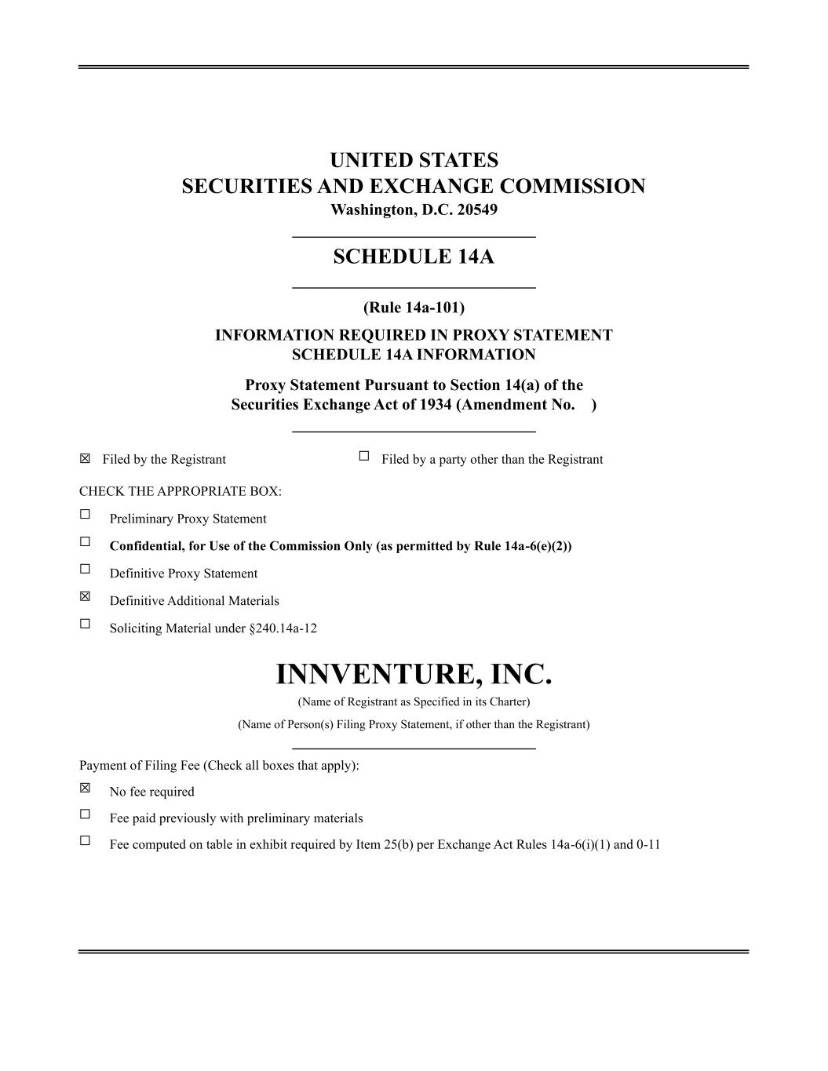
UNITED STATES SECURITIES AND EXCHANGE COMMISSION Washington, D.C. 20549 ______________________________ SCHEDULE 14A ______________________________ (Rule 14a-101) INFORMATION REQUIRED IN PROXY STATEMENT SCHEDULE 14A INFORMATION Proxy Statement Pursuant to Section 14(a) of the Securities Exchange Act of 1934 (Amendment No. ) ______________________________ ☒ Filed by the Registrant ☐ Filed by a party other than the Registrant CHECK THE APPROPRIATE BOX: ☐ Preliminary Proxy Statement ☐ Confidential, for Use of the Commission Only (as permitted by Rule 14a-6(e)(2)) ☐ Definitive Proxy Statement ☒ Definitive Additional Materials ☐ Soliciting Material under §240.14a-12 INNVENTURE, INC. (Name of Registrant as Specified in its Charter) (Name of Person(s) Filing Proxy Statement, if other than the Registrant) ______________________________ Payment of Filing Fee (Check all boxes that apply): ☒ No fee required ☐ Fee paid previously with preliminary materials ☐ Fee computed on table in exhibit required by Item 25(b) per Exchange Act Rules 14a-6(i)(1) and 0-11


On April 30, 2026, Innventure, Inc. (the “Company”) issued the following Form 8-K, which contains information relating to the Company’s 2026 Annual Meeting of Shareholders to be held on June 17, 2026.

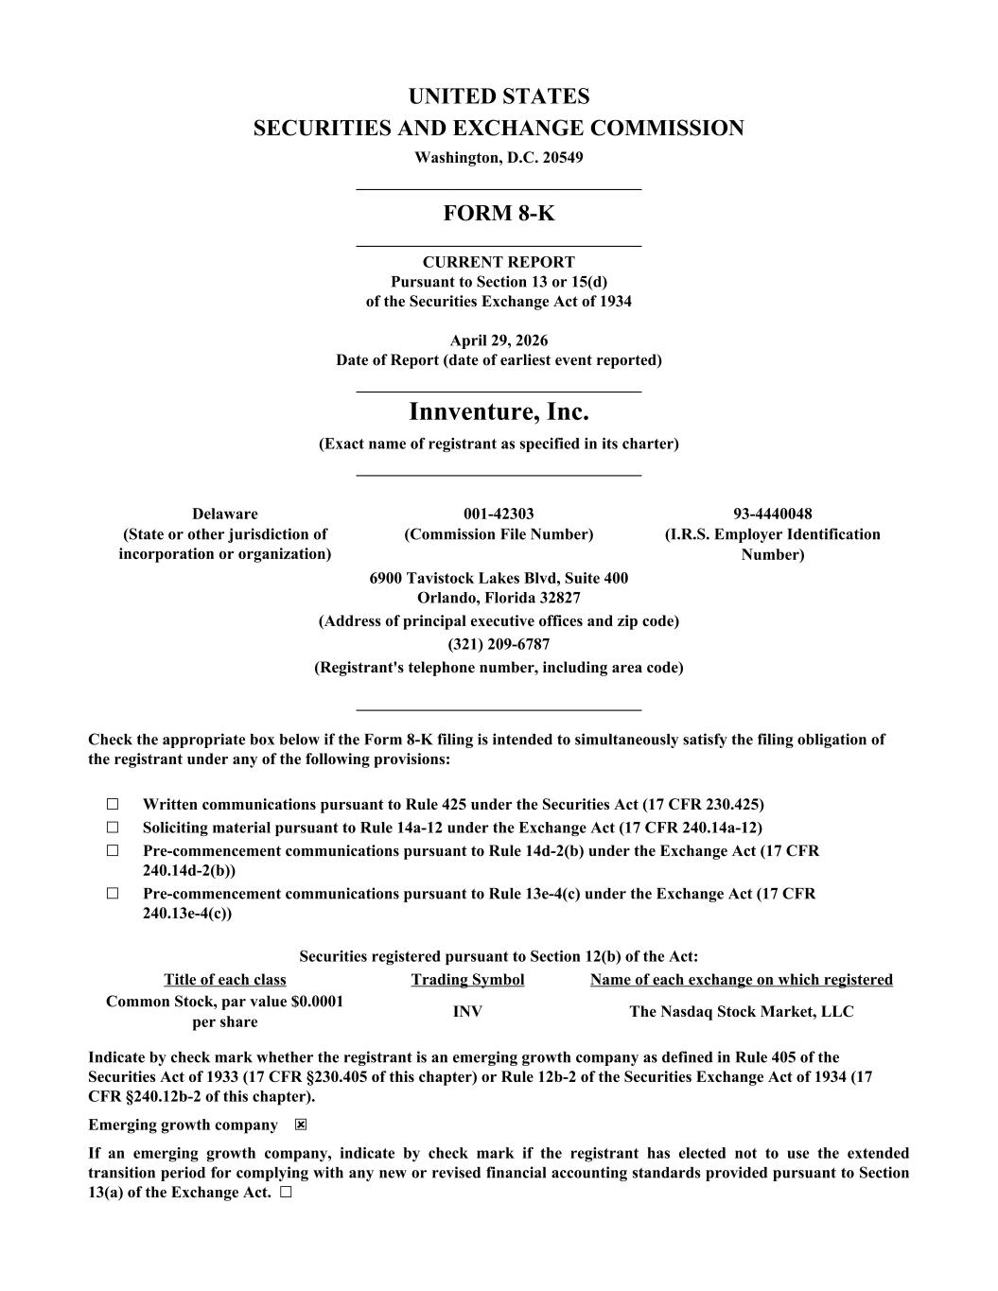
UNITED STATES SECURITIES AND EXCHANGE COMMISSION Washington, D.C. 20549 ___________________________________ FORM 8-K ___________________________________ CURRENT REPORT Pursuant to Section 13 or 15(d) of the Securities Exchange Act of 1934 April 29, 2026 Date of Report (date of earliest event reported) ___________________________________ Innventure, Inc. (Exact name of registrant as specified in its charter) ___________________________________ Delaware (State or other jurisdiction of incorporation or organization) 001-42303 (Commission File Number) 93-4440048 (I.R.S. Employer Identification Number) 6900 Tavistock Lakes Blvd, Suite 400 Orlando, Florida 32827 (Address of principal executive offices and zip code) (321) 209-6787 (Registrant's telephone number, including area code) ___________________________________ Check the appropriate box below if the Form 8-K filing is intended to simultaneously satisfy the filing obligation of the registrant under any of the following provisions: ☐ Written communications pursuant to Rule 425 under the Securities Act (17 CFR 230.425) ☐ Soliciting material pursuant to Rule 14a-12 under the Exchange Act (17 CFR 240.14a-12) ☐ Pre-commencement communications pursuant to Rule 14d-2(b) under the Exchange Act (17 CFR 240.14d-2(b)) ☐ Pre-commencement communications pursuant to Rule 13e-4(c) under the Exchange Act (17 CFR 240.13e-4(c)) Securities registered pursuant to Section 12(b) of the Act: Title of each class Trading Symbol Name of each exchange on which registered Common Stock, par value $0.0001 per share INV The Nasdaq Stock Market, LLC Indicate by check mark whether the registrant is an emerging growth company as defined in Rule 405 of the Securities Act of 1933 (17 CFR §230.405 of this chapter) or Rule 12b-2 of the Securities Exchange Act of 1934 (17 CFR §240.12b-2 of this chapter). Emerging growth company ☒ If an emerging growth company, indicate by check mark if the registrant has elected not to use the extended transition period for complying with any new or revised financial accounting standards provided pursuant to Section 13(a) of the Exchange Act. ☐

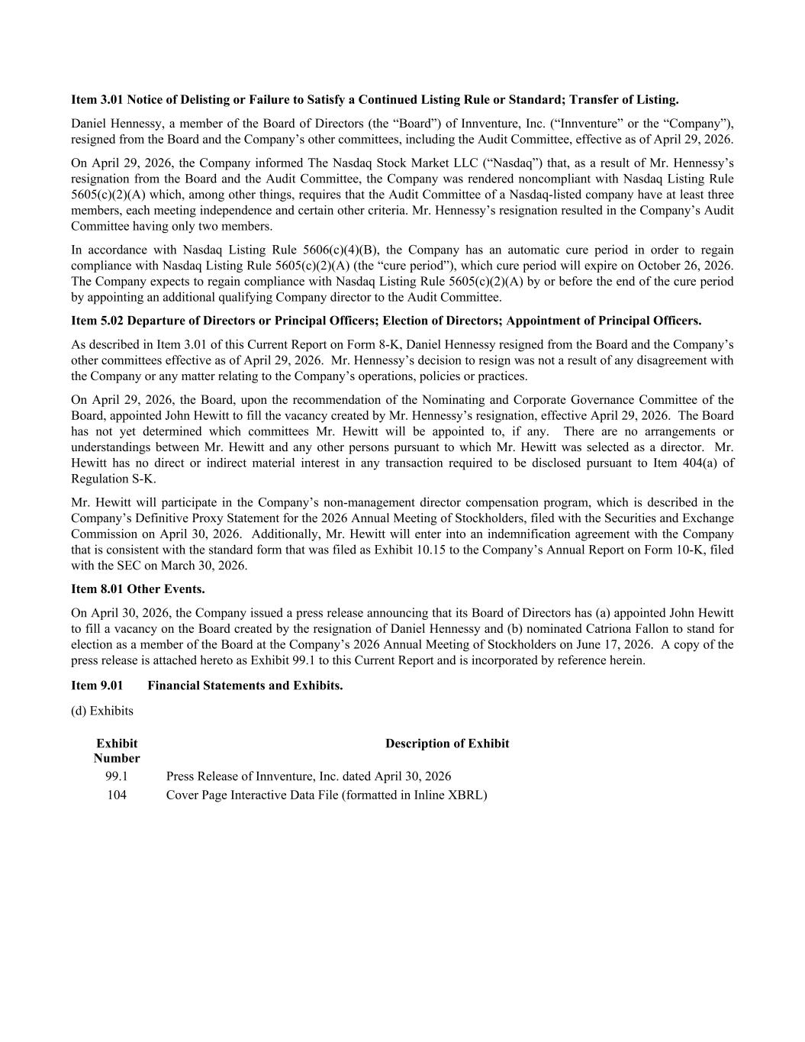
Item 3.01 Notice of Delisting or Failure to Satisfy a Continued Listing Rule or Standard; Transfer of Listing. Daniel Hennessy, a member of the Board of Directors (the “Board”) of Innventure, Inc. (“Innventure” or the “Company”), resigned from the Board and the Company’s other committees, including the Audit Committee, effective as of April 29, 2026. On April 29, 2026, the Company informed The Nasdaq Stock Market LLC (“Nasdaq”) that, as a result of Mr. Hennessy’s resignation from the Board and the Audit Committee, the Company was rendered noncompliant with Nasdaq Listing Rule 5605(c)(2)(A) which, among other things, requires that the Audit Committee of a Nasdaq-listed company have at least three members, each meeting independence and certain other criteria. Mr. Hennessy’s resignation resulted in the Company’s Audit Committee having only two members. In accordance with Nasdaq Listing Rule 5606(c)(4)(B), the Company has an automatic cure period in order to regain compliance with Nasdaq Listing Rule 5605(c)(2)(A) (the “cure period”), which cure period will expire on October 26, 2026. The Company expects to regain compliance with Nasdaq Listing Rule 5605(c)(2)(A) by or before the end of the cure period by appointing an additional qualifying Company director to the Audit Committee. Item 5.02 Departure of Directors or Principal Officers; Election of Directors; Appointment of Principal Officers. As described in Item 3.01 of this Current Report on Form 8-K, Daniel Hennessy resigned from the Board and the Company’s other committees effective as of April 29, 2026. Mr. Hennessy’s decision to resign was not a result of any disagreement with the Company or any matter relating to the Company’s operations, policies or practices. On April 29, 2026, the Board, upon the recommendation of the Nominating and Corporate Governance Committee of the Board, appointed John Hewitt to fill the vacancy created by Mr. Hennessy’s resignation, effective April 29, 2026. The Board has not yet determined which committees Mr. Hewitt will be appointed to, if any. There are no arrangements or understandings between Mr. Hewitt and any other persons pursuant to which Mr. Hewitt was selected as a director. Mr. Hewitt has no direct or indirect material interest in any transaction required to be disclosed pursuant to Item 404(a) of Regulation S-K. Mr. Hewitt will participate in the Company’s non-management director compensation program, which is described in the Company’s Definitive Proxy Statement for the 2026 Annual Meeting of Stockholders, filed with the Securities and Exchange Commission on April 30, 2026. Additionally, Mr. Hewitt will enter into an indemnification agreement with the Company that is consistent with the standard form that was filed as Exhibit 10.15 to the Company’s Annual Report on Form 10-K, filed with the SEC on March 30, 2026. Item 8.01 Other Events. On April 30, 2026, the Company issued a press release announcing that its Board of Directors has (a) appointed John Hewitt to fill a vacancy on the Board created by the resignation of Daniel Hennessy and (b) nominated Catriona Fallon to stand for election as a member of the Board at the Company’s 2026 Annual Meeting of Stockholders on June 17, 2026. A copy of the press release is attached hereto as Exhibit 99.1 to this Current Report and is incorporated by reference herein. Item 9.01 Financial Statements and Exhibits. (d) Exhibits Exhibit Number Description of Exhibit 99.1 Press Release of Innventure, Inc. dated April 30, 2026 104 Cover Page Interactive Data File (formatted in Inline XBRL)


SIGNATURES Pursuant to the requirements of the Securities Exchange Act of 1934, as amended, the registrant has duly caused this report to be signed on its behalf by the undersigned hereunto duly authorized. INNVENTURE, INC. Date: April 30, 2026 By: /s/ David Yablunosky Name: David Yablunosky Title: Chief Financial Officer

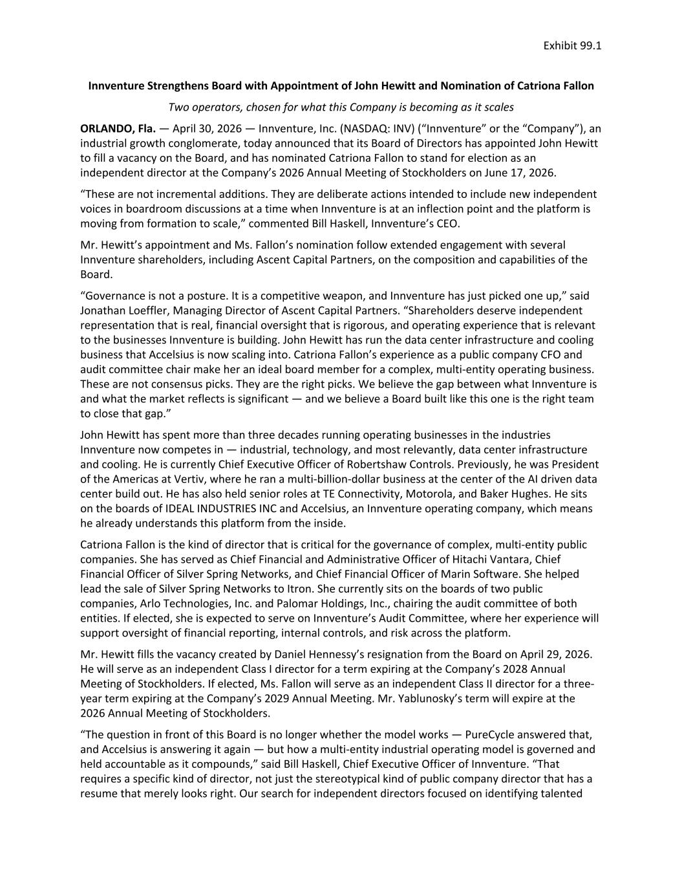
Innventure Strengthens Board with Appointment of John Hewitt and Nomination of Catriona Fallon Two operators, chosen for what this Company is becoming as it scales ORLANDO, Fla. — April 30, 2026 — Innventure, Inc. (NASDAQ: INV) (“Innventure” or the “Company”), an industrial growth conglomerate, today announced that its Board of Directors has appointed John Hewitt to fill a vacancy on the Board, and has nominated Catriona Fallon to stand for election as an independent director at the Company’s 2026 Annual Meeting of Stockholders on June 17, 2026. “These are not incremental additions. They are deliberate actions intended to include new independent voices in boardroom discussions at a time when Innventure is at an inflection point and the platform is moving from formation to scale,” commented Bill Haskell, Innventure’s CEO. Mr. Hewitt’s appointment and Ms. Fallon’s nomination follow extended engagement with several Innventure shareholders, including Ascent Capital Partners, on the composition and capabilities of the Board. “Governance is not a posture. It is a competitive weapon, and Innventure has just picked one up,” said Jonathan Loeffler, Managing Director of Ascent Capital Partners. “Shareholders deserve independent representation that is real, financial oversight that is rigorous, and operating experience that is relevant to the businesses Innventure is building. John Hewitt has run the data center infrastructure and cooling business that Accelsius is now scaling into. Catriona Fallon’s experience as a public company CFO and audit committee chair make her an ideal board member for a complex, multi-entity operating business. These are not consensus picks. They are the right picks. We believe the gap between what Innventure is and what the market reflects is significant — and we believe a Board built like this one is the right team to close that gap.” John Hewitt has spent more than three decades running operating businesses in the industries Innventure now competes in — industrial, technology, and most relevantly, data center infrastructure and cooling. He is currently Chief Executive Officer of Robertshaw Controls. Previously, he was President of the Americas at Vertiv, where he ran a multi-billion-dollar business at the center of the AI driven data center build out. He has also held senior roles at TE Connectivity, Motorola, and Baker Hughes. He sits on the boards of IDEAL INDUSTRIES INC and Accelsius, an Innventure operating company, which means he already understands this platform from the inside. Catriona Fallon is the kind of director that is critical for the governance of complex, multi-entity public companies. She has served as Chief Financial and Administrative Officer of Hitachi Vantara, Chief Financial Officer of Silver Spring Networks, and Chief Financial Officer of Marin Software. She helped lead the sale of Silver Spring Networks to Itron. She currently sits on the boards of two public companies, Arlo Technologies, Inc. and Palomar Holdings, Inc., chairing the audit committee of both entities. If elected, she is expected to serve on Innventure’s Audit Committee, where her experience will support oversight of financial reporting, internal controls, and risk across the platform. Mr. Hewitt fills the vacancy created by Daniel Hennessy’s resignation from the Board on April 29, 2026. He will serve as an independent Class I director for a term expiring at the Company’s 2028 Annual Meeting of Stockholders. If elected, Ms. Fallon will serve as an independent Class II director for a three- year term expiring at the Company’s 2029 Annual Meeting. Mr. Yablunosky’s term will expire at the 2026 Annual Meeting of Stockholders. “The question in front of this Board is no longer whether the model works — PureCycle answered that, and Accelsius is answering it again — but how a multi-entity industrial operating model is governed and held accountable as it compounds,” said Bill Haskell, Chief Executive Officer of Innventure. “That requires a specific kind of director, not just the stereotypical kind of public company director that has a resume that merely looks right. Our search for independent directors focused on identifying talented Exhibit 99.1

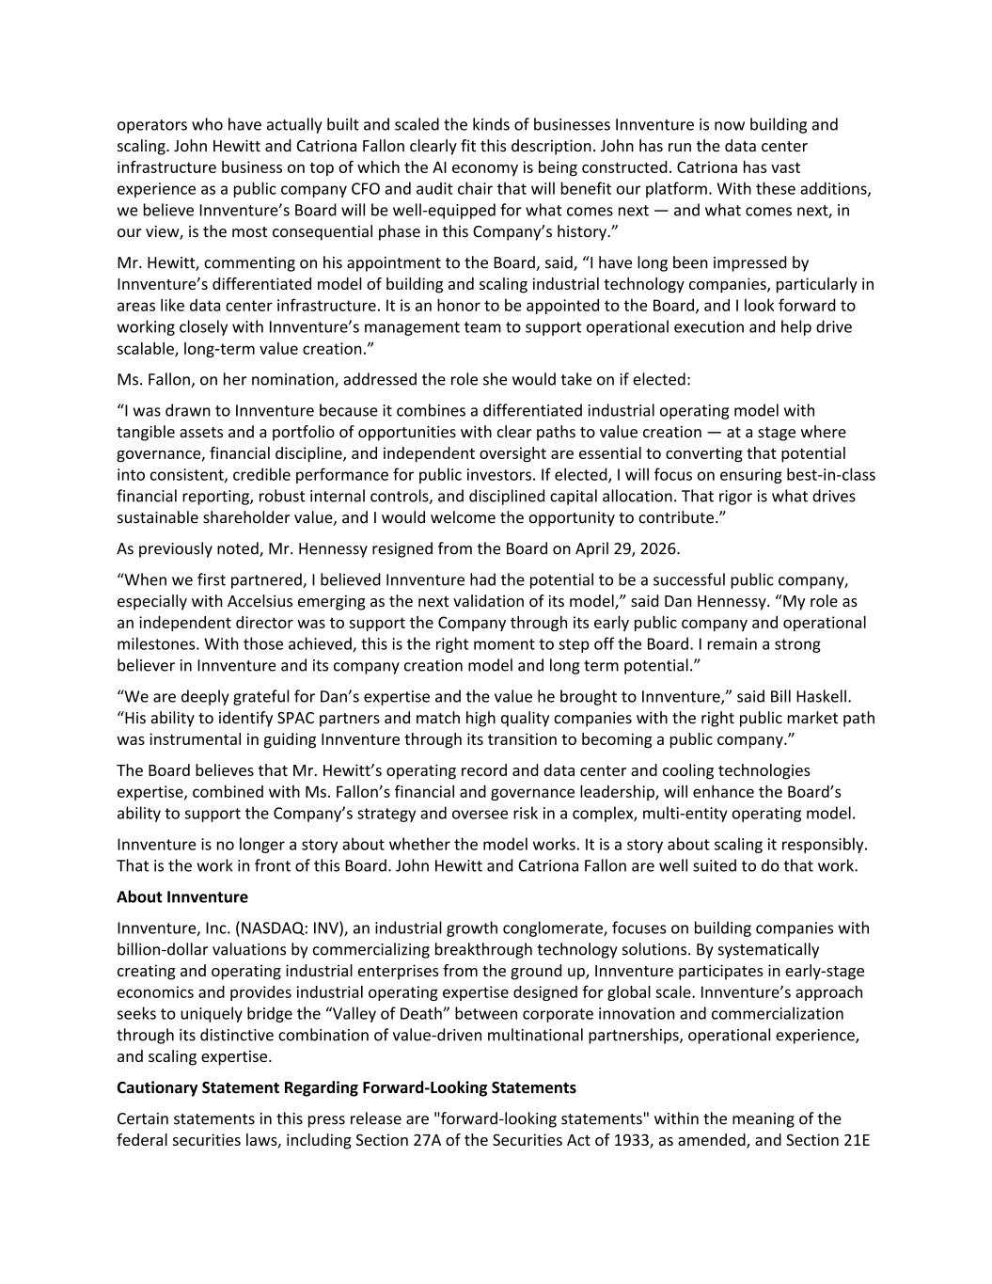
operators who have actually built and scaled the kinds of businesses Innventure is now building and scaling. John Hewitt and Catriona Fallon clearly fit this description. John has run the data center infrastructure business on top of which the AI economy is being constructed. Catriona has vast experience as a public company CFO and audit chair that will benefit our platform. With these additions, we believe Innventure’s Board will be well-equipped for what comes next — and what comes next, in our view, is the most consequential phase in this Company’s history.” Mr. Hewitt, commenting on his appointment to the Board, said, “I have long been impressed by Innventure’s differentiated model of building and scaling industrial technology companies, particularly in areas like data center infrastructure. It is an honor to be appointed to the Board, and I look forward to working closely with Innventure’s management team to support operational execution and help drive scalable, long-term value creation.” Ms. Fallon, on her nomination, addressed the role she would take on if elected: “I was drawn to Innventure because it combines a differentiated industrial operating model with tangible assets and a portfolio of opportunities with clear paths to value creation — at a stage where governance, financial discipline, and independent oversight are essential to converting that potential into consistent, credible performance for public investors. If elected, I will focus on ensuring best-in-class financial reporting, robust internal controls, and disciplined capital allocation. That rigor is what drives sustainable shareholder value, and I would welcome the opportunity to contribute.” As previously noted, Mr. Hennessy resigned from the Board on April 29, 2026. “When we first partnered, I believed Innventure had the potential to be a successful public company, especially with Accelsius emerging as the next validation of its model,” said Dan Hennessy. “My role as an independent director was to support the Company through its early public company and operational milestones. With those achieved, this is the right moment to step off the Board. I remain a strong believer in Innventure and its company creation model and long term potential.” “We are deeply grateful for Dan’s expertise and the value he brought to Innventure,” said Bill Haskell. “His ability to identify SPAC partners and match high quality companies with the right public market path was instrumental in guiding Innventure through its transition to becoming a public company.” The Board believes that Mr. Hewitt’s operating record and data center and cooling technologies expertise, combined with Ms. Fallon’s financial and governance leadership, will enhance the Board’s ability to support the Company’s strategy and oversee risk in a complex, multi-entity operating model. Innventure is no longer a story about whether the model works. It is a story about scaling it responsibly. That is the work in front of this Board. John Hewitt and Catriona Fallon are well suited to do that work. About Innventure Innventure, Inc. (NASDAQ: INV), an industrial growth conglomerate, focuses on building companies with billion-dollar valuations by commercializing breakthrough technology solutions. By systematically creating and operating industrial enterprises from the ground up, Innventure participates in early-stage economics and provides industrial operating expertise designed for global scale. Innventure’s approach seeks to uniquely bridge the “Valley of Death” between corporate innovation and commercialization through its distinctive combination of value-driven multinational partnerships, operational experience, and scaling expertise. Cautionary Statement Regarding Forward-Looking Statements Certain statements in this press release are "forward-looking statements" within the meaning of the federal securities laws, including Section 27A of the Securities Act of 1933, as amended, and Section 21E

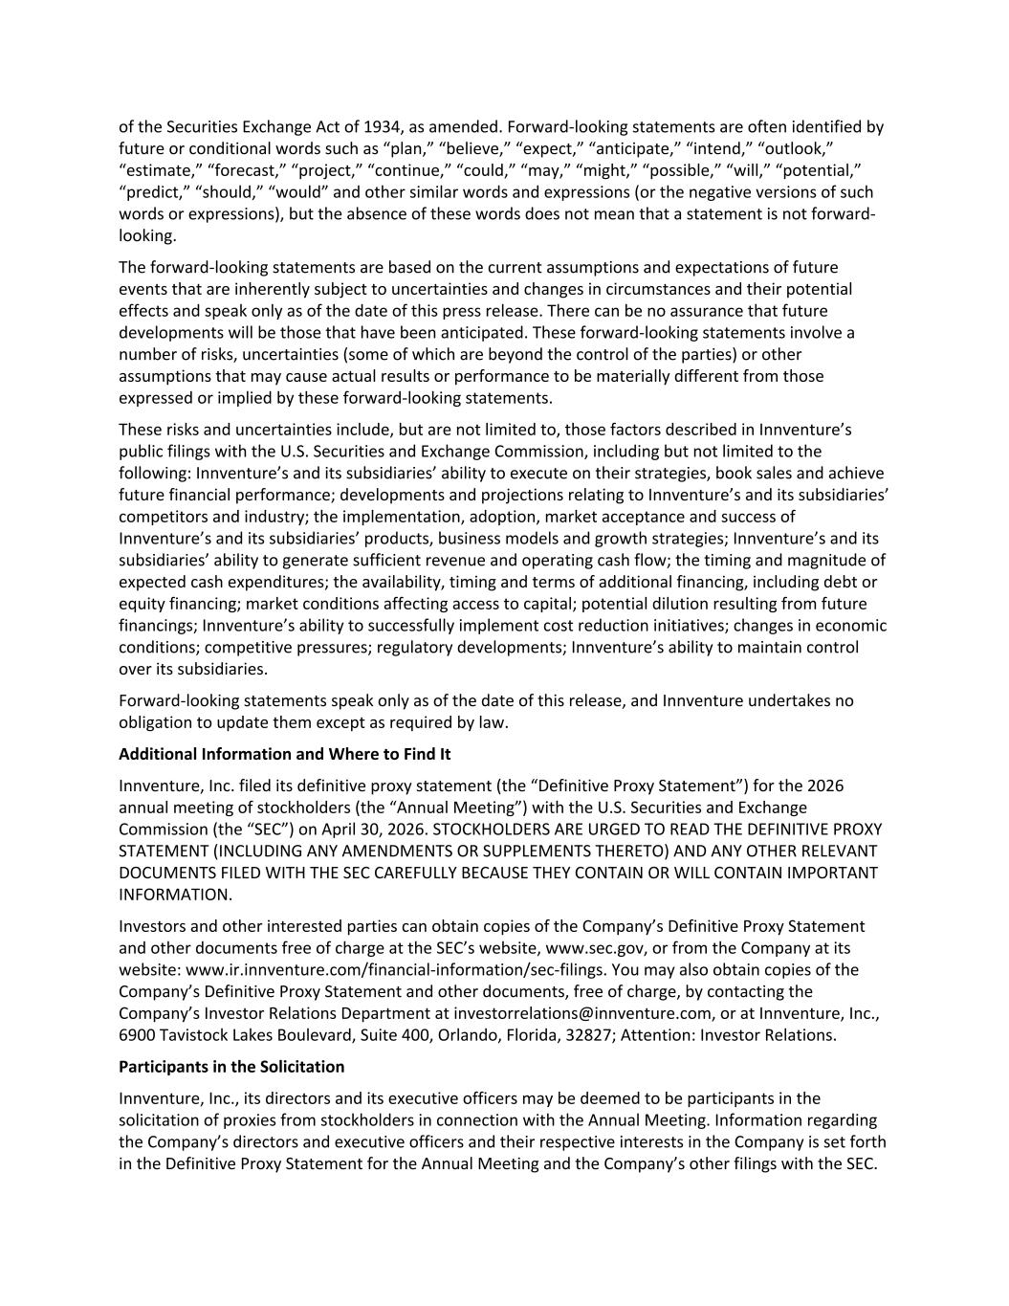
of the Securities Exchange Act of 1934, as amended. Forward-looking statements are often identified by future or conditional words such as “plan,” “believe,” “expect,” “anticipate,” “intend,” “outlook,” “estimate,” “forecast,” “project,” “continue,” “could,” “may,” “might,” “possible,” “will,” “potential,” “predict,” “should,” “would” and other similar words and expressions (or the negative versions of such words or expressions), but the absence of these words does not mean that a statement is not forward- looking. The forward-looking statements are based on the current assumptions and expectations of future events that are inherently subject to uncertainties and changes in circumstances and their potential effects and speak only as of the date of this press release. There can be no assurance that future developments will be those that have been anticipated. These forward-looking statements involve a number of risks, uncertainties (some of which are beyond the control of the parties) or other assumptions that may cause actual results or performance to be materially different from those expressed or implied by these forward-looking statements. These risks and uncertainties include, but are not limited to, those factors described in Innventure’s public filings with the U.S. Securities and Exchange Commission, including but not limited to the following: Innventure’s and its subsidiaries’ ability to execute on their strategies, book sales and achieve future financial performance; developments and projections relating to Innventure’s and its subsidiaries’ competitors and industry; the implementation, adoption, market acceptance and success of Innventure’s and its subsidiaries’ products, business models and growth strategies; Innventure’s and its subsidiaries’ ability to generate sufficient revenue and operating cash flow; the timing and magnitude of expected cash expenditures; the availability, timing and terms of additional financing, including debt or equity financing; market conditions affecting access to capital; potential dilution resulting from future financings; Innventure’s ability to successfully implement cost reduction initiatives; changes in economic conditions; competitive pressures; regulatory developments; Innventure’s ability to maintain control over its subsidiaries. Forward-looking statements speak only as of the date of this release, and Innventure undertakes no obligation to update them except as required by law. Additional Information and Where to Find It Innventure, Inc. filed its definitive proxy statement (the “Definitive Proxy Statement”) for the 2026 annual meeting of stockholders (the “Annual Meeting”) with the U.S. Securities and Exchange Commission (the “SEC”) on April 30, 2026. STOCKHOLDERS ARE URGED TO READ THE DEFINITIVE PROXY STATEMENT (INCLUDING ANY AMENDMENTS OR SUPPLEMENTS THERETO) AND ANY OTHER RELEVANT DOCUMENTS FILED WITH THE SEC CAREFULLY BECAUSE THEY CONTAIN OR WILL CONTAIN IMPORTANT INFORMATION. Investors and other interested parties can obtain copies of the Company’s Definitive Proxy Statement and other documents free of charge at the SEC’s website, www.sec.gov, or from the Company at its website: www.ir.innventure.com/financial-information/sec-filings. You may also obtain copies of the Company’s Definitive Proxy Statement and other documents, free of charge, by contacting the Company’s Investor Relations Department at investorrelations@innventure.com, or at Innventure, Inc., 6900 Tavistock Lakes Boulevard, Suite 400, Orlando, Florida, 32827; Attention: Investor Relations. Participants in the Solicitation Innventure, Inc., its directors and its executive officers may be deemed to be participants in the solicitation of proxies from stockholders in connection with the Annual Meeting. Information regarding the Company’s directors and executive officers and their respective interests in the Company is set forth in the Definitive Proxy Statement for the Annual Meeting and the Company’s other filings with the SEC.

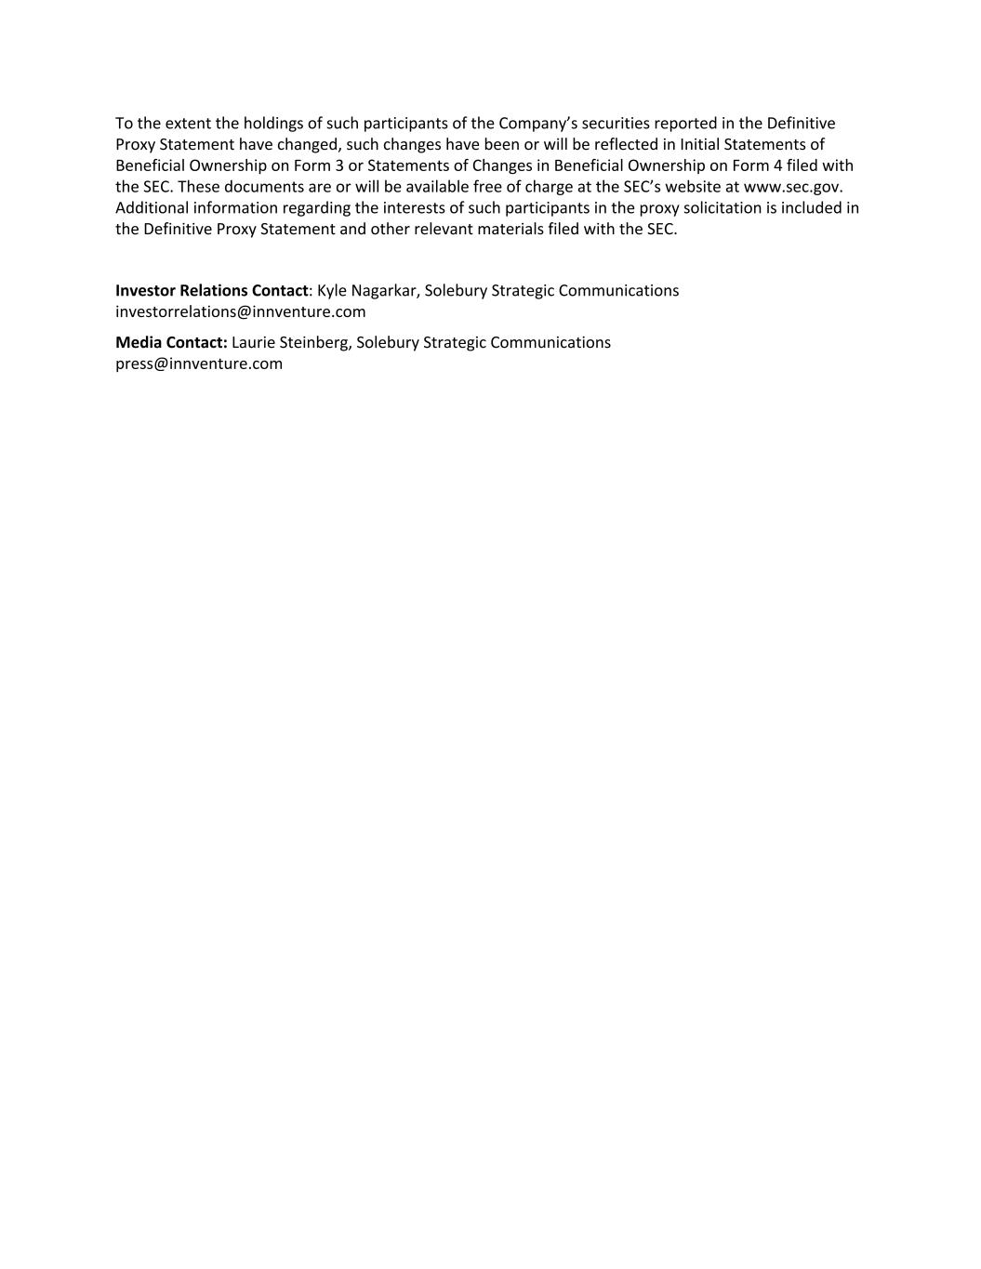
To the extent the holdings of such participants of the Company’s securities reported in the Definitive Proxy Statement have changed, such changes have been or will be reflected in Initial Statements of Beneficial Ownership on Form 3 or Statements of Changes in Beneficial Ownership on Form 4 filed with the SEC. These documents are or will be available free of charge at the SEC’s website at www.sec.gov. Additional information regarding the interests of such participants in the proxy solicitation is included in the Definitive Proxy Statement and other relevant materials filed with the SEC. Investor Relations Contact: Kyle Nagarkar, Solebury Strategic Communications investorrelations@innventure.com Media Contact: Laurie Steinberg, Solebury Strategic Communications press@innventure.com

