Filed pursuant to Rule 424(b)(3)
Registration No. 333-276714

Prospectus Supplement No. 5
(To Prospectus dated September 10, 2024)

INNVENTURE, INC.

This prospectus supplement updates, amends and supplements the prospectus dated September 10, 2024 (the “Prospectus”), which forms a part of our Registration Statement on Form S-4 (Registration No. 333-276714) and is being filed to update, amend and supplement the information included in the Prospectus with information contained in our Current Report on Form 8-K, which was filed with the Securities and Exchange Commission (the “SEC”) on November 14, 2024 (the “Current Report”). Accordingly, we have attached the Current Report to this prospectus supplement. Capitalized terms used in this prospectus supplement and not otherwise defined herein have the meanings specified in the Prospectus.

This prospectus supplement is not complete without the Prospectus. This prospectus supplement should be read in conjunction with the Prospectus, which is to be delivered with this prospectus supplement, and is qualified by reference thereto, except to the extent that the information in this prospectus supplement updates or supersedes the information contained in the Prospectus. Please keep this prospectus supplement with your Prospectus for future reference.

Shares of our common stock, par value $0.0001 per share (our “Common Stock”), are listed on The Nasdaq Stock Market, LLC under the symbol “INV.” On November 13, 2024, the closing price of our Common Stock was $10.64 per share.

Investing in our securities involves risks that are described in the “Risk Factors” section of the Prospectus.

Neither the SEC nor any state securities commission has approved or disapproved of the securities to be issued under the Prospectus or this prospectus supplement or determined if the Prospectus or this prospectus supplement is truthful or complete. Any representation to the contrary is a criminal offense.

The date of this prospectus supplement is November 14, 2024.

false000200155700020015572024-11-142024-11-14

UNITED STATES
SECURITIES AND EXCHANGE COMMISSION
Washington, D.C. 20549

FORM 8-K

CURRENT REPORT
Pursuant to Section 13 OR 15(d) of The Securities Exchange Act of 1934

Date of Report (Date of earliest event reported): November 14, 2024

Innventure, Inc.

(Exact name of registrant as specified in its charter)

Delaware | 001-42303 | 93-4440048
(State or other jurisdiction of incorporation) | (Commission File Number) | (IRS Employer Identification No.)

6900 Tavistock Lakes Blvd, Suite 400
Orlando, Florida |  | 32827
(Address of principal executive offices) |  | (Zip Code)

Registrant’s telephone number, including area code: (321) 209-6787

Not applicable
(Former name or former address, if changed since last report.)

Check the appropriate box below if the Form 8-K filing is intended to simultaneously satisfy the filing obligation of the registrant under any of the following provisions:

☐ | Written communications pursuant to Rule 425 under the Securities Act (17 CFR 230.425)

☐ | Soliciting material pursuant to Rule 14a-12 under the Exchange Act (17 CFR 240.14a-12)

☐ | Pre-commencement communications pursuant to Rule 14d-2(b) under the Exchange Act (17 CFR 240.14d-2(b))

☐ | Pre-commencement communications pursuant to Rule 13e-4(c) under the Exchange Act (17 CFR 240.13e-4(c))

Securities registered pursuant to Section 12(b) of the Act:

Title of each class | Trading Symbol(s) | Name of each exchange on which registered
Common Stock, par value $0.0001 per share | INV | The Nasdaq Stock Market, LLC

Indicate by check mark whether the registrant is an emerging growth company as defined in Rule 405 of the Securities Act of 1933 (§230.405 of this chapter) or Rule 12b-2 of the Securities Exchange Act of 1934 (§240.12b-2 of this chapter).

Emerging growth company ☒

If an emerging growth company, indicate by check mark if the registrant has elected not to use the extended transition period for complying with any new or revised financial accounting standards provided pursuant to Section 13(a) of the Exchange Act. ☐

Item 2.02 | Results of Operations and Financial Condition.

On November 14, 2024, Innventure, Inc. (the “Company”) issued a press release, attached hereto as Exhibit 99.1 and incorporated herein by reference, announcing the Company’s financial results for the third quarter ended September 30, 2024, and certain other information.

The information contained in Item 7.01 concerning the presentation to the Company’s investors is hereby incorporated into this Item 2.02 by reference.

Item 7.01 | Regulation FD Disclosure.

The slide presentation attached hereto as Exhibit 99.2, and incorporated herein by reference, will be presented to certain investors of the Company on November 14, 2024 and may be used by the Company in various other presentations to investors.

Item 9.01 | Financial Statements and Exhibits.

(d) Exhibits

Exhibit Number | Description of Exhibit
99.1 | Press Release by Innventure, Inc. dated November 14, 2024
99.2 | Innventure, Inc. presentation to investors
104 | Cover Page Interactive Data File (embedded within the Inline XBRL document)

SIGNATURES

Pursuant to the requirements of the Securities Exchange Act of 1934, the registrant has duly caused this report to be signed on its behalf by the undersigned hereunto duly authorized.

 | INNVENTURE, INC.
Date: November 14, 2024 | By: | /s/ David Yablunosky
 |  | Name: David Yablunosky
 |  | Title: Chief Financial Officer

Exhibit 99.1

Innventure Reports Third Quarter 2024 Results

Accelsius delivered first revenue generating system during third quarter

ORLANDO, Fla. (November 14, 2024) – Innventure, Inc. (NASDAQ: INV) (“Innventure”), a technology commercialization platform, today announced financial results for the quarter ended September 30, 2024.

“We are incredibly excited about Innventure’s accomplishments during the third quarter, which subsequently culminated in early October with the close of our business combination and first day of trading on the Nasdaq,” said Bill Haskell, Innventure’s Chief Executive Officer. “Our operating companies continue to outperform our expectations, with both AeroFlexx and Accelsius now delivering commercial product to the marketplace.”

Mr. Haskell continued, “We look forward to sharing more as we scale these companies and launch new companies in the future. I’d like to thank the entire Innventure team for their tireless work making our vision an ever expanding reality. Now as a public company, we can accelerate execution against our mission to bring breakthrough technologies to market and deliver long-term value for our shareholders.”

Conference Call and Webcast

A conference call to discuss these results has been scheduled for 8:30 a.m. ET on Thursday, November 14, 2024. Interested parties can join the call via teleconference by registering at this link: https://register.vevent.com/register/BIc433d3bf08f34d37b56270335fc659fe.

After registering, you will be provided dial in details and a unique dial-in PIN. Registration is open through the live call, but to ensure you are connected for the full call, we suggest registering in advance. Webcast information and conference call materials will be made available on Innventure’s Investor Relations website here: https://ir.innventure.com/.

About Innventure

Innventure founds, funds, and operates companies with a focus on transformative, sustainable technology solutions acquired or licensed from multinational corporations. As owner-operators, Innventure takes what it believes to be breakthrough technologies from early evaluation to scaled commercialization utilizing an approach designed to help mitigate risk as it builds disruptive companies it believes have the potential to achieve a target enterprise value of at least $1 billion. Innventure defines ‘‘disruptive’’ as innovations that have the ability to significantly change the way businesses, industries, markets and/or consumers operate.

Cautionary Statement Regarding Forward-Looking Statements

This press release contains forward-looking statements, including statements about the Company’s business model and its and its operating companies’ prospects. In addition, any statements that refer to projections, forecasts or other characterizations of future events or circumstances, including any underlying assumptions, are forward-looking statements. Forward-looking statements generally relate to future events or the Company’s future financial or operating performance and may refer to projections and forecasts. Forward-looking statements are often identified by future or conditional words such as “plan,” “believe,” “expect,” “anticipate,” “intend,” “outlook,” “estimate,” “forecast,” “project,” “continue,” “could,” “may,” “might,” “possible,” “will,” “potential,” “predict,” “should,” “would” and other similar words and expressions (or the negative versions of such words or expressions), but the absence of these words does not mean that a statement is not forward-looking.

The forward-looking statements are based on the current expectations of the Company’s management and are inherently subject to uncertainties and changes in circumstances and their potential effects and speak only as of the date of this press release. There can be no assurance that future developments will be those that have been anticipated. These forward-looking statements involve a number of risks, uncertainties (some of which are beyond the control of the parties) or other assumptions that may cause actual results or performance to be materially different from those expressed or implied by these forward-looking statements. These risks and uncertainties include, but are not limited to, those factors discussed and identified in other public filings made with the Securities and Exchange Commission by the Company and the following: (a) expectations regarding the Company’s and the Innventure Companies’ (as defined below) strategies and future financial performance, including their future business plans, expansion and acquisition plans or objectives, prospective performance and opportunities and competitors, revenues, products and services, pricing, operating expenses, market trends, liquidity, cash flows and uses of cash, capital expenditures, and the Company’s ability to invest in growth initiatives; (b) the implementation, market acceptance and success of the Company’s and the Innventure Companies’ business models and growth strategies; (c) the Company’s future capital requirements and sources and uses of cash; (d) the Company’s ability to meet the various conditions, including the available cash and performance targets, and access any of the installments draws under the WTI Line of Credit; (e) the Company’s ability to meet the various conditions and satisfy the various limitations under the Standby Equity Purchase Agreement (the “SEPA”) with YA II PN, Ltd., including exchange caps, issuances and subscriptions based on trading volumes, to access the funds available under the SEPA; (f) that the Company will have sufficient capital following the completion of the Business Combination to operate as anticipated; (g) the Company’s ability to obtain funding for its operations and future growth; (h) developments and projections relating to the Company’s and the Innventure Companies’ competitors and industry; (i) the Innventure Companies’ ability to meet, and to continue to meet, applicable regulatory requirements for the use of their products and the numerous regulatory requirements generally applicable to their products and facilities; (j) the outcome of any legal proceedings that may be instituted against the Company in connection with the completion of the Business Combination; (k) the Company’s ability to find future opportunities to license or acquire breakthrough technology solutions from multinational corporations (“MNCs”) and to satisfy the requirements imposed by or to avoid disagreements with its current and future MNC partners; (l) the risk that the Company may be deemed an investment company under the Investment Company Act, which would impose burdensome compliance requirements and restrictions on its activities; (m) the Company’s ability to sufficiently protect the intellectual property rights of itself and its subsidiaries, and to avoid or resolve in a timely and cost-effective manner any disputes that may arise relating to its use of the intellectual property of third parties; (n) the risk of a cyber-attack or a failure of the Company’s information technology and data security infrastructure; (o) the ability to recognize the anticipated benefits of the Business Combination; (p) unexpected costs related to the Business Combination; (q) geopolitical risk and changes in applicable laws or regulations; (r) potential adverse effects of other economic, business, and/or competitive factors; and (s) operational risks related to the Company and its subsidiaries.

Media Contact: Laurie Steinberg, Solebury Strategic Communications
press@innventure.com

Investor Relations Contact: Sloan Bohlen, Solebury Strategic Communications
investorrelations@innventure.com

Innventure LLC and Subsidiaries
Condensed Consolidated Balance Sheets
(in thousands, except unit and per unit amounts) (Unaudited)

 |  | September 30,  2024 |  |  |  | December 31,  2023
 |  | (Unaudited)
Assets
Cash, cash equivalents and restricted cash |  | $ | 16,297 |  |  | $ | 2,575
Prepaid expenses and other current assets |  |  | 1,884 |  |  |  | 487
Inventory |  |  | 2,824 |  |  |  | —
Due from related parties |  |  | 210 |  |  |  | 2,602
Total Current Assets |  |  | 21,215 |  |  |  | 5,664
Investments |  |  | 32,359 |  |  |  | 14,167
Property, plant and equipment, net |  |  | 1,227 |  |  |  | 637
Other assets |  |  | 930 |  |  |  | 1,096
Total Assets |  |  | 55,731 |  |  |  | 21,564
Liabilities and Unitholders’ Capital
Accounts payable |  |  | 4,932 |  |  |  | 93
Accrued employee benefits |  |  | 7,617 |  |  |  | 3,779
Accrued expenses |  |  | 1,929 |  |  |  | 1,009
Related party payables |  |  | 815 |  |  |  | 347
Related party notes payable - current |  |  | 13,932 |  |  |  | 1,000
Notes payable - current |  |  | 693 |  |  |  | 912
Patent installment payable - current |  |  | 525 |  |  |  | 775
Liability for future preferred stock issuance |  |  | 10,870 |  |  |  | —
Other current liabilities |  |  | 288 |  |  |  | 253
Total Current Liabilities |  |  | 41,601 |  |  |  | 8,168
Notes payable, net of current portion |  |  | 282 |  |  |  | 999
Convertible promissory note, net |  |  | — |  |  |  | 1,120
Convertible promissory note due to related party, net |  |  | — |  |  |  | 3,381
Embedded derivative liability |  |  | — |  |  |  | 1,994
Patent installment payable, net of current |  |  | 13,075 |  |  |  | 13,075
Other liabilities |  |  | 501 |  |  |  | 683
Total Liabilities |  |  | 55,459 |  |  |  | 29,420
Commitments and Contingencies
Mezzanine Capital
Redeemable Class I Units, no par value, 1,000,000 units authorized, issued and outstanding |  |  | 4,477 |  |  |  | 2,912
Redeemable Class PCTA Units, no par value, 3,982,675 units authorized, issued and outstanding |  |  | 18,103 |  |  |  | 7,718
Unitholders' Deficit
Class B Preferred Units, no par value, 6,722,562 and 4,639,557 units authorized, 5,609,951 and 4,109,961 units issued and outstanding |  |  | 51,683 |  |  |  | 38,122
Class B-1 Preferred Units, no par value, 2,600,000 units authorized, 342,608 units issued and outstanding |  |  | 3,323 |  |  |  | 3,323
Class A Units, no par value, 10,975,000 units authorized, 10,875,000 units issued and outstanding |  |  | 1,950 |  |  |  | 1,950
Class C Units, no par value, 1,585,125 units authorized, 1,570,125 units issued and outstanding |  |  | 981 |  |  |  | 844
Accumulated deficit |  |  | (90,952 | ) |  |  | (64,284 | )
Accumulated other comprehensive loss |  |  | (2,373 | ) |  |  | —
Non-controlling interest |  |  | 13,080 |  |  |  | 1,559
Total Unitholders’ Deficit |  |  | (22,308 | ) |  |  | (18,486 | )
Total Liabilities, Mezzanine Capital, and Unitholders' Deficit |  | $ | 55,731 |  |  | $ | 21,564

See accompanying notes to condensed consolidated financial statements.

Innventure LLC and Subsidiaries
Condensed Consolidated Statements of Operations and Comprehensive Income (Loss)
(in thousands, except unit and per unit amounts) (Unaudited)

 |  | Three months ended  September 30, |  |  |  |  |  |  |  | Nine months ended  September 30,
 |  | 2024 |  |  |  | 2023 |  |  |  | 2024 |  |  |  | 2023
Revenue
Management fee income - related parties |  | $ | 222 |  |  | $ | 224 |  |  | $ | 669 |  |  | $ | 668
Consulting revenue |  |  | — |  |  |  | 50 |  |  |  | — |  |  |  | 225
Product sales |  |  | 95 |  |  |  | — |  |  |  | 95 |  |  |  | —
Total Revenue |  |  | 317 |  |  |  | 274 |  |  |  | 764 |  |  |  | 893
Operating Expenses
Cost of sales |  |  | 777 |  |  |  | — |  |  |  | 777 |  |  |  | —
General and administrative |  |  | 9,052 |  |  |  | 4,054 |  |  |  | 25,323 |  |  |  | 9,878
Sales and marketing |  |  | 1,629 |  |  |  | 696 |  |  |  | 4,178 |  |  |  | 1,901
Research and development |  |  | 2,533 |  |  |  | 1,240 |  |  |  | 5,978 |  |  |  | 2,822
Total Operating Expenses |  |  | 13,991 |  |  |  | 5,990 |  |  |  | 36,256 |  |  |  | 14,601
Loss from Operations |  |  | (13,674 | ) |  |  | (5,716 | ) |  |  | (35,492 | ) |  |  | (13,708 | )
Non-operating (Expense) and Income
Interest expense, net |  |  | (852 | ) |  |  | (364 | ) |  |  | (1,300 | ) |  |  | (841 | )
Net (loss) gain on investments |  |  | 7,148 |  |  |  | (12,148 | ) |  |  | 11,547 |  |  |  | (2,718 | )
Net (loss) gain on investments – due to related parties |  |  | (308 | ) |  |  | 436 |  |  |  | (468 | ) |  |  | 99
Change in fair value of embedded derivative liability |  |  | — |  |  |  | (451 | ) |  |  | (478 | ) |  |  | (492 | )
Equity method investment income (loss) |  |  | 109 |  |  |  | (673 | ) |  |  | 893 |  |  |  | (291 | )
Loss on conversion of promissory notes |  |  | — |  |  |  | — |  |  |  | (1,119 | ) |  |  | —
Other expenses |  |  | (64 | ) |  |  | — |  |  |  | (64 | ) |  |  | —
Total Non-operating (Expense) Income |  |  | 6,033 |  |  |  | (13,200 | ) |  |  | 9,011 |  |  |  | (4,243 | )
Income tax expense |  |  | — |  |  |  | — |  |  |  | — |  |  |  | —
Net Loss |  |  | (7,641 | ) |  |  | (18,916 | ) |  |  | (26,481 | ) |  |  | (17,951 | )
Less: Loss attributable to non-controlling interest |  |  | (5,430 | ) |  |  | (45 | ) |  |  | (11,762 | ) |  |  | (101 | )
Net Loss Attributable to Innventure LLC Unitholders |  | $ | (2,211 | ) |  | $ | (18,871 | ) |  | $ | (14,719 | ) |  | $ | (17,850 | )
Net Loss Attributable to Class A Unitholders |  | $ | (10,233 | ) |  | $ | (9,177 | ) |  | $ | (29,010 | ) |  | $ | (16,848 | )
Basic loss per unit |  | $ | (0.94 | ) |  | $ | (0.84 | ) |  | $ | (2.67 | ) |  | $ | (1.55 | )
Basic weighted average Class A Units |  |  | 10,875,000 |  |  |  | 10,875,000 |  |  |  | 10,875,000 |  |  |  | 10,875,000
Other comprehensive income (loss), net of taxes:
Unrealized loss on AFS debt securities - related party |  | $ | (2,373 | ) |  | $ | — |  |  | $ | (2,373 | ) |  | $ | —
Total other comprehensive loss, net of taxes |  |  | (2,373 | ) |  |  | — |  |  |  | (2,373 | ) |  |  | —
Total comprehensive loss, net of taxes |  |  | (10,014 | ) |  |  | (18,916 | ) |  |  | (28,854 | ) |  |  | (17,951 | )
Less: Comprehensive loss attributable to non-controlling interest |  |  | (5,430 | ) |  |  | (45 | ) |  |  | (11,762 | ) |  |  | (101 | )
Net Comprehensive Loss Attributable to Innventure LLC Unitholders |  | $ | (4,584 | ) |  | $ | (18,871 | ) |  | $ | (17,092 | ) |  | $ | (17,850 | )

See accompanying notes to condensed consolidated financial statements.

Innventure LLC and Subsidiaries
Condensed Consolidated Statements of Changes in Mezzanine Capital
(in thousands) (Unaudited)

 |  | Class I  Amount |  |  |  | Class PCTA  Amount |  |  |  | Total
December 31, 2022 |  | $ | 2,984 |  |  | $ | 12,882 |  |  | $ | 15,866
Accretion of redeemable units to redemption value |  |  | 1 |  |  |  | 457 |  |  |  | 458
March 31, 2023 |  |  | 2,985 |  |  |  | 13,339 |  |  |  | 16,324
Proceeds from capital calls to unitholders |  |  | 130 |  |  |  | — |  |  |  | 130
Accretion of redeemable units to redemption value |  |  | 423 |  |  |  | 7,031 |  |  |  | 7,454
June 30, 2023 |  |  | 3,538 |  |  |  | 20,370 |  |  |  | 23,908
Accretion of redeemable units to redemption value |  |  | (469 | ) |  |  | (9,680 | ) |  |  | (10,149 | )
September 30, 2023 |  | $ | 3,069 |  |  | $ | 10,690 |  |  | $ | 13,759
December 31, 2023 |  | $ | 2,912 |  |  | $ | 7,718 |  |  | $ | 10,630
Accretion of redeemable units to redemption value |  |  | 280 |  |  |  | 4,135 |  |  |  | 4,415
March 31, 2024 |  |  | 3,192 |  |  |  | 11,853 |  |  |  | 15,045
Accretion of redeemable units to redemption value |  |  | 934 |  |  |  | (572 | ) |  |  | 362
June 30, 2024 |  |  | 4,126 |  |  |  | 11,281 |  |  |  | 15,407
Accretion of redeemable units to redemption value |  |  | 351 |  |  |  | 6,822 |  |  |  | 7,173
September 30, 2024 |  | $ | 4,477 |  |  | $ | 18,103 |  |  | $ | 22,580

See accompanying notes to condensed consolidated financial statements.

Innventure LLC and Subsidiaries
Condensed Consolidated Statements of Changes in Unitholders' Deficit
(in thousands) (Unaudited)

 |  | Class B  Preferred |  |  |  | Class B-1  Preferred |  |  |  | Class A |  |  |  | Class C |  |  |  | Accumulated  Deficit |  |  |  | Accumulated Other Comprehensive Loss |  |  |  | Non-Controlling Interest |  |  |  | Total Unitholders' Deficit
December 31, 2023 |  | $ | 38,122 |  |  | $ | 3,323 |  |  | $ | 1,950 |  |  | $ | 844 |  |  | $ | (64,284 | ) |  | $ | — |  |  | $ | 1,559 |  |  | $ | (18,486 | )
Net loss |  |  | — |  |  |  | — |  |  |  | — |  |  |  | — |  |  |  | (5,219 | ) |  |  | — |  |  |  | (2,307 | ) |  |  | (7,526 | )
Units issued to NCI |  |  | — |  |  |  | — |  |  |  | — |  |  |  | — |  |  |  | — |  |  |  | — |  |  |  | 3,503 |  |  |  | 3,503
Issuance of preferred units, net of issuance costs |  |  | 7,566 |  |  |  | — |  |  |  | — |  |  |  | — |  |  |  | — |  |  |  | — |  |  |  | — |  |  |  | 7,566
Unit-based compensation |  |  | — |  |  |  | — |  |  |  | — |  |  |  | 51 |  |  |  | — |  |  |  | — |  |  |  | 345 |  |  |  | 396
Issuance of units to NCI in exchange of convertible promissory notes |  |  | — |  |  |  | — |  |  |  | — |  |  |  | — |  |  |  | — |  |  |  | — |  |  |  | 8,443 |  |  |  | 8,443
Accretion of redeemable units to redemption value |  |  | — |  |  |  | — |  |  |  | — |  |  |  | — |  |  |  | (4,415 | ) |  |  | — |  |  |  | — |  |  |  | (4,415 | )
March 31, 2024 |  |  | 45,688 |  |  |  | 3,323 |  |  |  | 1,950 |  |  |  | 895 |  |  |  | (73,918 | ) |  |  | — |  |  |  | 11,543 |  |  |  | (10,519 | )
Net loss |  |  | — |  |  |  | — |  |  |  | — |  |  |  | — |  |  |  | (7,288 | ) |  |  | — |  |  |  | (4,026 | ) |  |  | (11,314 | )
Units issued to NCI |  |  | — |  |  |  | — |  |  |  | — |  |  |  | — |  |  |  | — |  |  |  | — |  |  |  | 7,348 |  |  |  | 7,348
Issuance of preferred units, net of issuance costs |  |  | 2,852 |  |  |  | — |  |  |  | — |  |  |  | — |  |  |  | — |  |  |  | — |  |  |  | — |  |  |  | 2,852
Unit-based compensation |  |  | — |  |  |  | — |  |  |  | — |  |  |  | 45 |  |  |  | — |  |  |  | — |  |  |  | 248 |  |  |  | 293
Accretion of redeemable units to redemption value |  |  | — |  |  |  | — |  |  |  | — |  |  |  | — |  |  |  | (362 | ) |  |  | — |  |  |  | — |  |  |  | (362 | )
June 30, 2024 |  |  | 48,540 |  |  |  | 3,323 |  |  |  | 1,950 |  |  |  | 940 |  |  |  | (81,568 | ) |  |  | — |  |  |  | 15,113 |  |  |  | (11,702 | )
Net loss |  |  | — |  |  |  | — |  |  |  | — |  |  |  | — |  |  |  | (2,211 | ) |  |  | — |  |  |  | (5,430 | ) |  |  | (7,641 | )
Other comprehensive loss, net of taxes |  |  | — |  |  |  | — |  |  |  | — |  |  |  | — |  |  |  | — |  |  |  | (2,373 | ) |  |  | — |  |  |  | (2,373 | )
Units issued to NCI |  |  | — |  |  |  | — |  |  |  | — |  |  |  | — |  |  |  | — |  |  |  | — |  |  |  | 3,071 |  |  |  | 3,071
Issuance of preferred units, net of issuance costs |  |  | 3,143 |  |  |  | — |  |  |  | — |  |  |  | — |  |  |  | — |  |  |  | — |  |  |  | — |  |  |  | 3,143
Unit-based compensation |  |  | — |  |  |  | — |  |  |  | — |  |  |  | 41 |  |  |  | — |  |  |  | — |  |  |  | 326 |  |  |  | 367
Accretion of redeemable units to redemption value |  |  | — |  |  |  | — |  |  |  | — |  |  |  | — |  |  |  | (7,173 | ) |  |  | — |  |  |  | — |  |  |  | (7,173 | )
September 30, 2024 |  | $ | 51,683 |  |  | $ | 3,323 |  |  | $ | 1,950 |  |  | $ | 981 |  |  | $ | (90,952 | ) |  | $ | (2,373 | ) |  | $ | 13,080 |  |  | $ | (22,308 | )

Innventure LLC and Subsidiaries
Condensed Consolidated Statements of Changes in Unitholders' Deficit (continued)
(in thousands) (Unaudited)

 |  | Class B  Preferred |  |  |  | Class B-1  Preferred |  |  |  | Class A |  |  |  | Class C |  |  |  | Accumulated Deficit |  |  |  | Accumulated Other Comprehensive Loss |  |  |  | Non-Controlling Interest |  |  |  | Total Unitholders' Deficit
December 31, 2022 |  | $ | 20,803 |  |  | $ | 3,323 |  |  | $ | 1,950 |  |  | $ | 639 |  |  | $ | (38,564 | ) |  | $ | — |  |  | $ | 656 |  |  | $ | (11,193 | )
Net loss |  |  | — |  |  |  | — |  |  |  | — |  |  |  | — |  |  |  | (3,573 | ) |  |  | — |  |  |  | (23 | ) |  |  | (3,596 | )
Units issued to NCI |  |  | — |  |  |  | — |  |  |  | — |  |  |  | — |  |  |  | — |  |  |  | — |  |  |  | 104 |  |  |  | 104
Issuance of preferred units, net of issuance costs |  |  | 712 |  |  |  | — |  |  |  | — |  |  |  | — |  |  |  | — |  |  |  | — |  |  |  | — |  |  |  | 712
Unit-based compensation |  |  | — |  |  |  | — |  |  |  | — |  |  |  | 50 |  |  |  | — |  |  |  | — |  |  |  | 103 |  |  |  | 153
Accretion of redeemable units to redemption value |  |  | — |  |  |  | — |  |  |  | — |  |  |  | — |  |  |  | (458 | ) |  |  | — |  |  |  | — |  |  |  | (458 | )
March 31, 2023 |  |  | 21,515 |  |  |  | 3,323 |  |  |  | 1,950 |  |  |  | 689 |  |  |  | (42,595 | ) |  |  | — |  |  |  | 840 |  |  |  | (14,278 | )
Net loss |  |  | — |  |  |  | — |  |  |  | — |  |  |  | — |  |  |  | 4,594 |  |  |  | — |  |  |  | (33 | ) |  |  | 4,561
Issuance of preferred units, net of issuance costs |  |  | 2,599 |  |  |  | — |  |  |  | — |  |  |  | — |  |  |  | — |  |  |  | — |  |  |  | — |  |  |  | 2,599
Unit-based compensation |  |  | — |  |  |  | — |  |  |  | — |  |  |  | 52 |  |  |  | — |  |  |  | — |  |  |  | 133 |  |  |  | 185
Accretion of redeemable units to redemption value |  |  | — |  |  |  | — |  |  |  | — |  |  |  | — |  |  |  | (7,454 | ) |  |  | — |  |  |  | — |  |  |  | (7,454 | )
June 30, 2023 |  |  | 24,114 |  |  |  | 3,323 |  |  |  | 1,950 |  |  |  | 741 |  |  |  | (45,455 | ) |  |  | — |  |  |  | 940 |  |  |  | (14,387 | )
Net loss |  |  | — |  |  |  | — |  |  |  | — |  |  |  | — |  |  |  | (18,871 | ) |  |  | — |  |  |  | (45 | ) |  |  | (18,916 | )
Units issued to NCI |  |  | — |  |  |  | — |  |  |  | — |  |  |  | — |  |  |  | — |  |  |  | — |  |  |  | 101 |  |  |  | 101
Issuance of preferred units, net of issuance costs |  |  | 5,038 |  |  |  | — |  |  |  | — |  |  |  | — |  |  |  | — |  |  |  | — |  |  |  | — |  |  |  | 5,038
Tax advanced distributions to members |  |  | — |  |  |  | — |  |  |  | — |  |  |  | — |  |  |  | (243 | ) |  |  | — |  |  |  | — |  |  |  | (243 | )
Unit-based compensation |  |  | — |  |  |  | — |  |  |  | — |  |  |  | 51 |  |  |  | — |  |  |  | — |  |  |  | 244 |  |  |  | 295
Accretion of redeemable units to redemption value |  |  | — |  |  |  | — |  |  |  | — |  |  |  | — |  |  |  | 10,149 |  |  |  | — |  |  |  | — |  |  |  | 10,149
September 30, 2023 |  | $ | 29,152 |  |  | $ | 3,323 |  |  | $ | 1,950 |  |  | $ | 792 |  |  | $ | (54,420 | ) |  | $ | — |  |  | $ | 1,240 |  |  | $ | (17,963 | )

See accompanying notes to condensed consolidated financial statements

Innventure LLC and Subsidiaries
Condensed Consolidated Statements of Cash Flows
(in thousands) (Unaudited)

 |  | Nine months ended September 30,
 |  | 2024 |  |  |  | 2023
Cash Flows Used in Operating Activities
Net loss |  | $ | (26,481 | ) |  | $ | (17,951 | )
Adjustments to reconcile net loss to net cash and cash equivalents used in operating activities:
Unit-based compensation |  |  | 1,056 |  |  |  | 633
Interest income on debt securities - related party |  |  | (110 | ) |  |  | —
Accrued unpaid interest on note payable |  |  | 931 |  |  |  | 397
Change in fair value of embedded derivative liability |  |  | 478 |  |  |  | 492
Change in fair value of payables due to related parties |  |  | 468 |  |  |  | (99 | )
Non-cash interest expense on notes payable |  |  | 351 |  |  |  | 252
Net (gain) loss on investments |  |  | (11,547 | ) |  |  | 2,718
Equity method investment loss (gain) |  |  | (893 | ) |  |  | 291
Loss on conversion of promissory notes |  |  | 1,119 |  |  |  | —
Depreciation expense |  |  | 146 |  |  |  | —
Non-cash rent costs |  |  | 186 |  |  |  | 133
Amortization of debt issuance costs - related party |  |  | — |  |  |  | —
Other, net |  |  | — |  |  |  | 27
Changes in operating assets and liabilities:
Prepaid expenses and other current assets |  |  | (1,605 | ) |  |  | (930 | )
Inventory |  |  | (2,824 | ) |  |  | —
Accounts payable |  |  | 4,863 |  |  |  | (32 | )
Accrued employee benefits |  |  | 3,838 |  |  |  | 2,111
Accrued expenses |  |  | 674 |  |  |  | 113
Other current liabilities |  |  | (147 | ) |  |  | (89 | )
Liability for future preferred stock issuance |  |  | 10,870 |  |  |  | —
Other assets |  |  | (20 | ) |  |  | (202 | )
Net Cash Used in Operating Activities |  |  | (18,647 | ) |  |  | (12,136 | )
Cash Flows Used in Investing Activities
Purchase of shares in equity method investees |  |  | — |  |  |  | (2,000 | )
Contributions to equity method investees |  |  | — |  |  |  | (130 | )
Investment in debt securities - related party |  |  | (7,400 | ) |  |  | —
Acquisition of property, plant and equipment |  |  | (736 | ) |  |  | (173 | )
Proceeds received related to PCT stock sale |  |  | 2,314 |  |  |  | 708
Net Cash Used in Investing Activities |  |  | (5,822 | ) |  |  | (1,595 | )
Cash Flows Provided by Financing Activities
Proceeds from issuance of capital, net of issuance costs |  |  | 13,122 |  |  |  | 8,249
Proceeds from the issuance of units to NCI |  |  | 13,859 |  |  |  | 205
Proceeds from convertible notes payable |  |  | — |  |  |  | 2,000
Payment of debts |  |  | (790 | ) |  |  | (19 | )
Receipt of Capital from Class I Unitholder |  |  | — |  |  |  | 130
Tax advance distribution to Members |  |  | — |  |  |  | (243 | )
Proceeds of related party notes payable |  |  | 12,000 |  |  |  | 3
Net Cash Provided by Financing Activities |  |  | 38,191 |  |  |  | 10,325
Net (Decrease) Increase in Cash, Cash Equivalents and Restricted Cash |  |  | 13,722 |  |  |  | (3,406 | )
Cash, Cash Equivalents and Restricted Cash Beginning of period |  |  | 2,575 |  |  |  | 7,544
Cash, Cash Equivalents and Restricted Cash End of period |  | $ | 16,297 |  |  | $ | 4,138

Innventure LLC and Subsidiaries
Condensed Consolidated Statements of Cash Flows (continued)
(in thousands) (Unaudited)

 |  | Nine months ended September 30,
 |  | 2024 |  |  |  | 2023
Supplemental Cash Flow Information
Cash paid for interest |  | $ | 1,070 |  |  | $ | 220
Supplemental Disclosure of Noncash Financing Information
Accretion of redeemable units to redemption value |  | $ | 11,950 |  |  | $ | 2,237
Debt discount and embedded derivative upon issuance |  | $ | — |  |  | $ | 1,119
Issuance of Class Preferred B Units to extinguish convertible notes payable |  | $ | 396 |  |  | $ | 100
Issuance of Class B Preferred Units in exchange for Innventus ESG Fund Equity |  | $ | 183 |  |  | $ | —
Issuance of NCI in exchange for interest in Innventus ESG Fund |  | $ | 146 |  |  | $ | —
Commissions payable on issuance of Class B Preferred Units |  | $ | 163 |  |  | $ | —
Commissions payable on issuance of NCI |  | $ | 83 |  |  | $ | —
Issuance of Class B Preferred Units to extinguish consulting fees payable |  | $ | 24 |  |  | $ | —
Issuance of units to NCI in exchange of convertible promissory notes |  | $ | 7,324 |  |  | $ | —
Conversion of working capital loans to equity method investees into investments in debt securities - related party |  | $ | 2,600 |  |  | $ | —
Unrealized loss on investments in debt Securities - related party through OCI |  | $ | 2,373 |  |  | $ | —
Recognition of right of use asset and corresponding lease liability |  | $ | — |  |  | $ | 731

See accompanying notes to condensed consolidated financial statements.

Exhibit 99.2


Third Quarter 2024 Earnings November 14, 2024 Exhibit 99.2

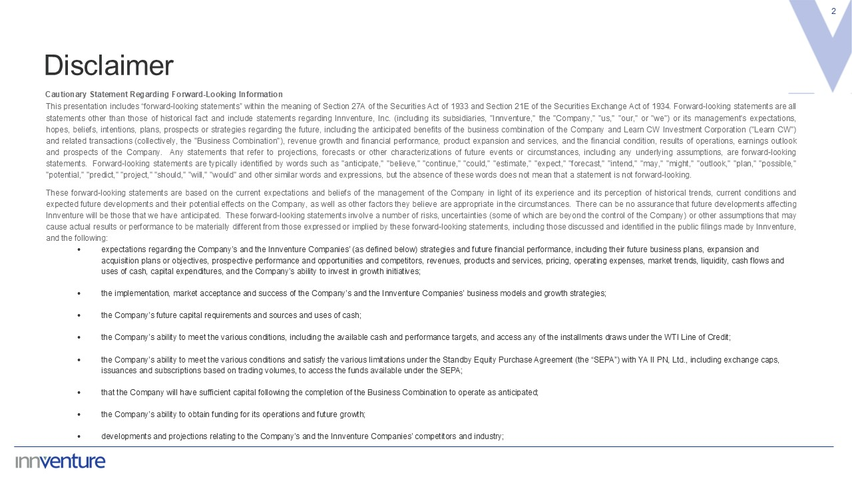
2 Cautionary Statement Regarding Forward-Looking Information This presentation includes “forward-looking statements” within the meaning of Section 27A of the Securities Act of 1933 and Section 21E of the Securities Exchange Act of 1934. Forward-looking statements are all statements other than those of historical fact and include statements regarding Innventure, Inc. (including its subsidiaries, "Innventure," the "Company," "us," "our," or "we") or its management's expectations, hopes, beliefs, intentions, plans, prospects or strategies regarding the future, including the anticipated benefits of the business combination of the Company and Learn CW Investment Corporation ("Learn CW") and related transactions (collectively, the "Business Combination"), revenue growth and financial performance, product expansion and services, and the financial condition, results of operations, earnings outlook and prospects of the Company. Any statements that refer to projections, forecasts or other characterizations of future events or circumstances, including any underlying assumptions, are forward-looking statements. Forward-looking statements are typically identified by words such as "anticipate," "believe," "continue," "could," "estimate," "expect," "forecast," "intend," "may," "might," "outlook," "plan," "possible," "potential," "predict," "project," "should," "will," "would" and other similar words and expressions, but the absence of these words does not mean that a statement is not forward-looking. These forward-looking statements are based on the current expectations and beliefs of the management of the Company in light of its experience and its perception of historical trends, current conditions and expected future developments and their potential effects on the Company, as well as other factors they believe are appropriate in the circumstances. There can be no assurance that future developments affecting Innventure will be those that we have anticipated. These forward-looking statements involve a number of risks, uncertainties (some of which are beyond the control of the Company) or other assumptions that may cause actual results or performance to be materially different from those expressed or implied by these forward-looking statements, including those discussed and identified in the public filings made by Innventure, and the following: expectations regarding the Company’s and the Innventure Companies’ (as defined below) strategies and future financial performance, including their future business plans, expansion and acquisition plans or objectives, prospective performance and opportunities and competitors, revenues, products and services, pricing, operating expenses, market trends, liquidity, cash flows and uses of cash, capital expenditures, and the Company’s ability to invest in growth initiatives; the implementation, market acceptance and success of the Company’s and the Innventure Companies’ business models and growth strategies; the Company’s future capital requirements and sources and uses of cash; the Company’s ability to meet the various conditions, including the available cash and performance targets, and access any of the installments draws under the WTI Line of Credit; the Company’s ability to meet the various conditions and satisfy the various limitations under the Standby Equity Purchase Agreement (the “SEPA”) with YA II PN, Ltd., including exchange caps, issuances and subscriptions based on trading volumes, to access the funds available under the SEPA; that the Company will have sufficient capital following the completion of the Business Combination to operate as anticipated; the Company’s ability to obtain funding for its operations and future growth; developments and projections relating to the Company’s and the Innventure Companies’ competitors and industry; Disclaimer

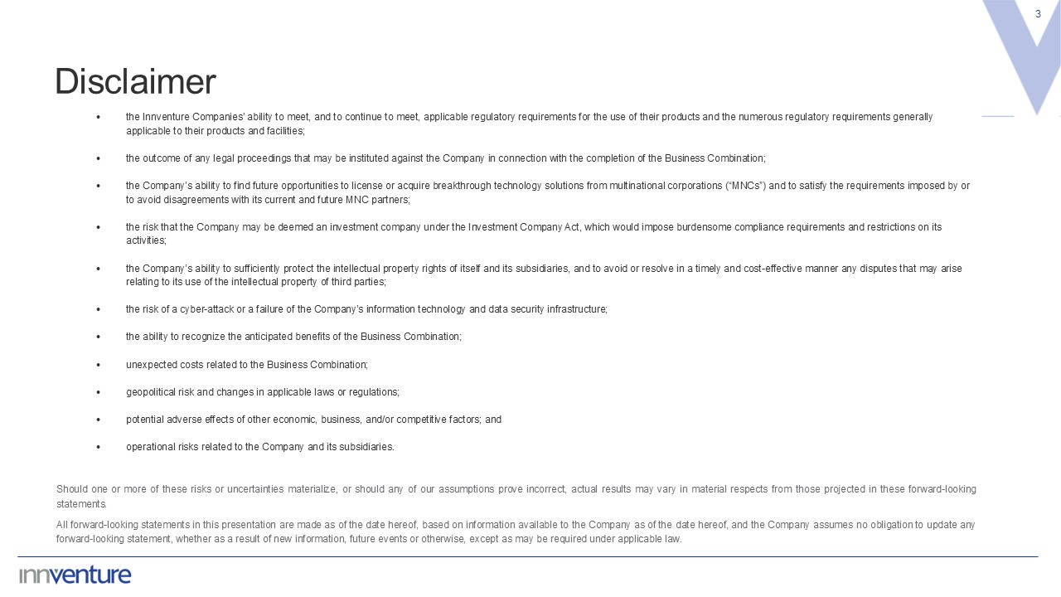
3 the Innventure Companies’ ability to meet, and to continue to meet, applicable regulatory requirements for the use of their products and the numerous regulatory requirements generally applicable to their products and facilities; the outcome of any legal proceedings that may be instituted against the Company in connection with the completion of the Business Combination; the Company’s ability to find future opportunities to license or acquire breakthrough technology solutions from multinational corporations (“MNCs”) and to satisfy the requirements imposed by or to avoid disagreements with its current and future MNC partners; the risk that the Company may be deemed an investment company under the Investment Company Act, which would impose burdensome compliance requirements and restrictions on its activities; the Company’s ability to sufficiently protect the intellectual property rights of itself and its subsidiaries, and to avoid or resolve in a timely and cost-effective manner any disputes that may arise relating to its use of the intellectual property of third parties; the risk of a cyber-attack or a failure of the Company’s information technology and data security infrastructure; the ability to recognize the anticipated benefits of the Business Combination; unexpected costs related to the Business Combination; geopolitical risk and changes in applicable laws or regulations; potential adverse effects of other economic, business, and/or competitive factors; and operational risks related to the Company and its subsidiaries. Should one or more of these risks or uncertainties materialize, or should any of our assumptions prove incorrect, actual results may vary in material respects from those projected in these forward-looking statements. All forward-looking statements in this presentation are made as of the date hereof, based on information available to the Company as of the date hereof, and the Company assumes no obligation to update any forward-looking statement, whether as a result of new information, future events or otherwise, except as may be required under applicable law. Disclaimer

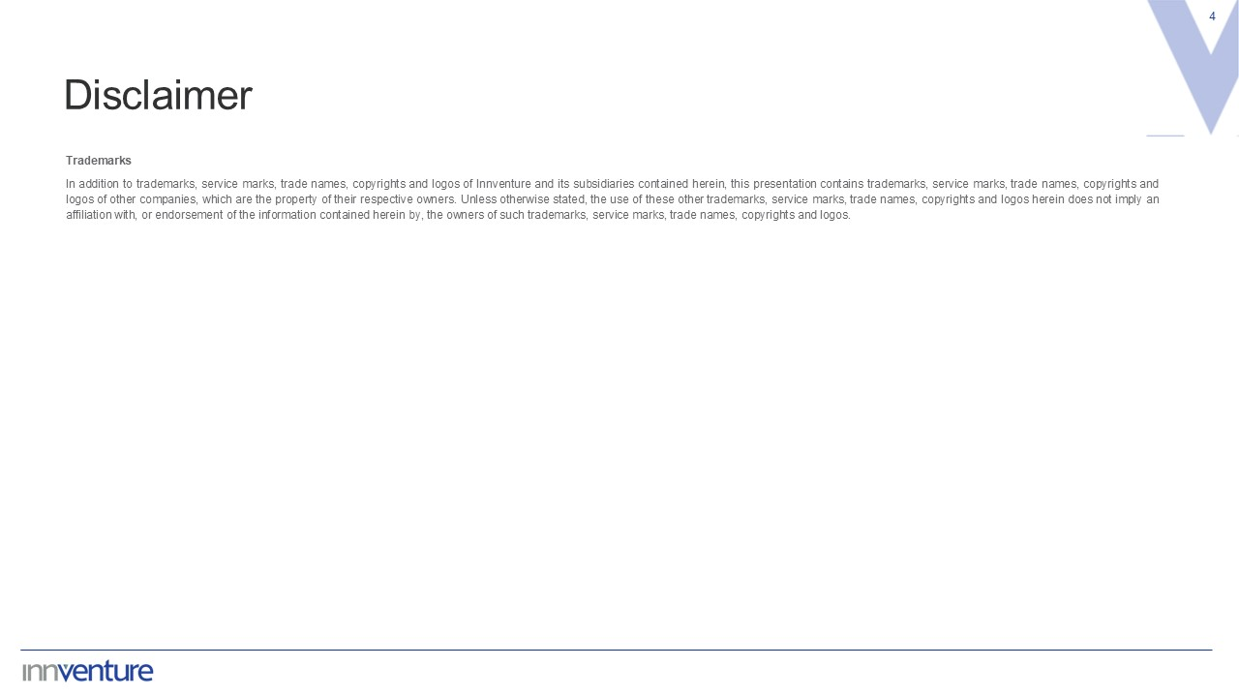
4 Trademarks In addition to trademarks, service marks, trade names, copyrights and logos of Innventure and its subsidiaries contained herein, this presentation contains trademarks, service marks, trade names, copyrights and logos of other companies, which are the property of their respective owners. Unless otherwise stated, the use of these other trademarks, service marks, trade names, copyrights and logos herein does not imply an affiliation with, or endorsement of the information contained herein by, the owners of such trademarks, service marks, trade names, copyrights and logos. Disclaimer


5 COMPANY OVERVIEW

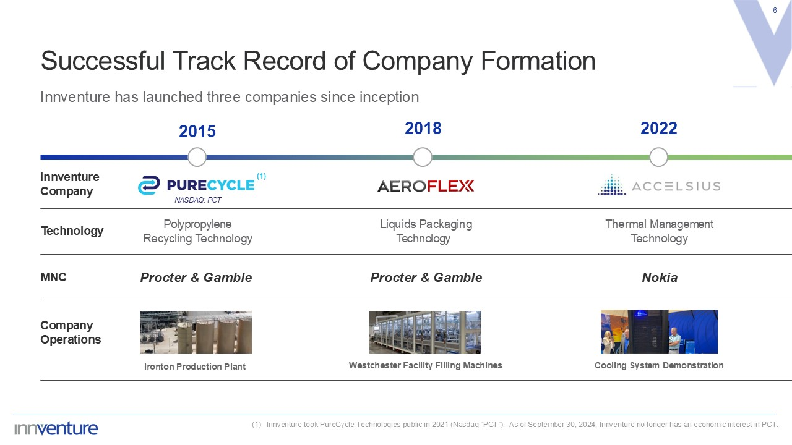
6 Successful Track Record of Company Formation Innventure Company Technology MNC Innventure has launched three companies since inception 2022 Thermal Management Technology Nokia 2018 Liquids Packaging Technology Procter & Gamble Innventure took PureCycle Technologies public in 2021 (Nasdaq “PCT”). As of September 30, 2024, Innventure no longer has an economic interest in PCT. NASDAQ: PCT 2015 Polypropylene Recycling Technology Procter & Gamble (1) Company Operations Ironton Production Plant Westchester Facility Filling Machines Cooling System Demonstration

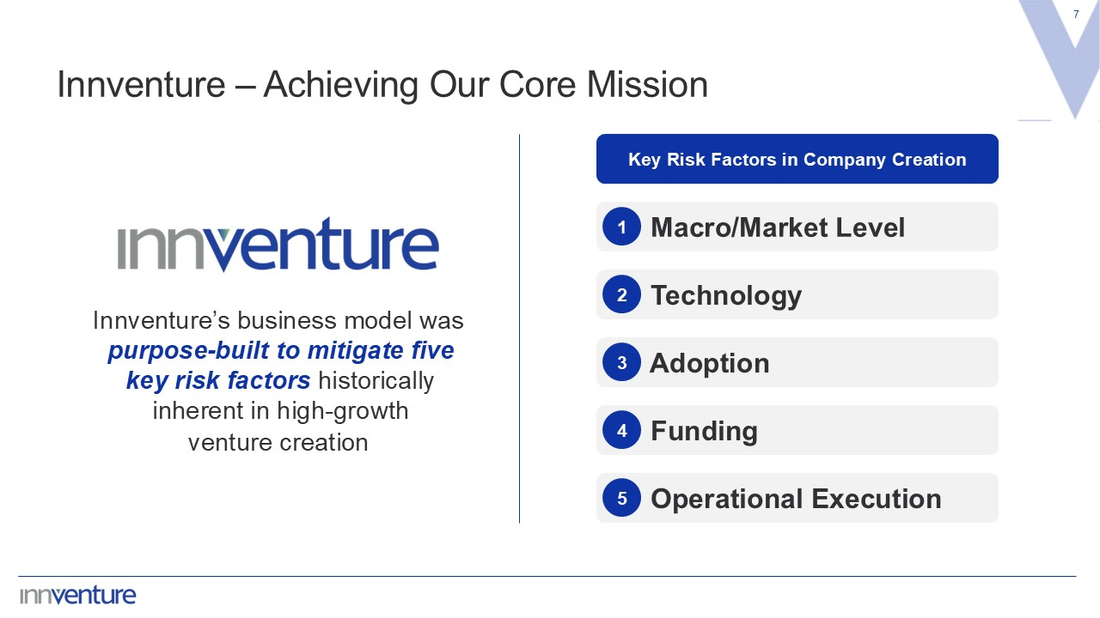
7 Innventure – Achieving Our Core Mission Innventure’s business model was purpose-built to mitigate five key risk factors historically inherent in high-growth venture creation Macro/Market Level 1 Technology 2 Adoption 3 Funding 4 Operational Execution 5 Key Risk Factors in Company Creation

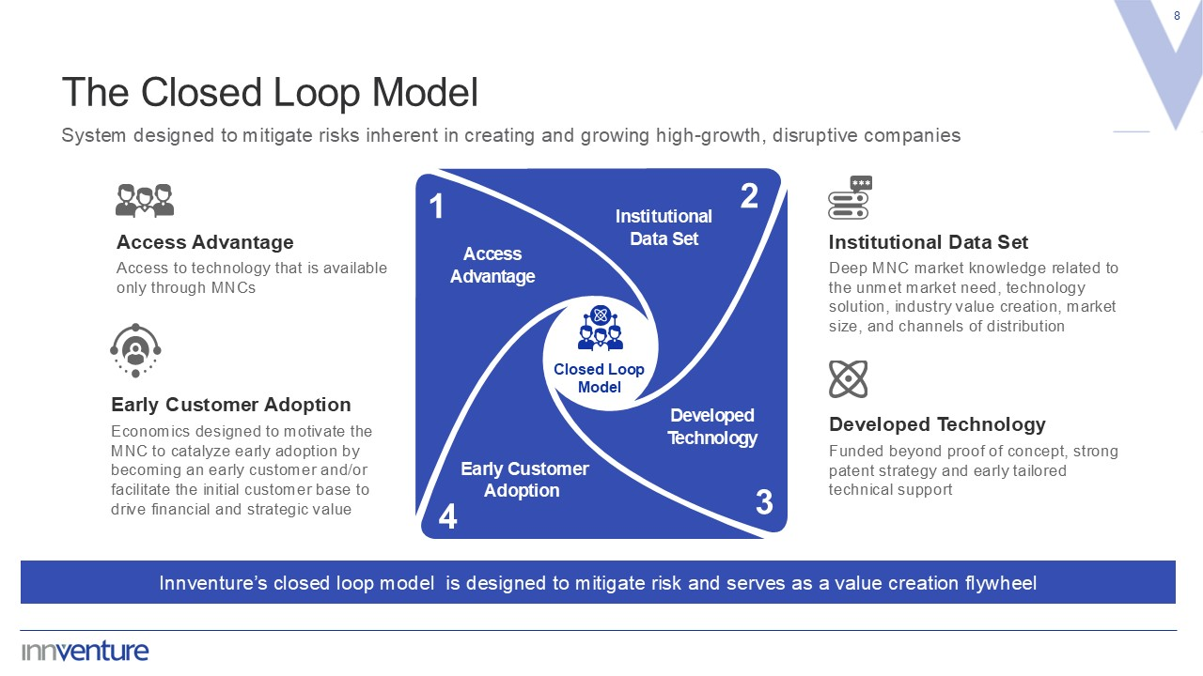
8 The Closed Loop Model Innventure’s closed loop model is designed to mitigate risk and serves as a value creation flywheel System designed to mitigate risks inherent in creating and growing high-growth, disruptive companies Deep MNC market knowledge related to the unmet market need, technology solution, industry value creation, market size, and channels of distribution Institutional Data Set Access to technology that is available only through MNCs Access Advantage Early Customer Adoption Economics designed to motivate the MNC to catalyze early adoption by becoming an early customer and/or facilitate the initial customer base to drive financial and strategic value Funded beyond proof of concept, strong patent strategy and early tailored technical support Developed Technology Institutional Data Set Developed Technology Early Customer Adoption Access Advantage Closed Loop Model 1 2 3 4

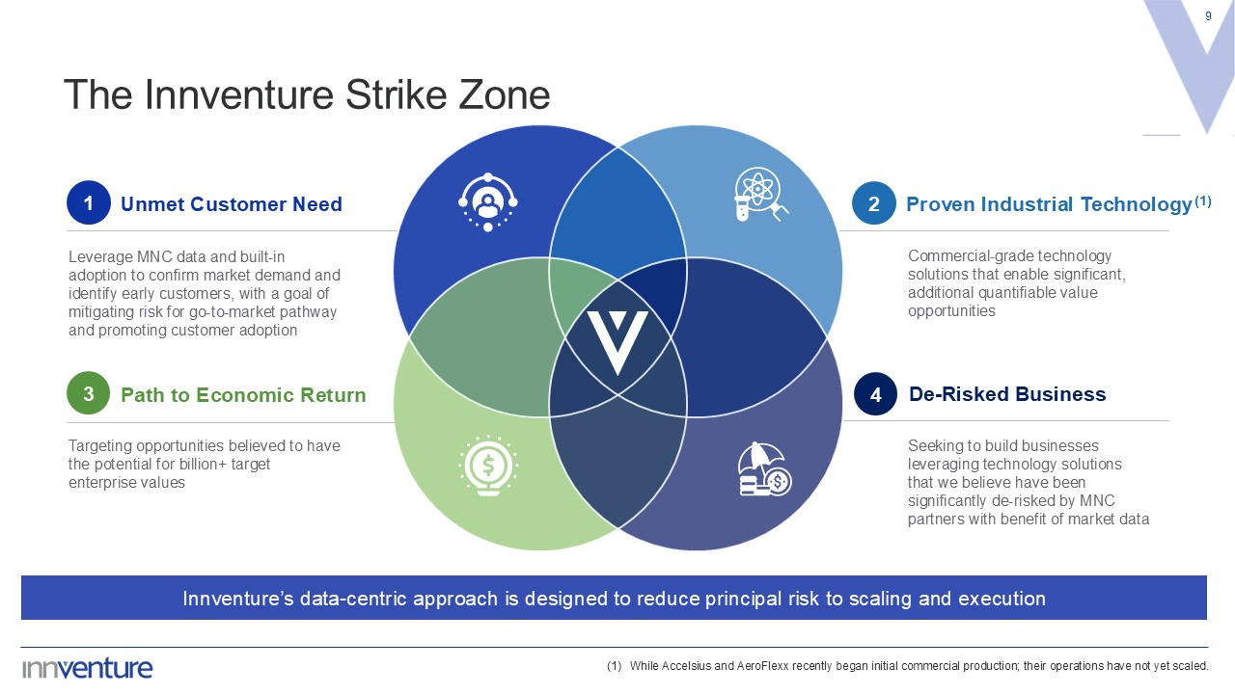
Commercial-grade technology solutions that enable significant, additional quantifiable value opportunities Proven Industrial Technology(1) Seeking to build businesses leveraging technology solutions that we believe have been significantly de-risked by MNC partners with benefit of market data De-Risked Business 2 4 9 The Innventure Strike Zone Leverage MNC data and built-in adoption to confirm market demand and identify early customers, with a goal of mitigating risk for go-to-market pathway and promoting customer adoption Unmet Customer Need Targeting opportunities believed to have the potential for billion+ target enterprise values Path to Economic Return While Accelsius and AeroFlexx recently began initial commercial production; their operations have not yet scaled. 1 3 Innventure’s data-centric approach is designed to reduce principal risk to scaling and execution

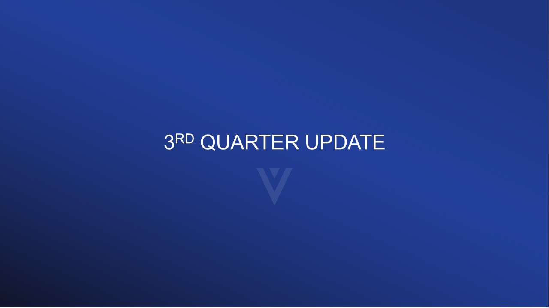
10 3RD QUARTER UPDATE

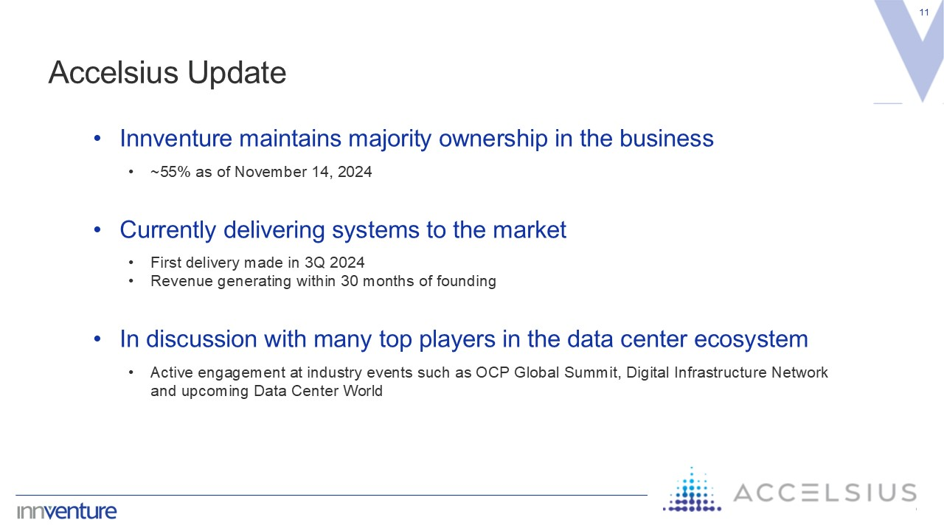
11 Accelsius Update Innventure maintains majority ownership in the business ~55% as of November 14, 2024 Currently delivering systems to the market First delivery made in 3Q 2024 Revenue generating within 30 months of founding In discussion with many top players in the data center ecosystem Active engagement at industry events such as OCP Global Summit, Digital Infrastructure Network and upcoming Data Center World

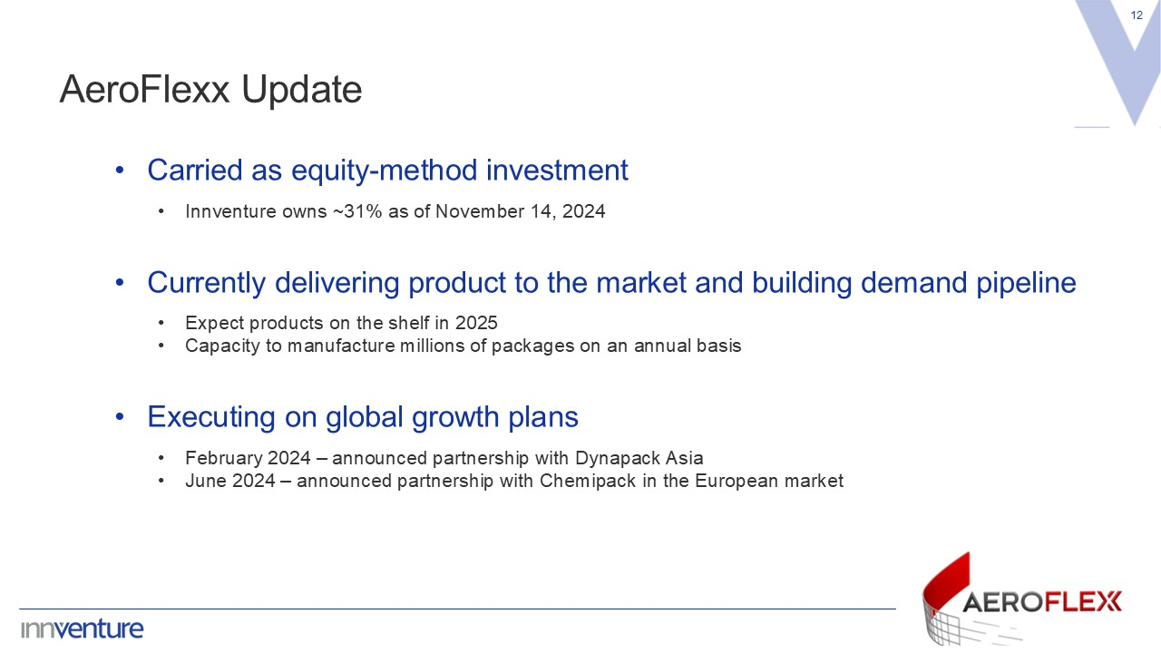
12 AeroFlexx Update Carried as equity-method investment Innventure owns ~31% as of November 14, 2024 Currently delivering product to the market and building demand pipeline Expect products on the shelf in 2025 Capacity to manufacture millions of packages on an annual basis Executing on global growth plans February 2024 – announced partnership with Dynapack Asia June 2024 – announced partnership with Chemipack in the European market

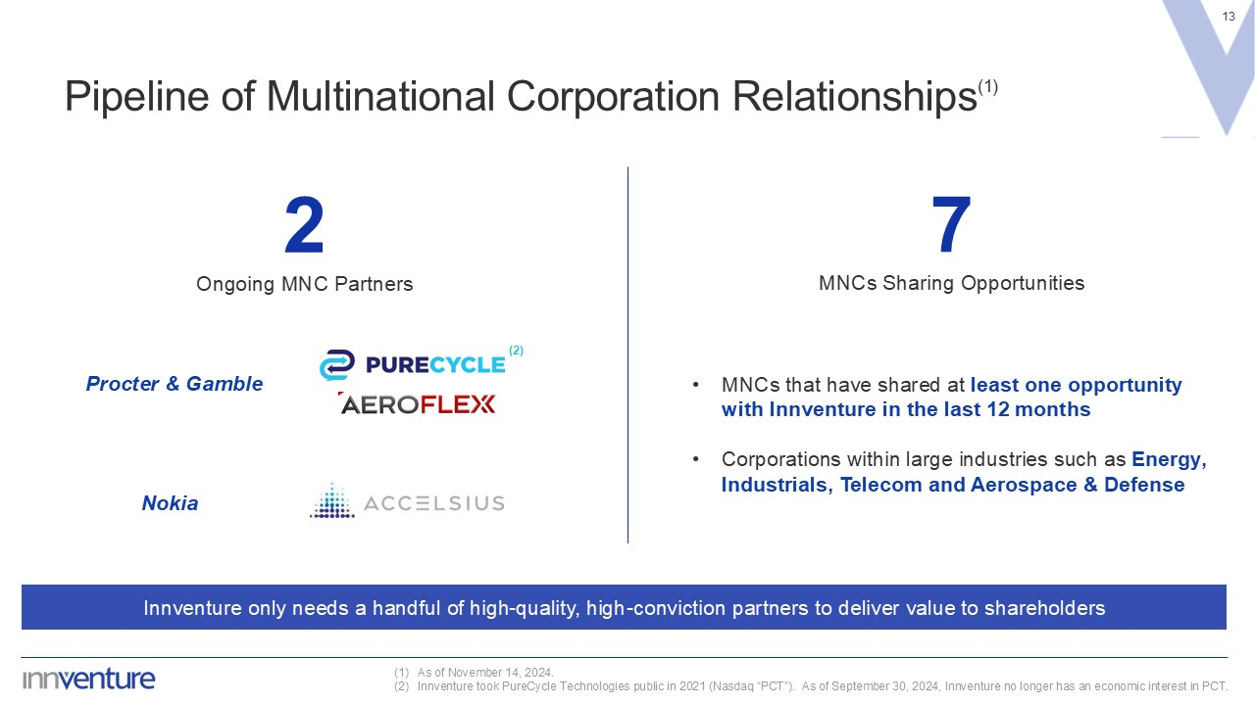
13 Pipeline of Multinational Corporation Relationships(1) As of November 14, 2024. Innventure took PureCycle Technologies public in 2021 (Nasdaq “PCT”). As of September 30, 2024, Innventure no longer has an economic interest in PCT. 2 Ongoing MNC Partners Innventure only needs a handful of high-quality, high-conviction partners to deliver value to shareholders MNCs that have shared at least one opportunity with Innventure in the last 12 months Corporations within large industries such as Energy, Industrials, Telecom and Aerospace & Defense (2) Nokia Procter & Gamble 7 MNCs Sharing Opportunities


14 FINANCIAL OVERVIEW

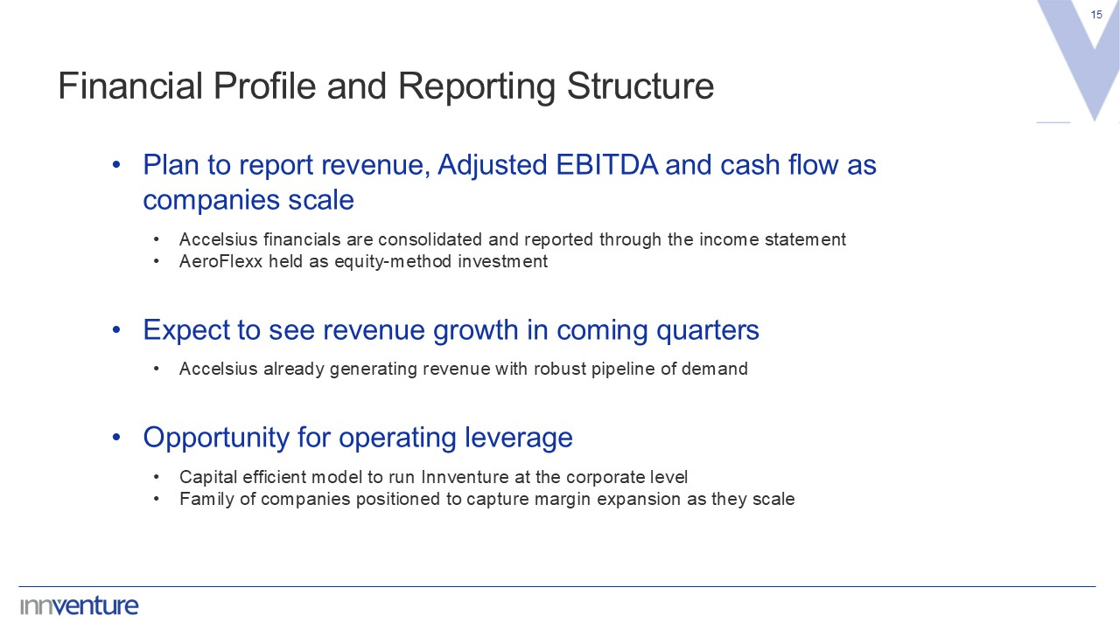
15 Financial Profile and Reporting Structure Plan to report revenue, Adjusted EBITDA and cash flow as companies scale Accelsius financials are consolidated and reported through the income statement AeroFlexx held as equity-method investment Expect to see revenue growth in coming quarters Accelsius already generating revenue with robust pipeline of demand Opportunity for operating leverage Capital efficient model to run Innventure at the corporate level Family of companies positioned to capture margin expansion as they scale

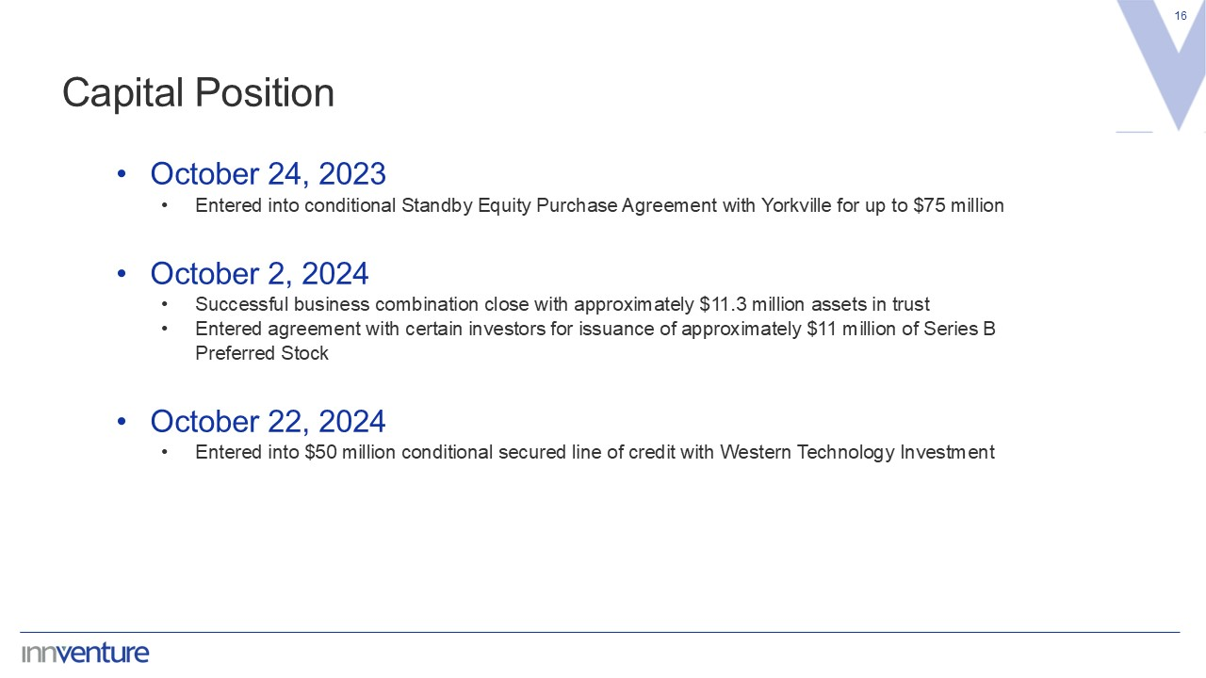
16 Capital Position October 24, 2023 Entered into conditional Standby Equity Purchase Agreement with Yorkville for up to $75 million October 2, 2024 Successful business combination close with approximately $11.3 million assets in trust Entered agreement with certain investors for issuance of approximately $11 million of Series B Preferred Stock October 22, 2024 Entered into $50 million conditional secured line of credit with Western Technology Investment

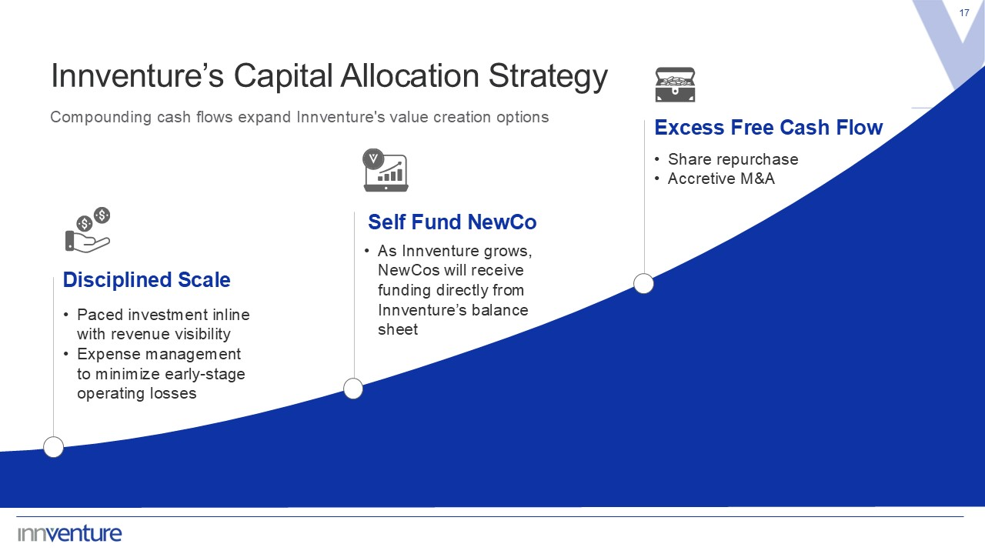
Innventure’s Capital Allocation Strategy 17 Compounding cash flows expand Innventure's value creation options Paced investment inline with revenue visibility Expense management to minimize early-stage operating losses Disciplined Scale As Innventure grows, NewCos will receive funding directly from Innventure’s balance sheet Self Fund NewCo Excess Free Cash Flow Share repurchase Accretive M&A


18 Q&A



