Filed by Learn SPAC HoldCo, Inc.
pursuant to Rule 425 under the Securities Act of 1933
and deemed filed pursuant to Rule 14a-12
under the Securities Exchange Act of 1934
Subject Company: Learn CW Investment Corporation
Registration No.: 001-40885
Date: March 20, 2024

UNITED STATES
SECURITIES AND EXCHANGE COMMISSION
Washington, D.C. 20549

FORM 8-K

CURRENT REPORT

Pursuant To Section 13 or 15(d) of the Securities Exchange Act of 1934

Date of Report (Date of earliest event reported): March 20, 2024

LEARN CW INVESTMENT CORPORATION
(Exact name of registrant as specified in its charter)

Cayman Islands | 001-40885 | 98-1583469
(State or other jurisdiction of incorporation) | (Commission File Number) | (I.R.S. Employer Identification No.)

11755 Wilshire Blvd.
Suite 2320
Los Angeles, California |  | 90025
(Address of principal executive offices) |  | (Zip Code)

Registrant’s telephone number, including area code: (424) 324-2990

Not Applicable
(Former name or former address, if changed since last report)

Check the appropriate box below if the Form 8-K filing is intended to simultaneously satisfy the filing obligation of the registrant under any of the following provisions:

☒ | Written communications pursuant to Rule 425 under the Securities Act (17 CFR 230.425)

☐ | Soliciting material pursuant to Rule 14a-12 under the Exchange Act (17 CFR 240.14a-12)

☐ | Pre-commencement communications pursuant to Rule 14d-2(b) under the Exchange Act (17 CFR 240.14d-2(b))

☐ | Pre-commencements communications pursuant to Rule 13e-4(c) under the Exchange Act (17 CFR 240.13e-4(c))

Securities registered pursuant to Section 12(b) of the Securities Exchange Act of 1934:

Title of each class | Trading  Symbol(s) | Name of each  exchange  on which  registered
Units, each consisting of one Class A Ordinary Share, $0.0001 par value, and one-half of one redeemable warrant | LCW.U | NYSE
Class A Ordinary Shares included as part of the units | LCW | NYSE
Warrants included as part of the units, each whole warrant exercisable for one Class A Ordinary Share at an exercise price of $11.50 | LCW.WS | NYSE

Indicate by check mark whether the registrant is an emerging growth company as defined in Rule 405 of the Securities Act of 1933 (§230.405 of this chapter) or Rule 12b-2 of the Securities Exchange Act of 1934 (§240.12b-2 of this chapter).

Emerging growth company ☒

If an emerging growth company, indicate by check mark if the registrant has elected not to use the extended transition period for complying with any new or revised financial accounting standards provided pursuant to Section 13(a) of the Exchange Act. ☐

Item 7.01. | Regulation FD Disclosure.

Attached hereto as Exhibit 99.1, Exhibit 99.2 and Exhibit 99.3 are three investor presentations that Learn CW Investment Corporation (“Learn CW”) and Innventure LLC (“Innventure”) have prepared for use in connection with their previously announced business combination transaction (the “Business Combination”) respectively.

The information in this Item 7.01, and Exhibit 99.1, Exhibit 99.2 and Exhibit 99.3 attached hereto, is furnished pursuant to the rules and regulations of the Securities and Exchange Commission (the “SEC”) and shall not be deemed “filed” for purposes of Section 18 of the Securities Exchange Act of 1934, as amended (the “Exchange Act”), or otherwise subject to the liabilities of that section, nor shall it be deemed incorporated by reference in any filing under the Securities Act of 1933, as amended (the “Securities Act”), or the Exchange Act, except as expressly set forth by specific reference in such a filing.

Additional Information and Where to Find It

In connection with the Business Combination, Learn CW HoldCo, Inc. (“Holdco”) has filed with the SEC a registration statement on Form S-4 containing a preliminary proxy statement of Learn CW, a preliminary consent solicitation statement of Innventure and a preliminary prospectus with respect to the combined company’s securities to be issued in connection with the Business Combination, and after the registration statement is declared effective, the definitive proxy statement/consent solicitation statement/prospectus relating to the Business Combination will be mailed to Learn CW shareholders and will be sent to Innventure unitholders. This Current Report does not contain all the information that should be considered concerning the Business Combination and is not intended to form the basis of any investment decision or any other decision in respect of the Business Combination. Learn CW’s shareholders, Innventure’s unitholders and other interested persons are urged to read the preliminary proxy statement/consent solicitation statement/prospectus and the amendments thereto and, when available, the definitive proxy statement/consent solicitation statement/prospectus and other documents filed in connection with the Business Combination, as these materials will contain important information about Innventure, Learn CW, the combined company and the Business Combination. When available, the definitive proxy statement/consent solicitation statement/prospectus and other relevant materials for the proposed business combination will be mailed to shareholders of Learn CW as of a record date to be established for voting on the Business Combination. Such shareholders will also be able to obtain copies of the preliminary and definitive proxy statement/consent solicitation statement/prospectus and other documents filed with the SEC, without charge, once available, at the SEC’s website at www.sec.gov, or by directing a request to Learn CW Investment Corporation, 11755 Wilshire Blvd., Suite 2320, Los Angeles, California 90025.

No Offer or Solicitation

This Current Report shall not constitute an offer to sell or the solicitation of an offer to buy any securities, or a solicitation of any vote or approval, nor shall there be any sale of any such securities in any state or jurisdiction in which such offer, solicitation or sale would be unlawful prior to registration or qualification under the securities laws of any such state or jurisdiction. This Current Report does not constitute either advice or a recommendation regarding any securities. No offering of securities shall be made except by means of a prospectus meeting the requirements of the Securities Act, or an exemption therefrom.

Participants in the Solicitation

Learn CW, Innventure and their respective directors, executive officers, other members of management, and employees, under SEC rules, may be deemed to be participants in the solicitation of proxies of Learn CW’s shareholders in connection with the Business Combination. Information regarding the persons who may, under SEC rules, be deemed participants in the solicitation of Learn CW’s shareholders in connection with the Business Combination are set forth in the registration statement on Form S-4, including the preliminary proxy statement/consent solicitation statement/prospectus, and will also be set forth in the definitive proxy statement/consent solicitation statement/prospectus when available. Investors and security holders may obtain more detailed information regarding the names and interests in the proposed business combination of Learn CW’s directors and officers in Learn CW’s filings with the SEC and such information is also set forth in the registration statement filed with the SEC by Holdco, including the proxy statement of Learn CW for the Business Combination.

Cautionary Note Regarding Forward-Looking Statements

This Current Report contains forward-looking statements within the meaning of Section 27A of the Securities Act of 1933, as amended, and Section 21E of the Exchange Act, including statements regarding the parties or the parties’ respective management team’s expectations, hopes, beliefs, intentions, plans, prospects or strategies regarding the future, including the business combination, the parties’ ability to close the referenced business combination, the anticipated benefits of the business combination, including revenue growth and financial performance, product expansion and services, and the financial condition, results of operations, earnings outlook and prospects of Innventure and/or Learn CW, including, in all cases, statements for the period following the consummation of the business combination. Any statements contained herein that are not statements of historical fact may be deemed to be forward-looking statements. In addition, any statements that refer to projections, forecasts or other characterizations of future events or circumstances, including any underlying assumptions, are forward-looking statements. The words “anticipate,” “believe,” “continue,” “could,” “estimate,” “expect,” “intends,” “may,” “might,” “plan,” “possible,” “potential,” “predict,” “project,” “should,” “will,” “would” and similar expressions may identify forward-looking statements, but the absence of these words does not mean that a statement is not forward-looking. The forward-looking statements contained in this Current Report are based on our current expectations and beliefs made by the management of Learn CW and Innventure in light of their respective experience and their perception of historical trends, current conditions and expected future developments and their potential effects on Learn CW and Innventure as well as other factors they believe are appropriate in the circumstances. There can be no assurance that future developments affecting Learn CW or Innventure will be those that we have anticipated. These forward-looking statements involve a number of risks, uncertainties (some of which are beyond the control of the parties) or other assumptions that may cause actual results or performance to be materially different from those expressed or implied by these forward-looking statements, including those discussed and identified in the public filings made or to be made with the SEC by Learn CW, including in the final prospectus relating to Learn CW’s initial public offering, which was filed with the SEC on October 12, 2021 under the heading “Risk Factors,” or made or to be made by Holdco upon closing of the transaction, and the following: expectations regarding Innventure’s strategies and future financial performance, including its future business plans, expansion plans or objectives, prospective performance and opportunities and competitors, revenues, products and services, pricing, operating expenses, product and service acceptance, market trends, liquidity, cash flows and uses of cash, capital expenditures, and Innventure’s ability to invest in growth initiatives; the implementation, market acceptance and success of Innventure’s business model and growth strategy; Innventure’s future capital requirements and sources and uses of cash; that Innventure will have sufficient capital upon the approval of the transaction to operate as anticipated; Innventure’s ability to obtain funding for its operations and future growth; developments and projections relating to Innventure’s competitors and industry; the occurrence of any event, change or other circumstances that could give rise to the termination of the Business Combination Agreement (the “Business Combination Agreement”), dated October 24, 2023, by and among Learn CW, Holdco, LCW Merger Sub, Inc., Innventure Merger Sub, LLC and Innventure; the outcome of any legal proceedings that may be instituted against Holdco, Learn CW or Innventure following announcement of the Business Combination Agreement and the transactions contemplated therein; the inability to complete the business combination due to, among other things, the failure to obtain Learn CW shareholder approval; regulatory approvals; the risk that the announcement and consummation of the Business Combination disrupts Innventure’s current plans; the ability to recognize the anticipated benefits of the business combination; unexpected costs related to the Business Combination; the amount of any redemptions by existing holders of Learn CW’s common stock being greater than expected; limited liquidity and trading of Learn CW’s securities; geopolitical risk and changes in applicable laws or regulations; the possibility that Learn CW and/or Innventure may be adversely affected by other economic, business, and/or competitive factors; the potential characterization of Innventure as an investment company subject to the Investment Company Act of 1940; operational risk; and the risk that the consummation of the business combination is substantially delayed or does not occur. Should one or more of these risks or uncertainties materialize, or should any of our assumptions prove incorrect, actual results may vary in material respects from those projected in these forward-looking statements. All forward-looking statements in this Current Report are made as of the date hereof, based on information available to Learn CW and Innventure as of the date hereof, and Learn CW and Innventure assume no obligation to update any forward-looking statement, whether as a result of new information, future events or otherwise, except as may be required under applicable securities laws.

Item 9.01. | Financial Statements and Exhibits.

(d) | Exhibits.

Exhibit No. | Description of Exhibits
99.1 | DownSelect Presentation, dated March 2024
99.2 | Sustainability Presentation, dated March 2024
99.3 | Sustainability Case Study Presentation, dated March 2024
104 | Cover Page Interactive Data File (embedded within the Inline XBRL document)

SIGNATURE

Pursuant to the requirements of the Securities Exchange Act of 1934, as amended, the registrant has duly caused this report to be signed on its behalf by the undersigned hereunto duly authorized.

 | LEARN CW INVESTMENT CORPORATION
Date: March 20, 2024 | By: | /s/ Robert Hutter
 | Name: | Robert Hutter
 | Title: | Chief Executive Officer

Exhibit 99.1

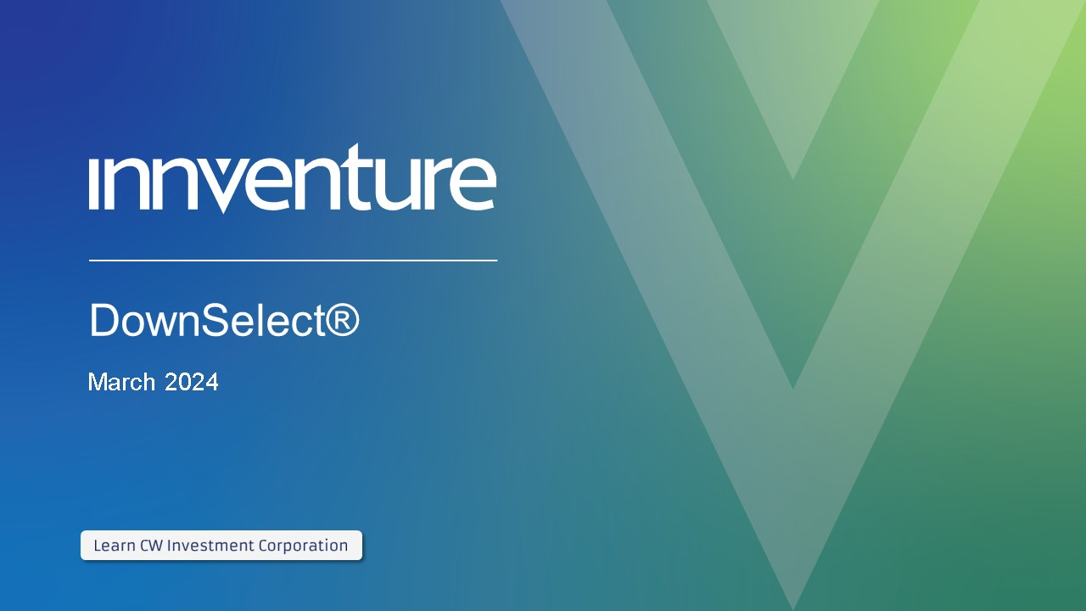
DownSelect® March 2024

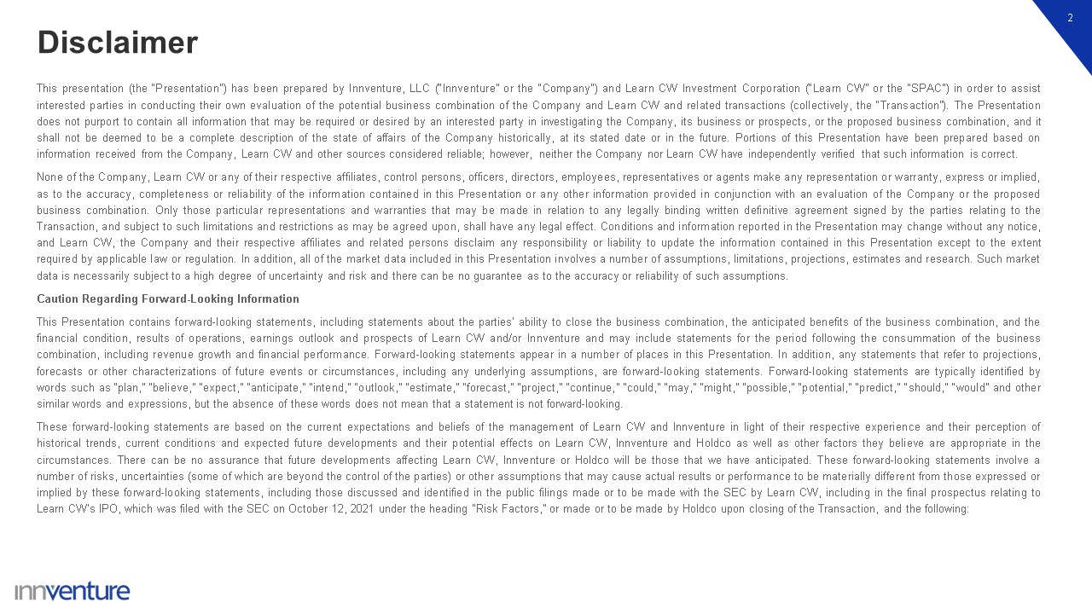
Disclaimer 2 This presentation (the “Presentation”) has been prepared by Innventure, LLC (“Innventure” or the “Company”) and Learn CW Investment Corporation (“Learn CW” or the “SPAC”) in order to assist interested parties in conducting their own evaluation of the potential business combination of the Company and Learn CW and related transactions (collectively, the “Transaction”). The Presentation does not purport to contain all information that may be required or desired by an interested party in investigating the Company, its business or prospects, or the proposed business combination, and it shall not be deemed to be a complete description of the state of affairs of the Company historically, at its stated date or in the future. Portions of this Presentation have been prepared based on information received from the Company, Learn CW and other sources considered reliable; however, neither the Company nor Learn CW have independently verified that such information is correct. None of the Company, Learn CW or any of their respective affiliates, control persons, officers, directors, employees, representatives or agents make any representation or warranty, express or implied, as to the accuracy, completeness or reliability of the information contained in this Presentation or any other information provided in conjunction with an evaluation of the Company or the proposed business combination. Only those particular representations and warranties that may be made in relation to any legally binding written definitive agreement signed by the parties relating to the Transaction, and subject to such limitations and restrictions as may be agreed upon, shall have any legal effect. Conditions and information reported in the Presentation may change without any notice, and Learn CW, the Company and their respective affiliates and related persons disclaim any responsibility or liability to update the information contained in this Presentation except to the extent required by applicable law or regulation. In addition, all of the market data included in this Presentation involves a number of assumptions, limitations, projections, estimates and research. Such market data is necessarily subject to a high degree of uncertainty and risk and there can be no guarantee as to the accuracy or reliability of such assumptions. Caution Regarding Forward-Looking Information This Presentation contains forward-looking statements, including statements about the parties’ ability to close the business combination, the anticipated benefits of the business combination, and the financial condition, results of operations, earnings outlook and prospects of Learn CW and/or Innventure and may include statements for the period following the consummation of the business combination, including revenue growth and financial performance. Forward-looking statements appear in a number of places in this Presentation. In addition, any statements that refer to projections, forecasts or other characterizations of future events or circumstances, including any underlying assumptions, are forward-looking statements. Forward-looking statements are typically identified by words such as “plan,” “believe,” “expect,” “anticipate,” “intend,” “outlook,” “estimate,” “forecast,” “project,” “continue,” “could,” “may,” “might,” “possible,” “potential,” “predict,” “should,” “would” and other similar words and expressions, but the absence of these words does not mean that a statement is not forward-looking. These forward-looking statements are based on the current expectations and beliefs of the management of Learn CW and Innventure in light of their respective experience and their perception of historical trends, current conditions and expected future developments and their potential effects on Learn CW, Innventure and Holdco as well as other factors they believe are appropriate in the circumstances. There can be no assurance that future developments affecting Learn CW, Innventure or Holdco will be those that we have anticipated. These forward-looking statements involve a number of risks, uncertainties (some of which are beyond the control of the parties) or other assumptions that may cause actual results or performance to be materially different from those expressed or implied by these forward-looking statements, including those discussed and identified in the public filings made or to be made with the SEC by Learn CW, including in the final prospectus relating to Learn CW’s IPO, which was filed with the SEC on October 12, 2021 under the heading “Risk Factors,” or made or to be made by Holdco upon closing of the Transaction, and the following:

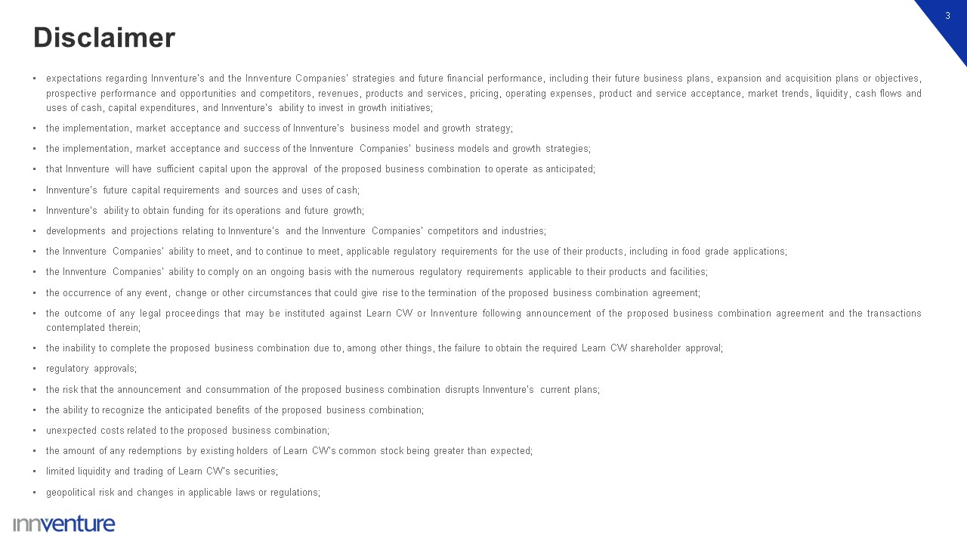
Disclaimer 3 expectations regarding Innventure’s and the Innventure Companies’ strategies and future financial performance, including their future business plans, expansion and acquisition plans or objectives, prospective performance and opportunities and competitors, revenues, products and services, pricing, operating expenses, product and service acceptance, market trends, liquidity, cash flows and uses of cash, capital expenditures, and Innventure’s ability to invest in growth initiatives; the implementation, market acceptance and success of Innventure’s business model and growth strategy; the implementation, market acceptance and success of the Innventure Companies’ business models and growth strategies; that Innventure will have sufficient capital upon the approval of the proposed business combination to operate as anticipated; Innventure’s future capital requirements and sources and uses of cash; Innventure’s ability to obtain funding for its operations and future growth; developments and projections relating to Innventure’s and the Innventure Companies’ competitors and industries; the Innventure Companies’ ability to meet, and to continue to meet, applicable regulatory requirements for the use of their products, including in food grade applications; the Innventure Companies’ ability to comply on an ongoing basis with the numerous regulatory requirements applicable to their products and facilities; the occurrence of any event, change or other circumstances that could give rise to the termination of the proposed business combination agreement; the outcome of any legal proceedings that may be instituted against Learn CW or Innventure following announcement of the proposed business combination agreement and the transactions contemplated therein; the inability to complete the proposed business combination due to, among other things, the failure to obtain the required Learn CW shareholder approval; regulatory approvals; the risk that the announcement and consummation of the proposed business combination disrupts Innventure’s current plans; the ability to recognize the anticipated benefits of the proposed business combination; unexpected costs related to the proposed business combination; the amount of any redemptions by existing holders of Learn CW’s common stock being greater than expected; limited liquidity and trading of Learn CW’s securities; geopolitical risk and changes in applicable laws or regulations;

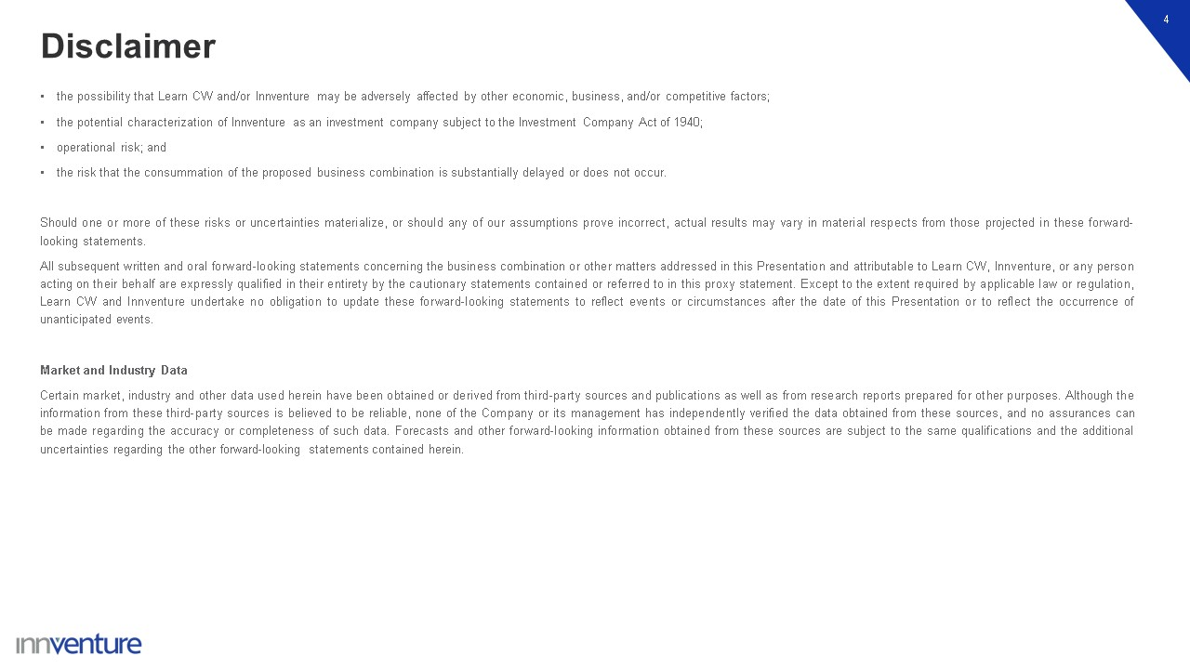
Disclaimer 4 the possibility that Learn CW and/or Innventure may be adversely affected by other economic, business, and/or competitive factors; the potential characterization of Innventure as an investment company subject to the Investment Company Act of 1940; operational risk; and the risk that the consummation of the proposed business combination is substantially delayed or does not occur. Should one or more of these risks or uncertainties materialize, or should any of our assumptions prove incorrect, actual results may vary in material respects from those projected in these forward-looking statements. All subsequent written and oral forward-looking statements concerning the business combination or other matters addressed in this Presentation and attributable to Learn CW, Innventure, or any person acting on their behalf are expressly qualified in their entirety by the cautionary statements contained or referred to in this proxy statement. Except to the extent required by applicable law or regulation, Learn CW and Innventure undertake no obligation to update these forward-looking statements to reflect events or circumstances after the date of this Presentation or to reflect the occurrence of unanticipated events. Market and Industry Data Certain market, industry and other data used herein have been obtained or derived from third-party sources and publications as well as from research reports prepared for other purposes. Although the information from these third-party sources is believed to be reliable, none of the Company or its management has independently verified the data obtained from these sources, and no assurances can be made regarding the accuracy or completeness of such data. Forecasts and other forward-looking information obtained from these sources are subject to the same qualifications and the additional uncertainties regarding the other forward-looking statements contained herein.

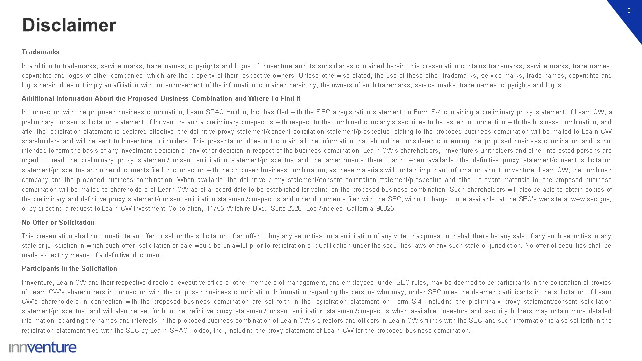
Disclaimer 5 Trademarks In addition to trademarks, service marks, trade names, copyrights and logos of Innventure and its subsidiaries contained herein, this presentation contains trademarks, service marks, trade names, copyrights and logos of other companies, which are the property of their respective owners. Unless otherwise stated, the use of these other trademarks, service marks, trade names, copyrights and logos herein does not imply an affiliation with, or endorsement of the information contained herein by, the owners of such trademarks, service marks, trade names, copyrights and logos. Additional Information About the Proposed Business Combination and Where To Find It In connection with the proposed business combination, Learn SPAC Holdco, Inc. has filed with the SEC a registration statement on Form S-4 containing a preliminary proxy statement of Learn CW, a preliminary consent solicitation statement of Innventure and a preliminary prospectus with respect to the combined company’s securities to be issued in connection with the business combination, and after the registration statement is declared effective, the definitive proxy statement/consent solicitation statement/prospectus relating to the proposed business combination will be mailed to Learn CW shareholders and will be sent to Innventure unitholders. This presentation does not contain all the information that should be considered concerning the proposed business combination and is not intended to form the basis of any investment decision or any other decision in respect of the business combination. Learn CW’s shareholders, Innventure’s unitholders and other interested persons are urged to read the preliminary proxy statement/consent solicitation statement/prospectus and the amendments thereto and, when available, the definitive proxy statement/consent solicitation statement/prospectus and other documents filed in connection with the proposed business combination, as these materials will contain important information about Innventure, Learn CW, the combined company and the proposed business combination. When available, the definitive proxy statement/consent solicitation statement/prospectus and other relevant materials for the proposed business combination will be mailed to shareholders of Learn CW as of a record date to be established for voting on the proposed business combination. Such shareholders will also be able to obtain copies of the preliminary and definitive proxy statement/consent solicitation statement/prospectus and other documents filed with the SEC, without charge, once available, at the SEC’s website at www.sec.gov, or by directing a request to Learn CW Investment Corporation, 11755 Wilshire Blvd., Suite 2320, Los Angeles, California 90025. No Offer or Solicitation This presentation shall not constitute an offer to sell or the solicitation of an offer to buy any securities, or a solicitation of any vote or approval, nor shall there be any sale of any such securities in any state or jurisdiction in which such offer, solicitation or sale would be unlawful prior to registration or qualification under the securities laws of any such state or jurisdiction. No offer of securities shall be made except by means of a definitive document. Participants in the Solicitation Innventure, Learn CW and their respective directors, executive officers, other members of management, and employees, under SEC rules, may be deemed to be participants in the solicitation of proxies of Learn CW’s shareholders in connection with the proposed business combination. Information regarding the persons who may, under SEC rules, be deemed participants in the solicitation of Learn CW’s shareholders in connection with the proposed business combination are set forth in the registration statement on Form S-4, including the preliminary proxy statement/consent solicitation statement/prospectus, and will also be set forth in the definitive proxy statement/consent solicitation statement/prospectus when available. Investors and security holders may obtain more detailed information regarding the names and interests in the proposed business combination of Learn CW’s directors and officers in Learn CW’s filings with the SEC and such information is also set forth in the registration statement filed with the SEC by Learn SPAC Holdco, Inc., including the proxy statement of Learn CW for the proposed business combination.

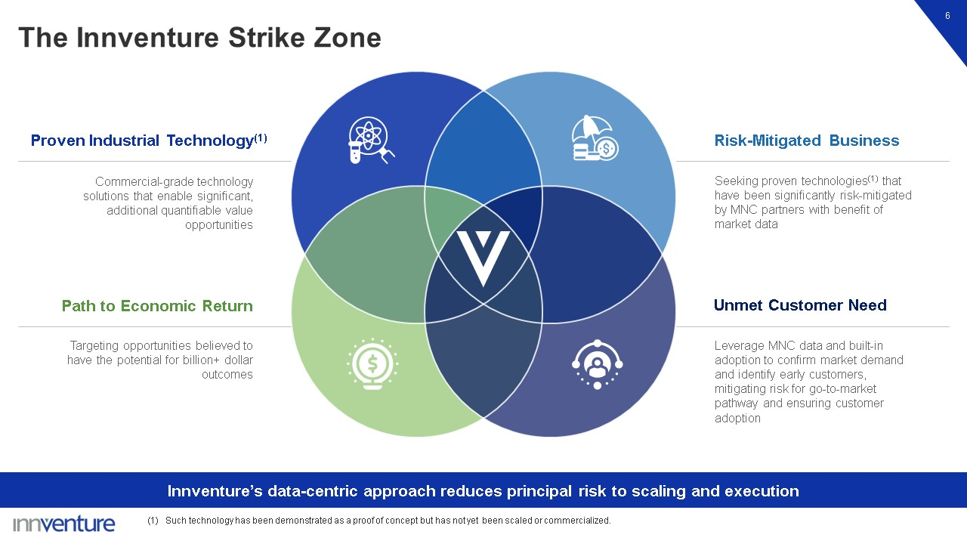
Seeking proven technologies(1) that have been significantly risk-mitigated by MNC partners with benefit of market data Risk-Mitigated Business Leverage MNC data and built-in adoption to confirm market demand and identify early customers, mitigating risk for go-to-market pathway and ensuring customer adoption Commercial-grade technology solutions that enable significant, additional quantifiable value opportunities Proven Industrial Technology(1) Targeting opportunities believed to have the potential for billion+ dollar outcomes Path to Economic Return The Innventure Strike Zone 6 Innventure’s data-centric approach reduces principal risk to scaling and execution Such technology has been demonstrated as a proof of concept but has not yet been scaled or commercialized. Unmet Customer Need

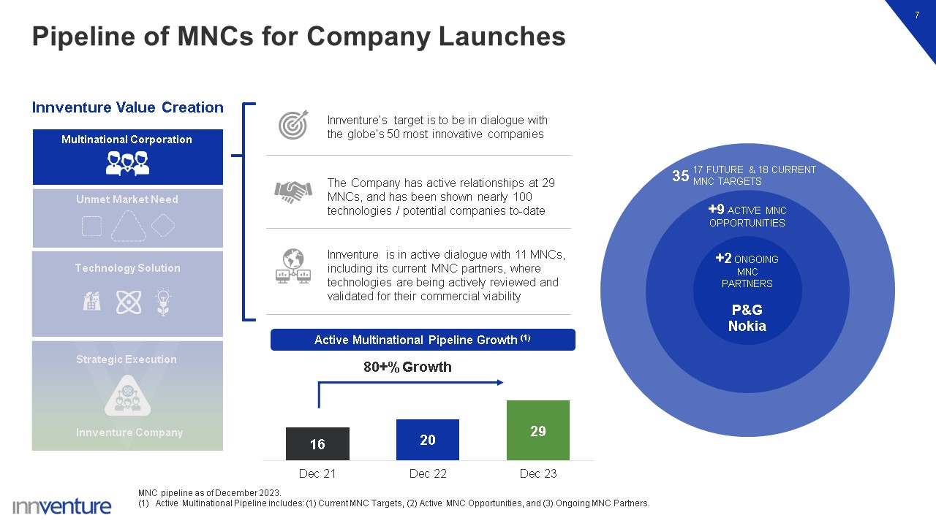
Pipeline of MNCs for Company Launches 7 Innventure’s target is to be in dialogue with the globe’s 50 most innovative companies The Company has active relationships at 29 MNCs, and has been shown nearly 100 technologies / potential companies to-date Innventure is in active dialogue with 11 MNCs, including its current MNC partners, where technologies are being actively reviewed and validated for their commercial viability +2 ONGOING MNC PARTNERS P&G Nokia +9 ACTIVE MNC OPPORTUNITIES Active Multinational Pipeline Growth (1) 80+% Growth MNC pipeline as of December 2023. Active Multinational Pipeline includes: (1) Current MNC Targets, (2) Active MNC Opportunities, and (3) Ongoing MNC Partners. Innventure Value Creation 17 FUTURE & 18 CURRENT MNC TARGETS 35 Technology Solution Strategic Execution Unmet Market Need Multinational Corporation Innventure Company

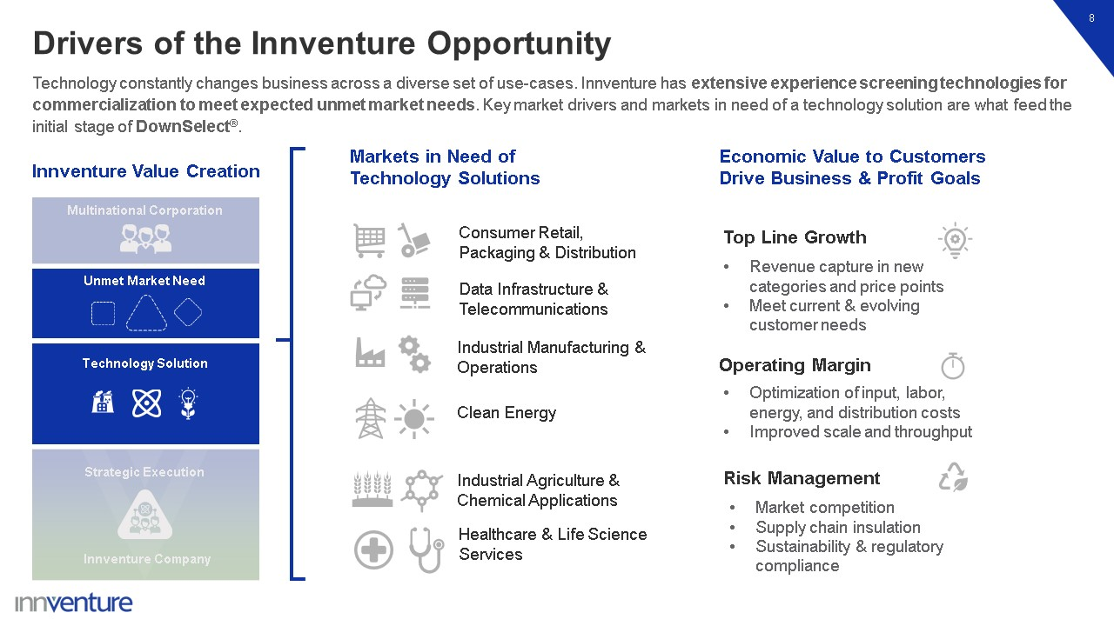
Drivers of the Innventure Opportunity 8 Technology constantly changes business across a diverse set of use-cases. Innventure has extensive experience screening technologies for commercialization to meet expected unmet market needs. Key market drivers and markets in need of a technology solution are what feed the initial stage of DownSelect®. Innventure Value Creation Markets in Need of Technology Solutions Economic Value to Customers Drive Business & Profit Goals Consumer Retail, Packaging & Distribution Data Infrastructure & Telecommunications Industrial Manufacturing & Operations Clean Energy Industrial Agriculture & Chemical Applications Healthcare & Life Science Services Market competition Supply chain insulation Sustainability & regulatory compliance Risk Management Operating Margin Optimization of input, labor, energy, and distribution costs Improved scale and throughput Revenue capture in new categories and price points Meet current & evolving customer needs Top Line Growth Technology Solution Strategic Execution Unmet Market Need Multinational Corporation Innventure Company

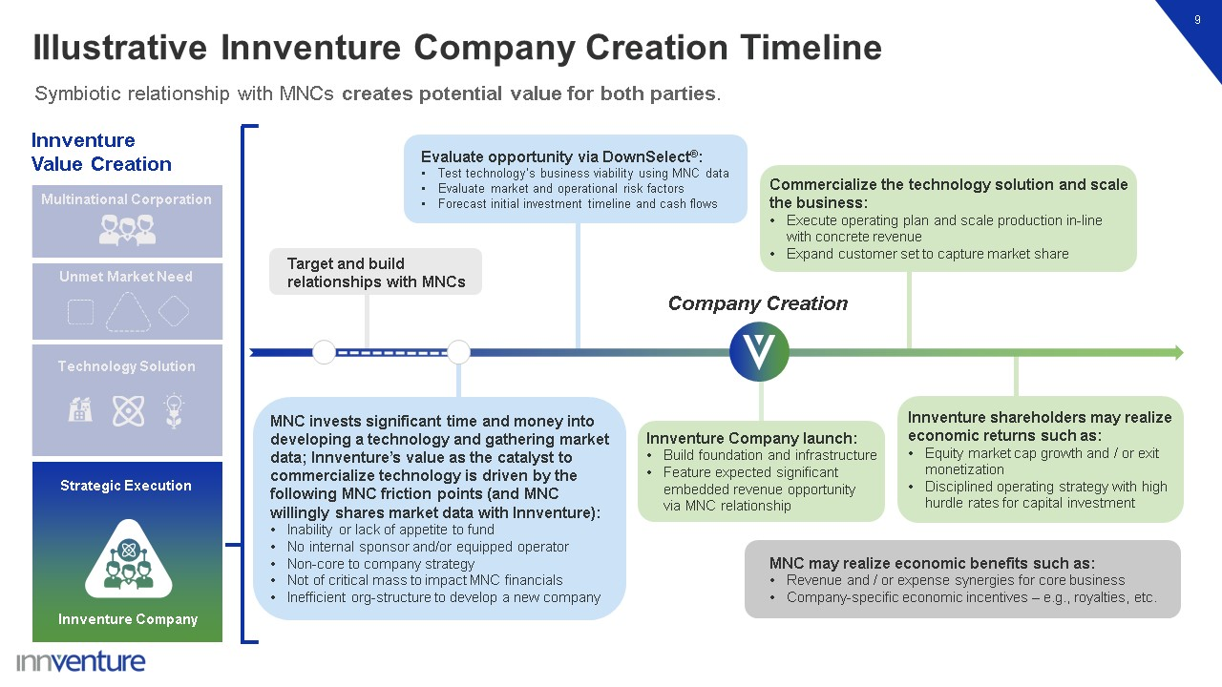
Illustrative Innventure Company Creation Timeline 9 Target and build relationships with MNCs Commercialize the technology solution and scale the business: Execute operating plan and scale production in-line with concrete revenue Expand customer set to capture market share Innventure shareholders may realize economic returns such as: Equity market cap growth and / or exit monetization Disciplined operating strategy with high hurdle rates for capital investment Evaluate opportunity via DownSelect®: Test technology’s business viability using MNC data Evaluate market and operational risk factors Forecast initial investment timeline and cash flows Innventure Company launch: Build foundation and infrastructure Feature expected significant embedded revenue opportunity via MNC relationship Company Creation MNC invests significant time and money into developing a technology and gathering market data; Innventure’s value as the catalyst to commercialize technology is driven by the following MNC friction points (and MNC willingly shares market data with Innventure): Inability or lack of appetite to fund No internal sponsor and/or equipped operator Non-core to company strategy Not of critical mass to impact MNC financials Inefficient org-structure to develop a new company Symbiotic relationship with MNCs creates potential value for both parties. Innventure Value Creation MNC may realize economic benefits such as: Revenue and / or expense synergies for core business Company-specific economic incentives – e.g., royalties, etc. Technology Solution Strategic Execution Innventure Company Unmet Market Need Multinational Corporation

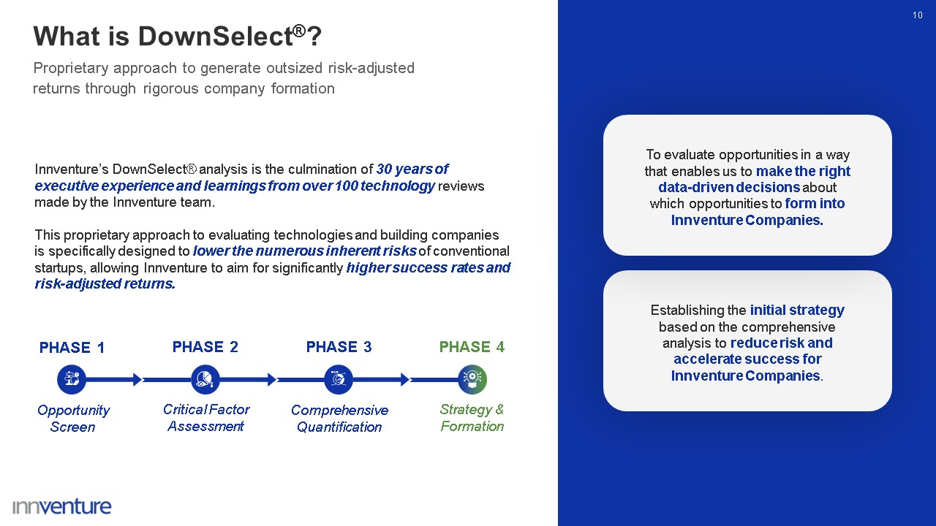
10 Proprietary approach to generate outsized risk-adjusted returns through rigorous company formation Innventure’s DownSelect® analysis is the culmination of 30 years of executive experience and learnings from over 100 technology reviews made by the Innventure team. This proprietary approach to evaluating technologies and building companies is specifically designed to lower the numerous inherent risks of conventional startups, allowing Innventure to aim for significantly higher success rates and risk-adjusted returns. Establishing the initial strategy based on the comprehensive analysis to reduce risk and accelerate success for Innventure Companies. To evaluate opportunities in a way that enables us to make the right data-driven decisions about which opportunities to form into Innventure Companies. What is DownSelect®? PHASE 3 PHASE 4 Strategy & Formation PHASE 2 PHASE 1 Opportunity Screen Critical Factor Assessment Comprehensive Quantification

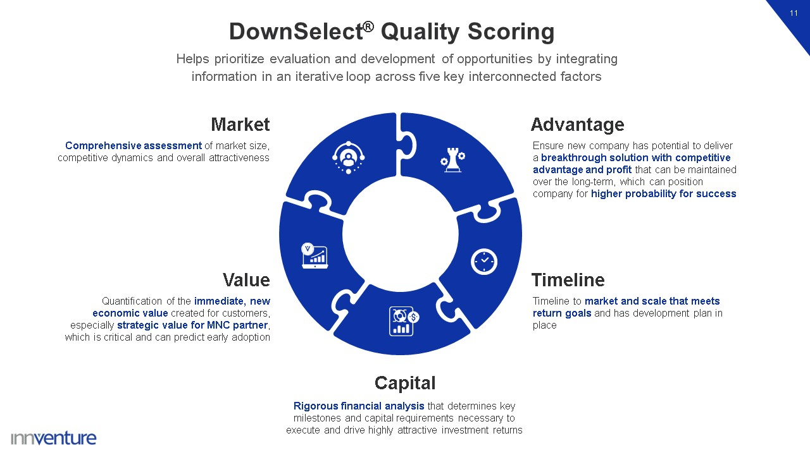
DownSelect® Quality Scoring 11 Helps prioritize evaluation and development of opportunities by integrating information in an iterative loop across five key interconnected factors Value Quantification of the immediate, new economic value created for customers, especially strategic value for MNC partner, which is critical and can predict early adoption Market Comprehensive assessment of market size, competitive dynamics and overall attractiveness Advantage Ensure new company has potential to deliver a breakthrough solution with competitive advantage and profit that can be maintained over the long-term, which can position company for higher probability for success Timeline Timeline to market and scale that meets return goals and has development plan in place Capital Rigorous financial analysis that determines key milestones and capital requirements necessary to execute and drive highly attractive investment returns

Innventure’s DownSelect® Phases 12 Each phase in the DownSelect® analysis seeks to best assess revenue opportunity, initial and scaled unit economics, capital requirements and risk. The ultimate output is a potential business launch that has met or exceeded a rigorous set of checks and balances. PHASE 1 Opportunity Screen PHASE 2 Critical Factor Assessment PHASE 4 Strategy & Formation PHASE 3 Comprehensive Quantification Quality Score Components continuously inform the analysis across all four phases Screen four key components of an opportunity: MNC Partner Significant Market Need Breakthrough Technology Solution Strategic Business Model Identify, assess, and prioritize an opportunity’s critical success and risk factors and develop a plan for in-depth systematic evaluation quantify value, address critical factors for success of a new business built around the opportunity, and mitigate risk factors Comprehensive review across all DownSelect® dimensions, with a core focus on quantitative analysis and strategy of the immediate new value created for customers Set the initial strategy, including go-to-market and initial business plan, for the Innventure Company, secure control of the technology via licensing or ownership, and create the new company

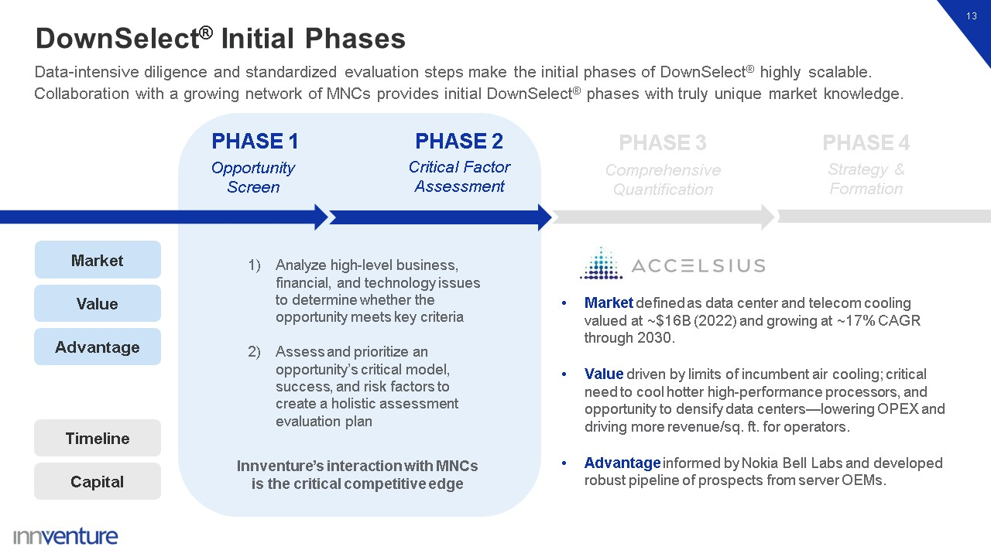
DownSelect® Initial Phases 13 Data-intensive diligence and standardized evaluation steps make the initial phases of DownSelect® highly scalable. Collaboration with a growing network of MNCs provides initial DownSelect® phases with truly unique market knowledge. PHASE 2 PHASE 3 PHASE 4 PHASE 1 Opportunity Screen Critical Factor Assessment Strategy & Formation Comprehensive Quantification Analyze high-level business, financial, and technology issues to determine whether the opportunity meets key criteria Assess and prioritize an opportunity’s critical model, success, and risk factors to create a holistic assessment evaluation plan Market defined as data center and telecom cooling valued at ~$16B (2022) and growing at ~17% CAGR through 2030. Value driven by limits of incumbent air cooling; critical need to cool hotter high-performance processors, and opportunity to densify data centers—lowering OPEX and driving more revenue/sq. ft. for operators. Advantage informed by Nokia Bell Labs and developed robust pipeline of prospects from server OEMs. Innventure’s interaction with MNCs is the critical competitive edge Capital Timeline Market Value Advantage

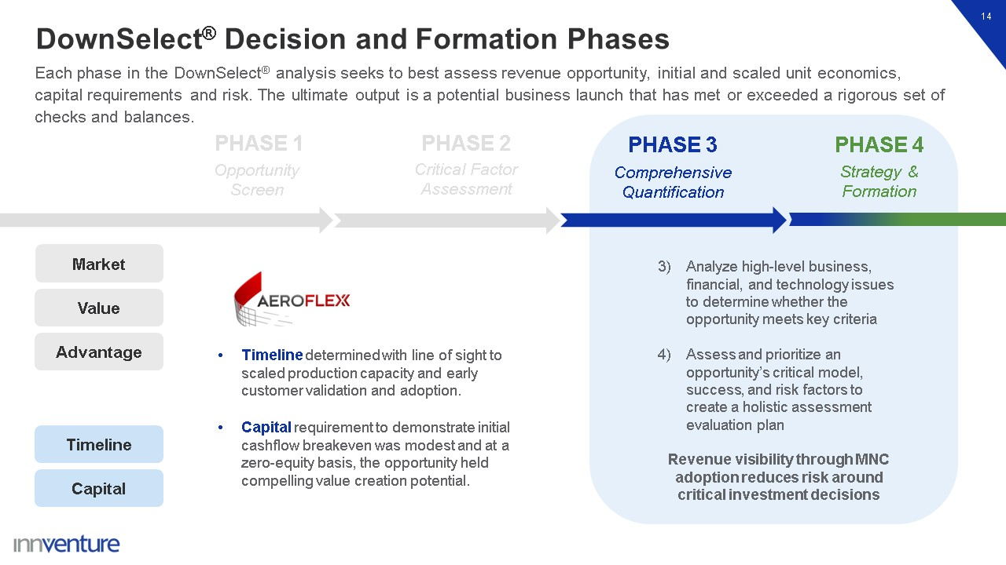
DownSelect® Decision and Formation Phases 14 Each phase in the DownSelect® analysis seeks to best assess revenue opportunity, initial and scaled unit economics, capital requirements and risk. The ultimate output is a potential business launch that has met or exceeded a rigorous set of checks and balances. PHASE 2 PHASE 3 PHASE 4 PHASE 1 Opportunity Screen Critical Factor Assessment Strategy & Formation Comprehensive Quantification Analyze high-level business, financial, and technology issues to determine whether the opportunity meets key criteria Assess and prioritize an opportunity’s critical model, success, and risk factors to create a holistic assessment evaluation plan Timeline determined with line of sight to scaled production capacity and early customer validation and adoption. Capital requirement to demonstrate initial cashflow breakeven was modest and at a zero-equity basis, the opportunity held compelling value creation potential. Revenue visibility through MNC adoption reduces risk around critical investment decisions Capital Timeline Market Value Advantage

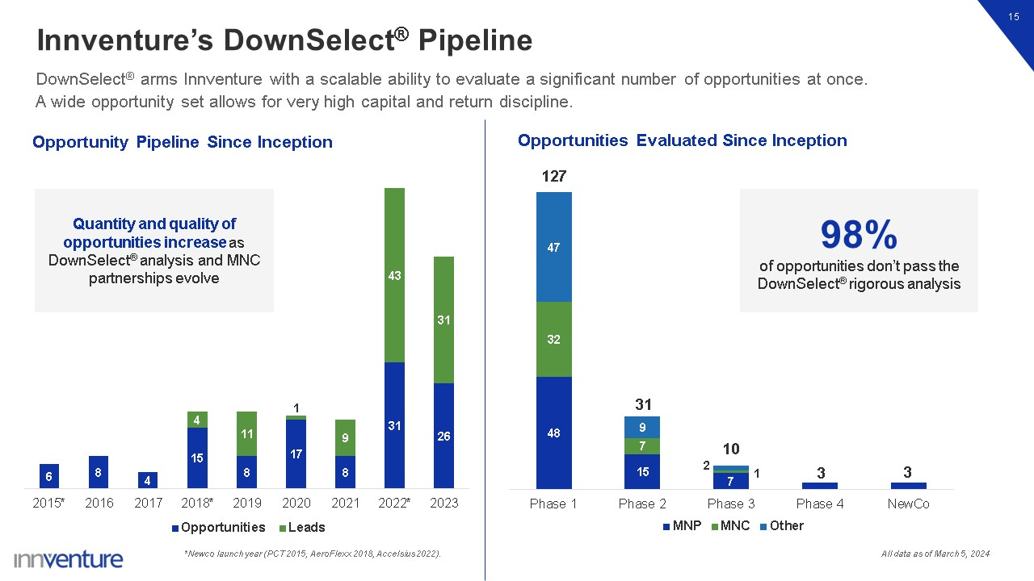
98% of opportunities don’t pass the DownSelect® rigorous analysis Innventure’s DownSelect® Pipeline 15 DownSelect® arms Innventure with a scalable ability to evaluate a significant number of opportunities at once. A wide opportunity set allows for very high capital and return discipline. *Newco launch year (PCT 2015, AeroFlexx 2018, Accelsius 2022). 127 31 10 Quantity and quality of opportunities increase as DownSelect® analysis and MNC partnerships evolve All data as of March 5, 2024

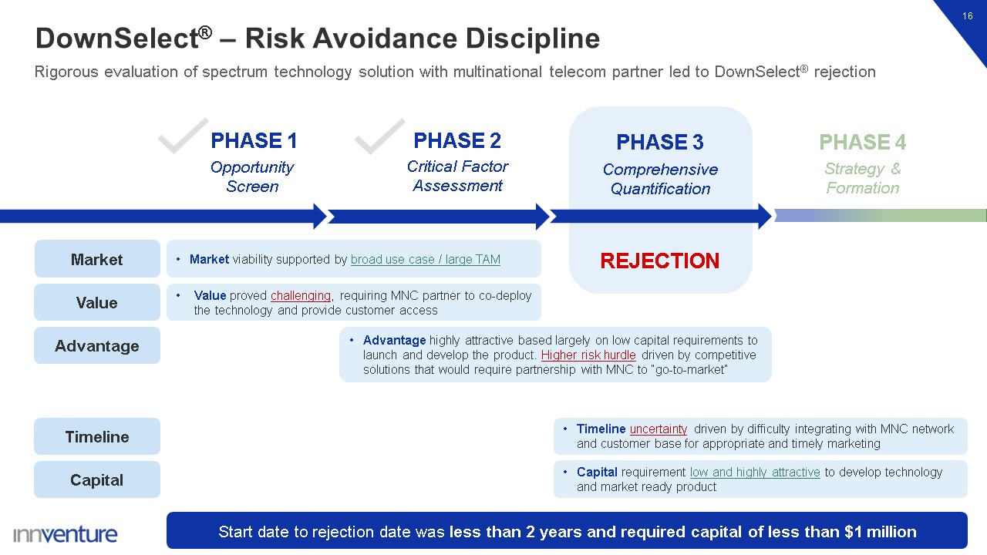
Capital Timeline DownSelect® – Risk Avoidance Discipline 16 Rigorous evaluation of spectrum technology solution with multinational telecom partner led to DownSelect® rejection PHASE 2 PHASE 3 PHASE 4 PHASE 1 Opportunity Screen Critical Factor Assessment Strategy & Formation Comprehensive Quantification Market REJECTION Start date to rejection date was less than 2 years and required capital of less than $1 million Market viability supported by broad use case / large TAM Value proved challenging, requiring MNC partner to co-deploy the technology and provide customer access Advantage highly attractive based largely on low capital requirements to launch and develop the product. Higher risk hurdle driven by competitive solutions that would require partnership with MNC to “go-to-market” Value Advantage Timeline uncertainty driven by difficulty integrating with MNC network and customer base for appropriate and timely marketing Capital requirement low and highly attractive to develop technology and market ready product

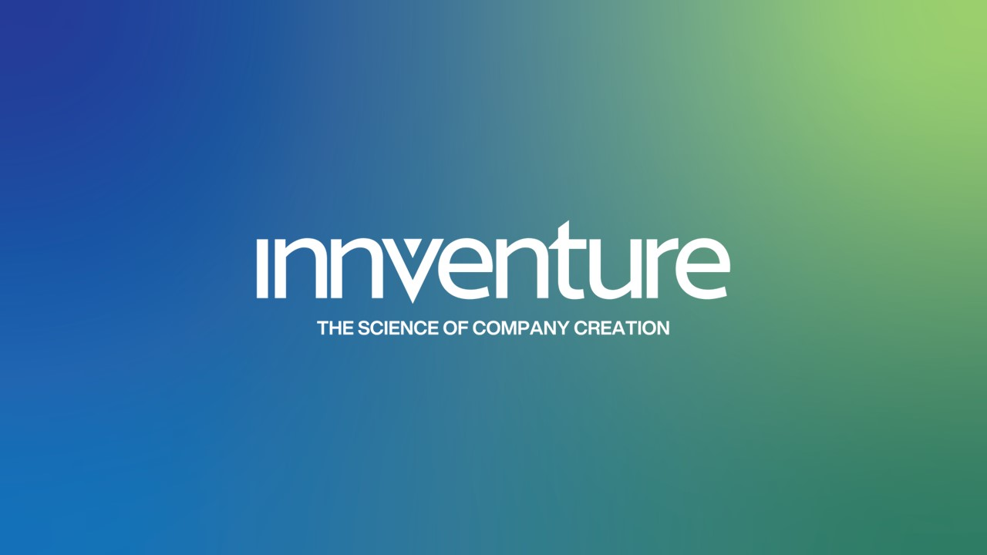

Exhibit 99.2

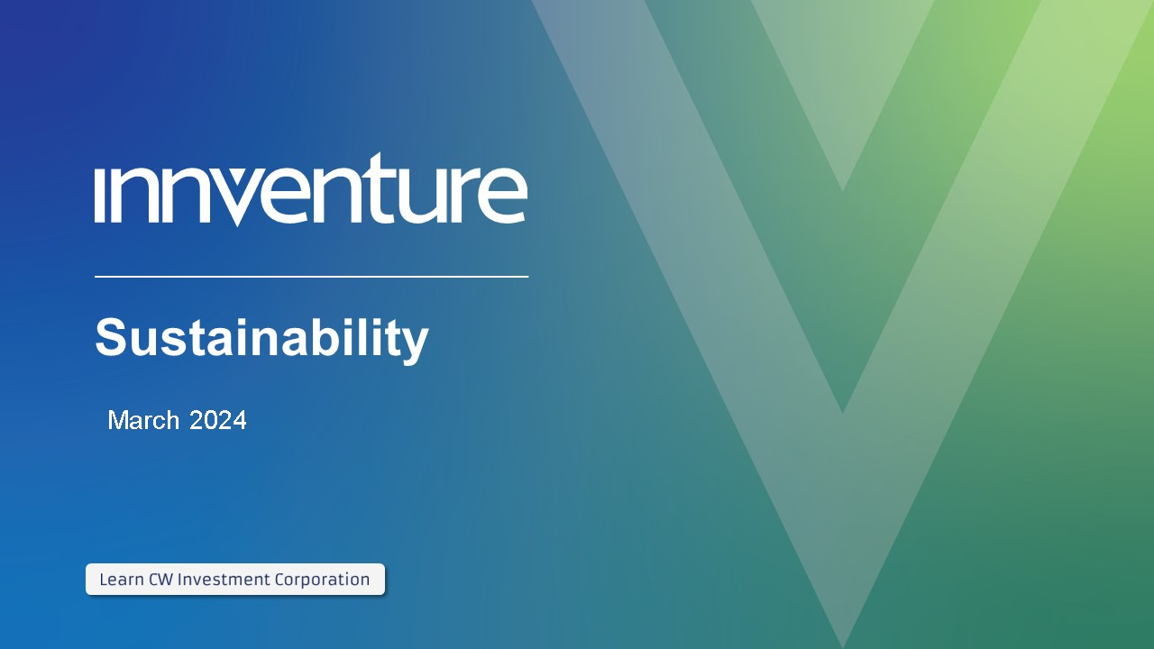
Sustainability March 2024

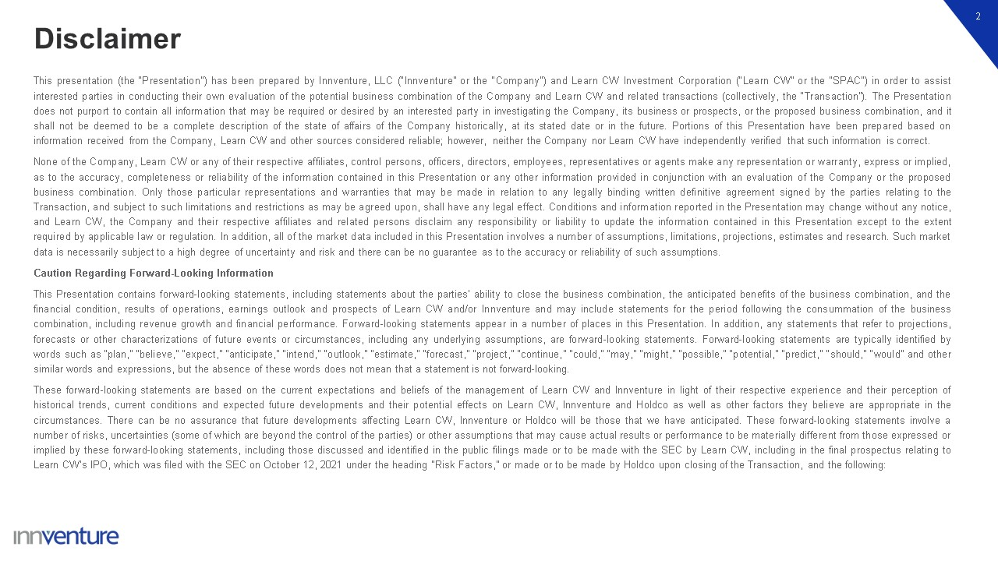
Disclaimer 2 This presentation (the “Presentation”) has been prepared by Innventure, LLC (“Innventure” or the “Company”) and Learn CW Investment Corporation (“Learn CW” or the “SPAC”) in order to assist interested parties in conducting their own evaluation of the potential business combination of the Company and Learn CW and related transactions (collectively, the “Transaction”). The Presentation does not purport to contain all information that may be required or desired by an interested party in investigating the Company, its business or prospects, or the proposed business combination, and it shall not be deemed to be a complete description of the state of affairs of the Company historically, at its stated date or in the future. Portions of this Presentation have been prepared based on information received from the Company, Learn CW and other sources considered reliable; however, neither the Company nor Learn CW have independently verified that such information is correct. None of the Company, Learn CW or any of their respective affiliates, control persons, officers, directors, employees, representatives or agents make any representation or warranty, express or implied, as to the accuracy, completeness or reliability of the information contained in this Presentation or any other information provided in conjunction with an evaluation of the Company or the proposed business combination. Only those particular representations and warranties that may be made in relation to any legally binding written definitive agreement signed by the parties relating to the Transaction, and subject to such limitations and restrictions as may be agreed upon, shall have any legal effect. Conditions and information reported in the Presentation may change without any notice, and Learn CW, the Company and their respective affiliates and related persons disclaim any responsibility or liability to update the information contained in this Presentation except to the extent required by applicable law or regulation. In addition, all of the market data included in this Presentation involves a number of assumptions, limitations, projections, estimates and research. Such market data is necessarily subject to a high degree of uncertainty and risk and there can be no guarantee as to the accuracy or reliability of such assumptions. Caution Regarding Forward-Looking Information This Presentation contains forward-looking statements, including statements about the parties’ ability to close the business combination, the anticipated benefits of the business combination, and the financial condition, results of operations, earnings outlook and prospects of Learn CW and/or Innventure and may include statements for the period following the consummation of the business combination, including revenue growth and financial performance. Forward-looking statements appear in a number of places in this Presentation. In addition, any statements that refer to projections, forecasts or other characterizations of future events or circumstances, including any underlying assumptions, are forward-looking statements. Forward-looking statements are typically identified by words such as “plan,” “believe,” “expect,” “anticipate,” “intend,” “outlook,” “estimate,” “forecast,” “project,” “continue,” “could,” “may,” “might,” “possible,” “potential,” “predict,” “should,” “would” and other similar words and expressions, but the absence of these words does not mean that a statement is not forward-looking. These forward-looking statements are based on the current expectations and beliefs of the management of Learn CW and Innventure in light of their respective experience and their perception of historical trends, current conditions and expected future developments and their potential effects on Learn CW, Innventure and Holdco as well as other factors they believe are appropriate in the circumstances. There can be no assurance that future developments affecting Learn CW, Innventure or Holdco will be those that we have anticipated. These forward-looking statements involve a number of risks, uncertainties (some of which are beyond the control of the parties) or other assumptions that may cause actual results or performance to be materially different from those expressed or implied by these forward-looking statements, including those discussed and identified in the public filings made or to be made with the SEC by Learn CW, including in the final prospectus relating to Learn CW’s IPO, which was filed with the SEC on October 12, 2021 under the heading “Risk Factors,” or made or to be made by Holdco upon closing of the Transaction, and the following:

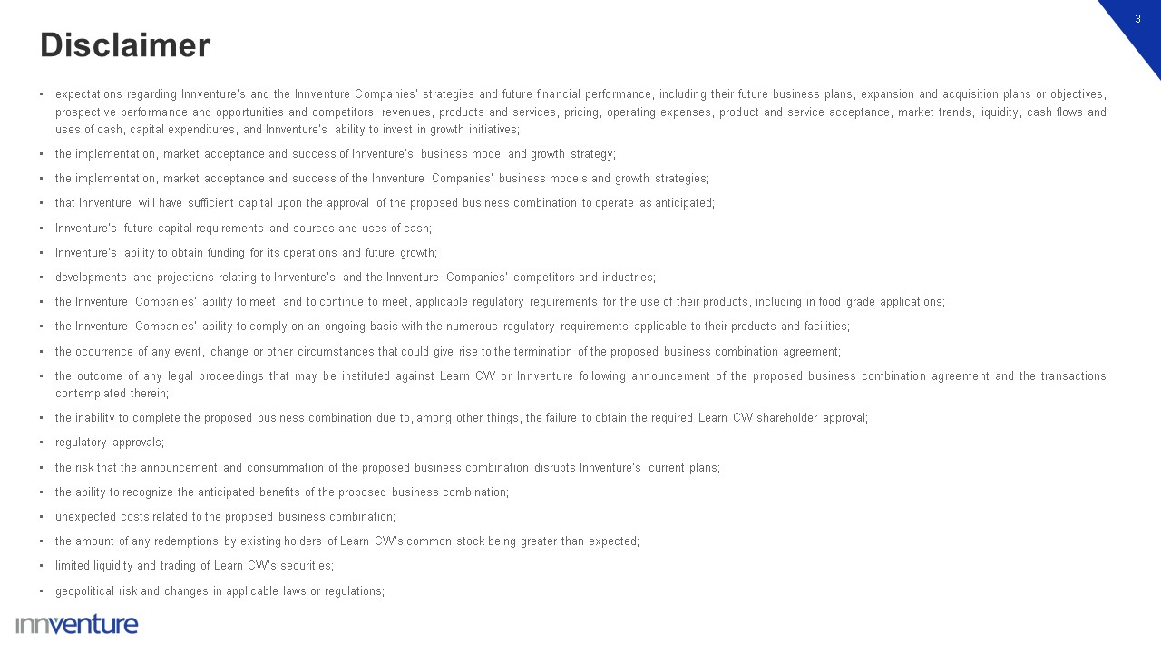
Disclaimer 3 expectations regarding Innventure’s and the Innventure Companies’ strategies and future financial performance, including their future business plans, expansion and acquisition plans or objectives, prospective performance and opportunities and competitors, revenues, products and services, pricing, operating expenses, product and service acceptance, market trends, liquidity, cash flows and uses of cash, capital expenditures, and Innventure’s ability to invest in growth initiatives; the implementation, market acceptance and success of Innventure’s business model and growth strategy; the implementation, market acceptance and success of the Innventure Companies’ business models and growth strategies; that Innventure will have sufficient capital upon the approval of the proposed business combination to operate as anticipated; Innventure’s future capital requirements and sources and uses of cash; Innventure’s ability to obtain funding for its operations and future growth; developments and projections relating to Innventure’s and the Innventure Companies’ competitors and industries; the Innventure Companies’ ability to meet, and to continue to meet, applicable regulatory requirements for the use of their products, including in food grade applications; the Innventure Companies’ ability to comply on an ongoing basis with the numerous regulatory requirements applicable to their products and facilities; the occurrence of any event, change or other circumstances that could give rise to the termination of the proposed business combination agreement; the outcome of any legal proceedings that may be instituted against Learn CW or Innventure following announcement of the proposed business combination agreement and the transactions contemplated therein; the inability to complete the proposed business combination due to, among other things, the failure to obtain the required Learn CW shareholder approval; regulatory approvals; the risk that the announcement and consummation of the proposed business combination disrupts Innventure’s current plans; the ability to recognize the anticipated benefits of the proposed business combination; unexpected costs related to the proposed business combination; the amount of any redemptions by existing holders of Learn CW’s common stock being greater than expected; limited liquidity and trading of Learn CW’s securities; geopolitical risk and changes in applicable laws or regulations;

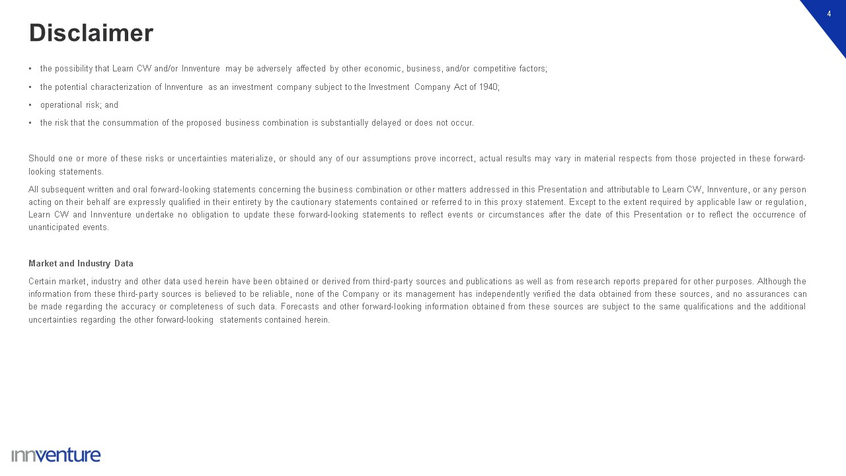
Disclaimer 4 the possibility that Learn CW and/or Innventure may be adversely affected by other economic, business, and/or competitive factors; the potential characterization of Innventure as an investment company subject to the Investment Company Act of 1940; operational risk; and the risk that the consummation of the proposed business combination is substantially delayed or does not occur. Should one or more of these risks or uncertainties materialize, or should any of our assumptions prove incorrect, actual results may vary in material respects from those projected in these forward-looking statements. All subsequent written and oral forward-looking statements concerning the business combination or other matters addressed in this Presentation and attributable to Learn CW, Innventure, or any person acting on their behalf are expressly qualified in their entirety by the cautionary statements contained or referred to in this proxy statement. Except to the extent required by applicable law or regulation, Learn CW and Innventure undertake no obligation to update these forward-looking statements to reflect events or circumstances after the date of this Presentation or to reflect the occurrence of unanticipated events. Market and Industry Data Certain market, industry and other data used herein have been obtained or derived from third-party sources and publications as well as from research reports prepared for other purposes. Although the information from these third-party sources is believed to be reliable, none of the Company or its management has independently verified the data obtained from these sources, and no assurances can be made regarding the accuracy or completeness of such data. Forecasts and other forward-looking information obtained from these sources are subject to the same qualifications and the additional uncertainties regarding the other forward-looking statements contained herein.

Disclaimer 5 Trademarks In addition to trademarks, service marks, trade names, copyrights and logos of Innventure and its subsidiaries contained herein, this presentation contains trademarks, service marks, trade names, copyrights and logos of other companies, which are the property of their respective owners. Unless otherwise stated, the use of these other trademarks, service marks, trade names, copyrights and logos herein does not imply an affiliation with, or endorsement of the information contained herein by, the owners of such trademarks, service marks, trade names, copyrights and logos. Additional Information About the Proposed Business Combination and Where To Find It In connection with the proposed business combination, Learn SPAC Holdco, Inc. has filed with the SEC a registration statement on Form S-4 containing a preliminary proxy statement of Learn CW, a preliminary consent solicitation statement of Innventure and a preliminary prospectus with respect to the combined company’s securities to be issued in connection with the business combination, and after the registration statement is declared effective, the definitive proxy statement/consent solicitation statement/prospectus relating to the proposed business combination will be mailed to Learn CW shareholders and will be sent to Innventure unitholders. This presentation does not contain all the information that should be considered concerning the proposed business combination and is not intended to form the basis of any investment decision or any other decision in respect of the business combination. Learn CW’s shareholders, Innventure’s unitholders and other interested persons are urged to read the preliminary proxy statement/consent solicitation statement/prospectus and the amendments thereto and, when available, the definitive proxy statement/consent solicitation statement/prospectus and other documents filed in connection with the proposed business combination, as these materials will contain important information about Innventure, Learn CW, the combined company and the proposed business combination. When available, the definitive proxy statement/consent solicitation statement/prospectus and other relevant materials for the proposed business combination will be mailed to shareholders of Learn CW as of a record date to be established for voting on the proposed business combination. Such shareholders will also be able to obtain copies of the preliminary and definitive proxy statement/consent solicitation statement/prospectus and other documents filed with the SEC, without charge, once available, at the SEC’s website at www.sec.gov, or by directing a request to Learn CW Investment Corporation, 11755 Wilshire Blvd., Suite 2320, Los Angeles, California 90025. No Offer or Solicitation This presentation shall not constitute an offer to sell or the solicitation of an offer to buy any securities, or a solicitation of any vote or approval, nor shall there be any sale of any such securities in any state or jurisdiction in which such offer, solicitation or sale would be unlawful prior to registration or qualification under the securities laws of any such state or jurisdiction. No offer of securities shall be made except by means of a definitive document. Participants in the Solicitation Innventure, Learn CW and their respective directors, executive officers, other members of management, and employees, under SEC rules, may be deemed to be participants in the solicitation of proxies of Learn CW’s shareholders in connection with the proposed business combination. Information regarding the persons who may, under SEC rules, be deemed participants in the solicitation of Learn CW’s shareholders in connection with the proposed business combination are set forth in the registration statement on Form S-4, including the preliminary proxy statement/consent solicitation statement/prospectus, and will also be set forth in the definitive proxy statement/consent solicitation statement/prospectus when available. Investors and security holders may obtain more detailed information regarding the names and interests in the proposed business combination of Learn CW’s directors and officers in Learn CW’s filings with the SEC and such information is also set forth in the registration statement filed with the SEC by Learn SPAC Holdco, Inc., including the proxy statement of Learn CW for the proposed business combination.

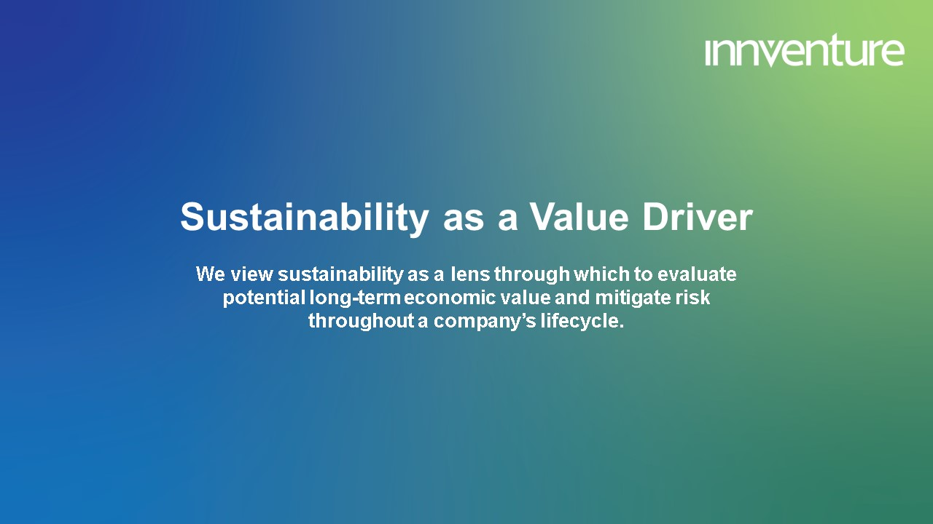
Sustainability as a Value DriverWe view sustainability as a lens through which to evaluate potential long-term economic value and mitigate risk throughout a company’s lifecycle.

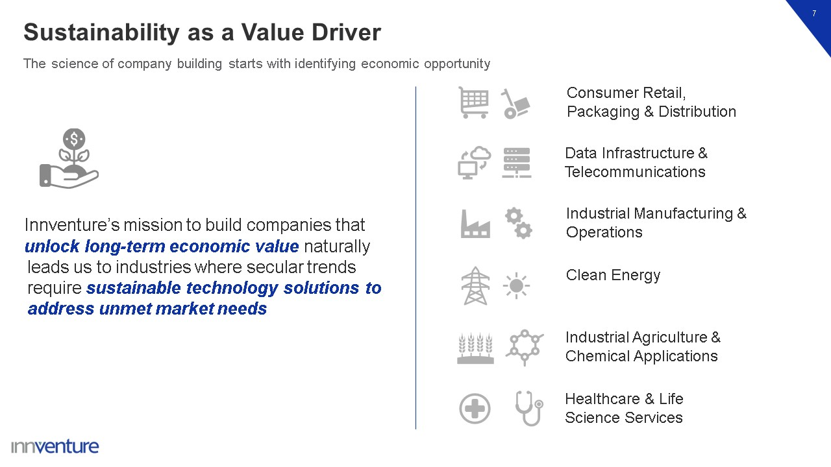
Sustainability as a Value Driver 7 The science of company building starts with identifying economic opportunity Consumer Retail, Packaging & Distribution Data Infrastructure & Telecommunications Industrial Manufacturing & Operations Clean Energy Industrial Agriculture & Chemical Applications Healthcare & Life Science Services Innventure’s mission to build companies that unlock long-term economic value naturally leads us to industries where secular trends require sustainable technology solutions to address unmet market needs

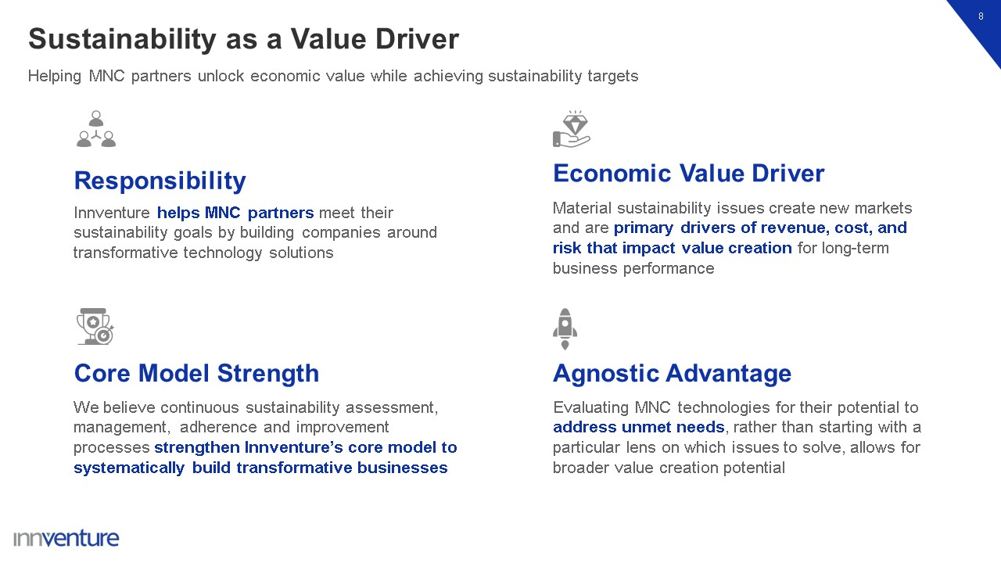
Sustainability as a Value Driver 8 Innventure helps MNC partners meet their sustainability goals by building companies around transformative technology solutions Responsibility Material sustainability issues create new markets and are primary drivers of revenue, cost, and risk that impact value creation for long-term business performance Economic Value Driver We believe continuous sustainability assessment, management, adherence and improvement processes strengthen Innventure’s core model to systematically build transformative businesses Core Model Strength Evaluating MNC technologies for their potential to address unmet needs, rather than starting with a particular lens on which issues to solve, allows for broader value creation potential Agnostic Advantage Helping MNC partners unlock economic value while achieving sustainability targets

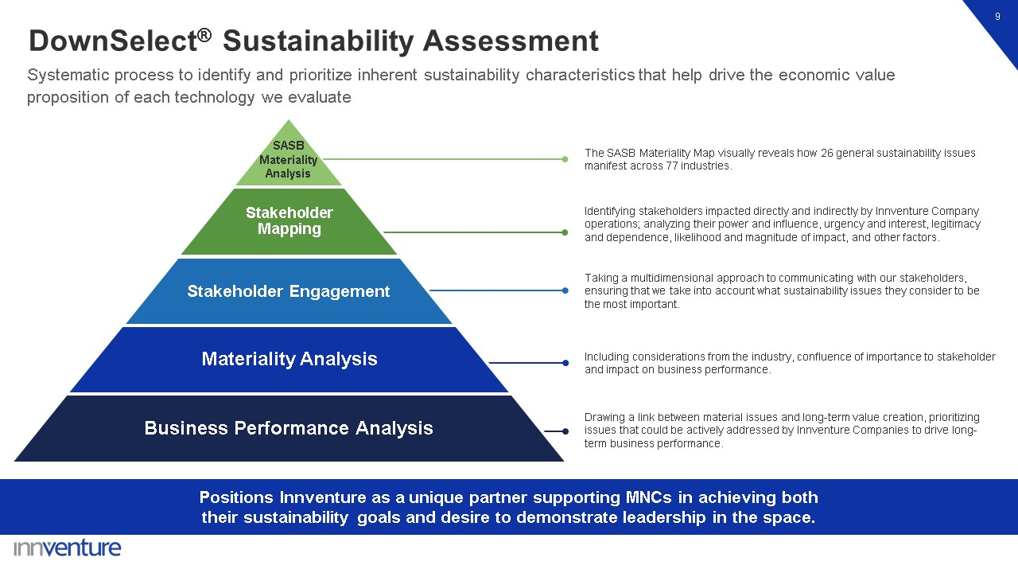
Stakeholder Mapping Stakeholder Engagement Materiality Analysis Business Performance Analysis Drawing a link between material issues and long-term value creation, prioritizing issues that could be actively addressed by Innventure Companies to drive long-term business performance. Including considerations from the industry, confluence of importance to stakeholder and impact on business performance. The SASB Materiality Map visually reveals how 26 general sustainability issues manifest across 77 industries. Identifying stakeholders impacted directly and indirectly by Innventure Company operations; analyzing their power and influence, urgency and interest, legitimacy and dependence, likelihood and magnitude of impact, and other factors. Taking a multidimensional approach to communicating with our stakeholders, ensuring that we take into account what sustainability issues they consider to be the most important. DownSelect® Sustainability Assessment 9 Systematic process to identify and prioritize inherent sustainability characteristics that help drive the economic value proposition of each technology we evaluate Positions Innventure as a unique partner supporting MNCs in achieving both their sustainability goals and desire to demonstrate leadership in the space. SASB Materiality Analysis

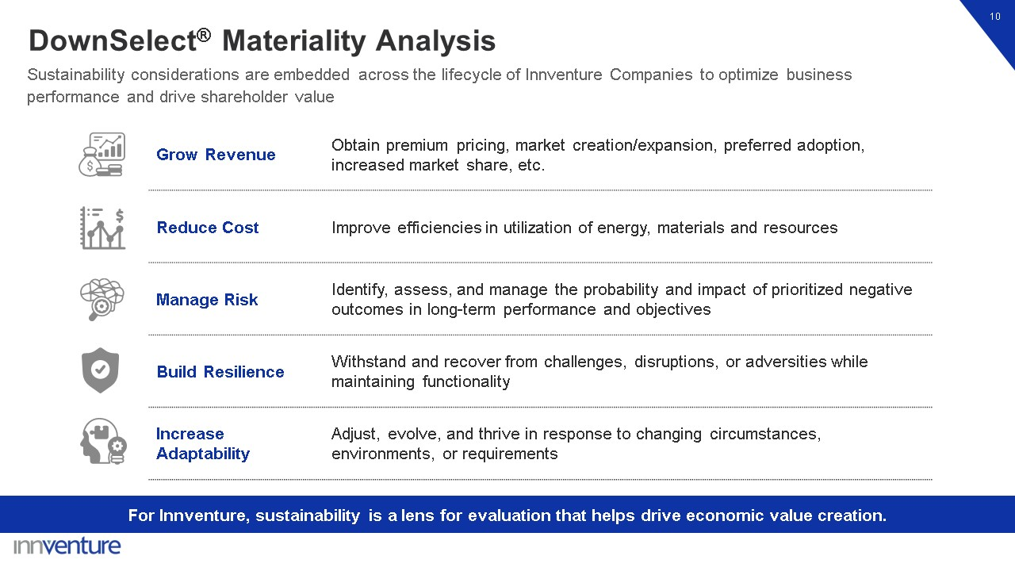
Grow Revenue Obtain premium pricing, market creation/expansion, preferred adoption, increased market share, etc. Reduce Cost Improve efficiencies in utilization of energy, materials and resources Manage Risk Identify, assess, and manage the probability and impact of prioritized negative outcomes in long-term performance and objectives Build Resilience Withstand and recover from challenges, disruptions, or adversities while maintaining functionality Increase Adaptability Adjust, evolve, and thrive in response to changing circumstances, environments, or requirements 10 For Innventure, sustainability is a lens for evaluation that helps drive economic value creation. DownSelect® Materiality Analysis Sustainability considerations are embedded across the lifecycle of Innventure Companies to optimize business performance and drive shareholder value

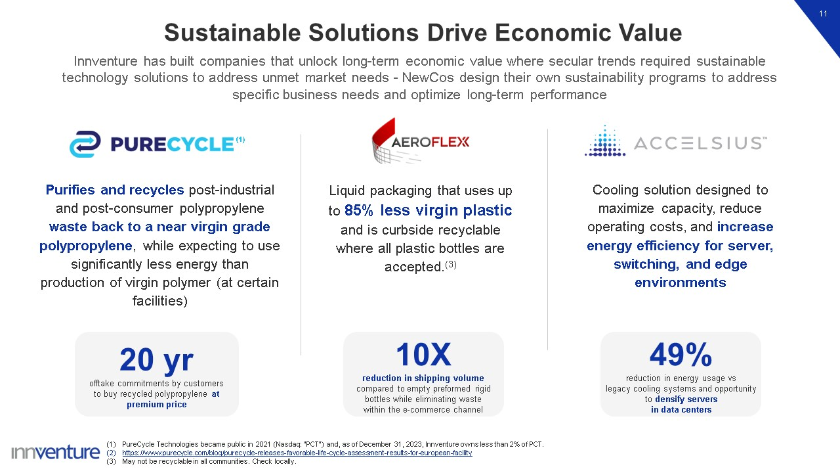
10X reduction in shipping volume compared to empty preformed rigid bottles while eliminating waste within the e-commerce channel Sustainable Solutions Drive Economic Value 11 Purifies and recycles post-industrial and post-consumer polypropylene waste back to a near virgin grade polypropylene, while expecting to use significantly less energy than production of virgin polymer (at certain facilities) PureCycle Technologies became public in 2021 (Nasdaq: “PCT”) and, as of December 31, 2023, Innventure owns less than 2% of PCT. https://www.purecycle.com/blog/purecycle-releases-favorable-life-cycle-assessment-results-for-european-facility May not be recyclable in all communities. Check locally. Liquid packaging that uses up to 85% less virgin plastic and is curbside recyclable where all plastic bottles are accepted.(3) Cooling solution designed to maximize capacity, reduce operating costs, and increase energy efficiency for server, switching, and edge environments (1) Innventure has built companies that unlock long-term economic value where secular trends required sustainable technology solutions to address unmet market needs - NewCos design their own sustainability programs to address specific business needs and optimize long-term performance 49% reduction in energy usage vs legacy cooling systems and opportunity to densify servers in data centers 20 yr offtake commitments by customers to buy recycled polypropylene at premium price

Exhibit 99.3

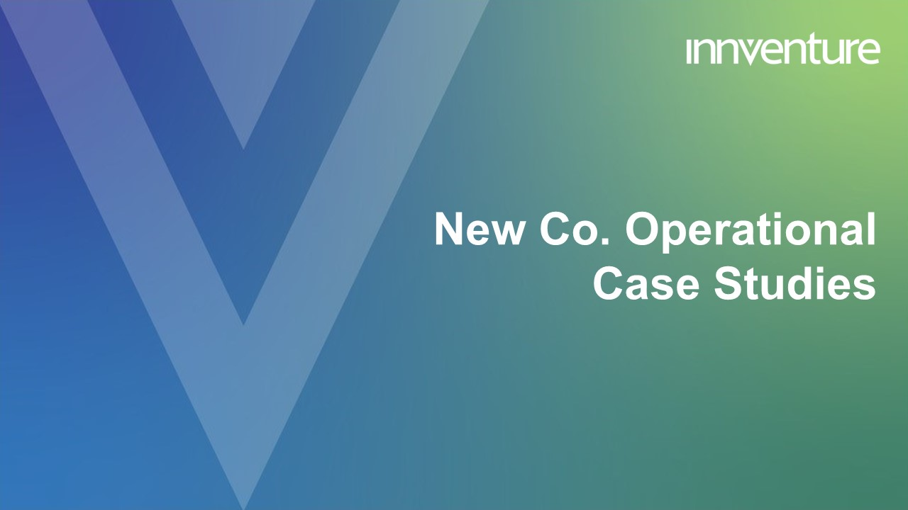
New Co. OperationalCase Studies

Disclaimer 2 This presentation (the “Presentation”) has been prepared by Innventure, LLC (“Innventure” or the “Company”) and Learn CW Investment Corporation (“Learn CW” or the “SPAC”) in order to assist interested parties in conducting their own evaluation of the potential business combination of the Company and Learn CW and related transactions (collectively, the “Transaction”). The Presentation does not purport to contain all information that may be required or desired by an interested party in investigating the Company, its business or prospects, or the proposed business combination, and it shall not be deemed to be a complete description of the state of affairs of the Company historically, at its stated date or in the future. Portions of this Presentation have been prepared based on information received from the Company, Learn CW and other sources considered reliable; however, neither the Company nor Learn CW have independently verified that such information is correct. None of the Company, Learn CW or any of their respective affiliates, control persons, officers, directors, employees, representatives or agents make any representation or warranty, express or implied, as to the accuracy, completeness or reliability of the information contained in this Presentation or any other information provided in conjunction with an evaluation of the Company or the proposed business combination. Only those particular representations and warranties that may be made in relation to any legally binding written definitive agreement signed by the parties relating to the Transaction, and subject to such limitations and restrictions as may be agreed upon, shall have any legal effect. Conditions and information reported in the Presentation may change without any notice, and Learn CW, the Company and their respective affiliates and related persons disclaim any responsibility or liability to update the information contained in this Presentation except to the extent required by applicable law or regulation. In addition, all of the market data included in this Presentation involves a number of assumptions, limitations, projections, estimates and research. Such market data is necessarily subject to a high degree of uncertainty and risk and there can be no guarantee as to the accuracy or reliability of such assumptions. Caution Regarding Forward-Looking Information This Presentation contains forward-looking statements, including statements about the parties’ ability to close the business combination, the anticipated benefits of the business combination, and the financial condition, results of operations, earnings outlook and prospects of Learn CW and/or Innventure and may include statements for the period following the consummation of the business combination, including revenue growth and financial performance. Forward-looking statements appear in a number of places in this Presentation. In addition, any statements that refer to projections, forecasts or other characterizations of future events or circumstances, including any underlying assumptions, are forward-looking statements. Forward-looking statements are typically identified by words such as “plan,” “believe,” “expect,” “anticipate,” “intend,” “outlook,” “estimate,” “forecast,” “project,” “continue,” “could,” “may,” “might,” “possible,” “potential,” “predict,” “should,” “would” and other similar words and expressions, but the absence of these words does not mean that a statement is not forward-looking. These forward-looking statements are based on the current expectations and beliefs of the management of Learn CW and Innventure in light of their respective experience and their perception of historical trends, current conditions and expected future developments and their potential effects on Learn CW, Innventure and Holdco as well as other factors they believe are appropriate in the circumstances. There can be no assurance that future developments affecting Learn CW, Innventure or Holdco will be those that we have anticipated. These forward-looking statements involve a number of risks, uncertainties (some of which are beyond the control of the parties) or other assumptions that may cause actual results or performance to be materially different from those expressed or implied by these forward-looking statements, including those discussed and identified in the public filings made or to be made with the SEC by Learn CW, including in the final prospectus relating to Learn CW’s IPO, which was filed with the SEC on October 12, 2021 under the heading “Risk Factors,” or made or to be made by Holdco upon closing of the Transaction, and the following:

Disclaimer 3 expectations regarding Innventure’s and the Innventure Companies’ strategies and future financial performance, including their future business plans, expansion and acquisition plans or objectives, prospective performance and opportunities and competitors, revenues, products and services, pricing, operating expenses, product and service acceptance, market trends, liquidity, cash flows and uses of cash, capital expenditures, and Innventure’s ability to invest in growth initiatives; the implementation, market acceptance and success of Innventure’s business model and growth strategy; the implementation, market acceptance and success of the Innventure Companies’ business models and growth strategies; that Innventure will have sufficient capital upon the approval of the proposed business combination to operate as anticipated; Innventure’s future capital requirements and sources and uses of cash; Innventure’s ability to obtain funding for its operations and future growth; developments and projections relating to Innventure’s and the Innventure Companies’ competitors and industries; the Innventure Companies’ ability to meet, and to continue to meet, applicable regulatory requirements for the use of their products, including in food grade applications; the Innventure Companies’ ability to comply on an ongoing basis with the numerous regulatory requirements applicable to their products and facilities; the occurrence of any event, change or other circumstances that could give rise to the termination of the proposed business combination agreement; the outcome of any legal proceedings that may be instituted against Learn CW or Innventure following announcement of the proposed business combination agreement and the transactions contemplated therein; the inability to complete the proposed business combination due to, among other things, the failure to obtain the required Learn CW shareholder approval; regulatory approvals; the risk that the announcement and consummation of the proposed business combination disrupts Innventure’s current plans; the ability to recognize the anticipated benefits of the proposed business combination; unexpected costs related to the proposed business combination; the amount of any redemptions by existing holders of Learn CW’s common stock being greater than expected; limited liquidity and trading of Learn CW’s securities; geopolitical risk and changes in applicable laws or regulations;

Disclaimer 4 the possibility that Learn CW and/or Innventure may be adversely affected by other economic, business, and/or competitive factors; the potential characterization of Innventure as an investment company subject to the Investment Company Act of 1940; operational risk; and the risk that the consummation of the proposed business combination is substantially delayed or does not occur. Should one or more of these risks or uncertainties materialize, or should any of our assumptions prove incorrect, actual results may vary in material respects from those projected in these forward-looking statements. All subsequent written and oral forward-looking statements concerning the business combination or other matters addressed in this Presentation and attributable to Learn CW, Innventure, or any person acting on their behalf are expressly qualified in their entirety by the cautionary statements contained or referred to in this proxy statement. Except to the extent required by applicable law or regulation, Learn CW and Innventure undertake no obligation to update these forward-looking statements to reflect events or circumstances after the date of this Presentation or to reflect the occurrence of unanticipated events. Market and Industry Data Certain market, industry and other data used herein have been obtained or derived from third-party sources and publications as well as from research reports prepared for other purposes. Although the information from these third-party sources is believed to be reliable, none of the Company or its management has independently verified the data obtained from these sources, and no assurances can be made regarding the accuracy or completeness of such data. Forecasts and other forward-looking information obtained from these sources are subject to the same qualifications and the additional uncertainties regarding the other forward-looking statements contained herein.

Disclaimer 5 Trademarks In addition to trademarks, service marks, trade names, copyrights and logos of Innventure and its subsidiaries contained herein, this presentation contains trademarks, service marks, trade names, copyrights and logos of other companies, which are the property of their respective owners. Unless otherwise stated, the use of these other trademarks, service marks, trade names, copyrights and logos herein does not imply an affiliation with, or endorsement of the information contained herein by, the owners of such trademarks, service marks, trade names, copyrights and logos. Additional Information About the Proposed Business Combination and Where To Find It In connection with the proposed business combination, Learn SPAC Holdco, Inc. has filed with the SEC a registration statement on Form S-4 containing a preliminary proxy statement of Learn CW, a preliminary consent solicitation statement of Innventure and a preliminary prospectus with respect to the combined company’s securities to be issued in connection with the business combination, and after the registration statement is declared effective, the definitive proxy statement/consent solicitation statement/prospectus relating to the proposed business combination will be mailed to Learn CW shareholders and will be sent to Innventure unitholders. This presentation does not contain all the information that should be considered concerning the proposed business combination and is not intended to form the basis of any investment decision or any other decision in respect of the business combination. Learn CW’s shareholders, Innventure’s unitholders and other interested persons are urged to read the preliminary proxy statement/consent solicitation statement/prospectus and the amendments thereto and, when available, the definitive proxy statement/consent solicitation statement/prospectus and other documents filed in connection with the proposed business combination, as these materials will contain important information about Innventure, Learn CW, the combined company and the proposed business combination. When available, the definitive proxy statement/consent solicitation statement/prospectus and other relevant materials for the proposed business combination will be mailed to shareholders of Learn CW as of a record date to be established for voting on the proposed business combination. Such shareholders will also be able to obtain copies of the preliminary and definitive proxy statement/consent solicitation statement/prospectus and other documents filed with the SEC, without charge, once available, at the SEC’s website at www.sec.gov, or by directing a request to Learn CW Investment Corporation, 11755 Wilshire Blvd., Suite 2320, Los Angeles, California 90025. No Offer or Solicitation This presentation shall not constitute an offer to sell or the solicitation of an offer to buy any securities, or a solicitation of any vote or approval, nor shall there be any sale of any such securities in any state or jurisdiction in which such offer, solicitation or sale would be unlawful prior to registration or qualification under the securities laws of any such state or jurisdiction. No offer of securities shall be made except by means of a definitive document. Participants in the Solicitation Innventure, Learn CW and their respective directors, executive officers, other members of management, and employees, under SEC rules, may be deemed to be participants in the solicitation of proxies of Learn CW’s shareholders in connection with the proposed business combination. Information regarding the persons who may, under SEC rules, be deemed participants in the solicitation of Learn CW’s shareholders in connection with the proposed business combination are set forth in the registration statement on Form S-4, including the preliminary proxy statement/consent solicitation statement/prospectus, and will also be set forth in the definitive proxy statement/consent solicitation statement/prospectus when available. Investors and security holders may obtain more detailed information regarding the names and interests in the proposed business combination of Learn CW’s directors and officers in Learn CW’s filings with the SEC and such information is also set forth in the registration statement filed with the SEC by Learn SPAC Holdco, Inc., including the proxy statement of Learn CW for the proposed business combination.

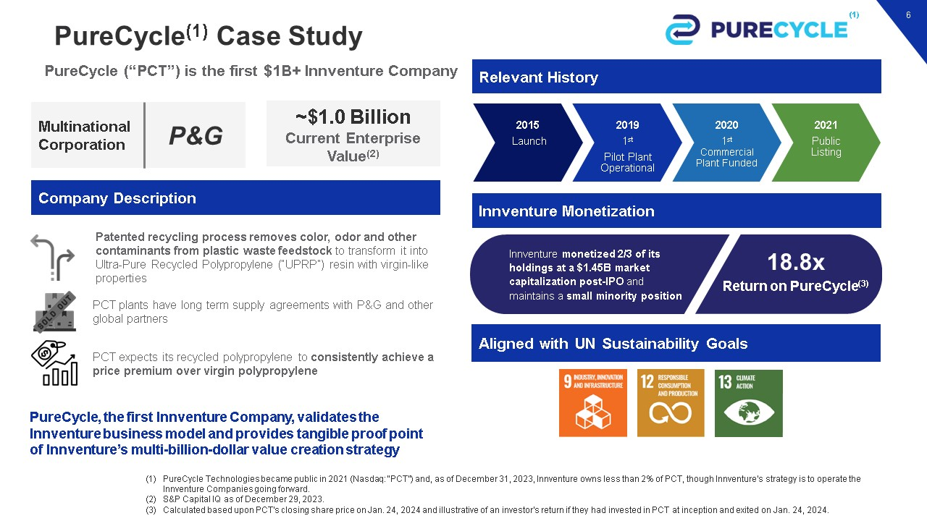
PureCycle(1) Case Study 6 PureCycle (“PCT”) is the first $1B+ Innventure Company PureCycle, the first Innventure Company, validates the Innventure business model and provides tangible proof point of Innventure’s multi-billion-dollar value creation strategy Multinational Corporation ~$1.0 Billion Current Enterprise Value(2) Relevant History Innventure Monetization Company Description PureCycle Technologies became public in 2021 (Nasdaq: “PCT”) and, as of December 31, 2023, Innventure owns less than 2% of PCT, though Innventure's strategy is to operate the Innventure Companies going forward. S&P Capital IQ as of December 29, 2023. Calculated based upon PCT's closing share price on Jan. 24, 2024 and illustrative of an investor's return if they had invested in PCT at inception and exited on Jan. 24, 2024. 2015 Launch 2019 1st Pilot Plant Operational 2020 1st Commercial Plant Funded 2021 Public Listing Patented recycling process removes color, odor and other contaminants from plastic waste feedstock to transform it into Ultra-Pure Recycled Polypropylene (“UPRP”) resin with virgin-like properties PCT plants have long term supply agreements with P&G and other global partners PCT expects its recycled polypropylene to consistently achieve a price premium over virgin polypropylene Aligned with UN Sustainability Goals P&G (1) Innventure monetized 2/3 of its holdings at a $1.45B market capitalization post-IPO and maintains a small minority position 18.8x Return on PureCycle(3)

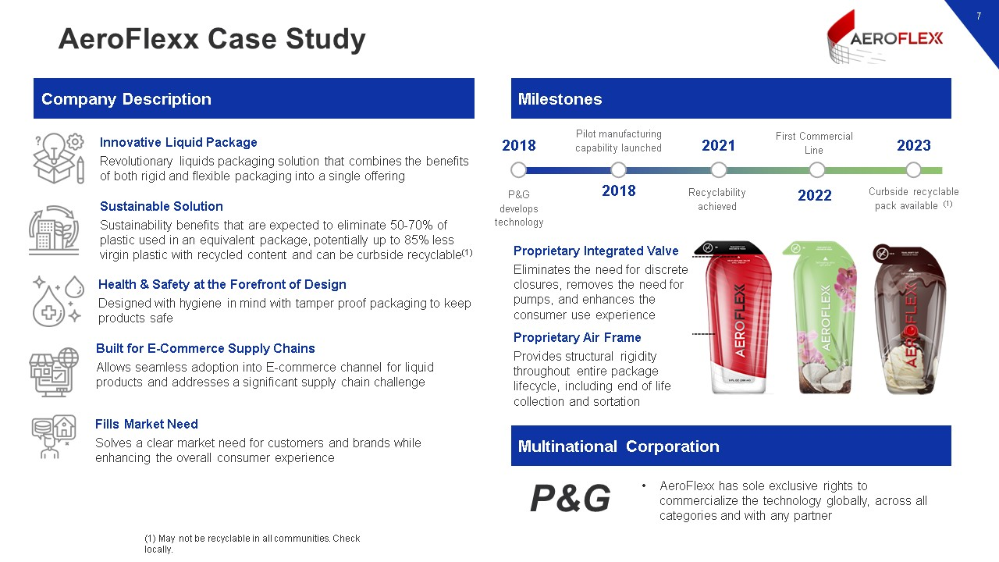
AeroFlexx Case Study 7 Milestones Company Description Multinational Corporation AeroFlexx has sole exclusive rights to commercialize the technology globally, across all categories and with any partner Proprietary Integrated Valve Eliminates the need for discrete closures, removes the need for pumps, and enhances the consumer use experience Proprietary Air Frame Provides structural rigidity throughout entire package lifecycle, including end of life collection and sortation 2018 P&G develops technology 2018 Pilot manufacturing capability launched Recyclability achieved First Commercial Line 2023 Curbside recyclable pack available (1) 2022 2021 Innovative Liquid Package Revolutionary liquids packaging solution that combines the benefits of both rigid and flexible packaging into a single offering Sustainable Solution Sustainability benefits that are expected to eliminate 50-70% of plastic used in an equivalent package, potentially up to 85% less virgin plastic with recycled content and can be curbside recyclable(1) Health & Safety at the Forefront of Design Designed with hygiene in mind with tamper proof packaging to keep products safe Built for E-Commerce Supply Chains Allows seamless adoption into E-commerce channel for liquid products and addresses a significant supply chain challenge Fills Market Need Solves a clear market need for customers and brands while enhancing the overall consumer experience (1) May not be recyclable in all communities. Check locally. P&G

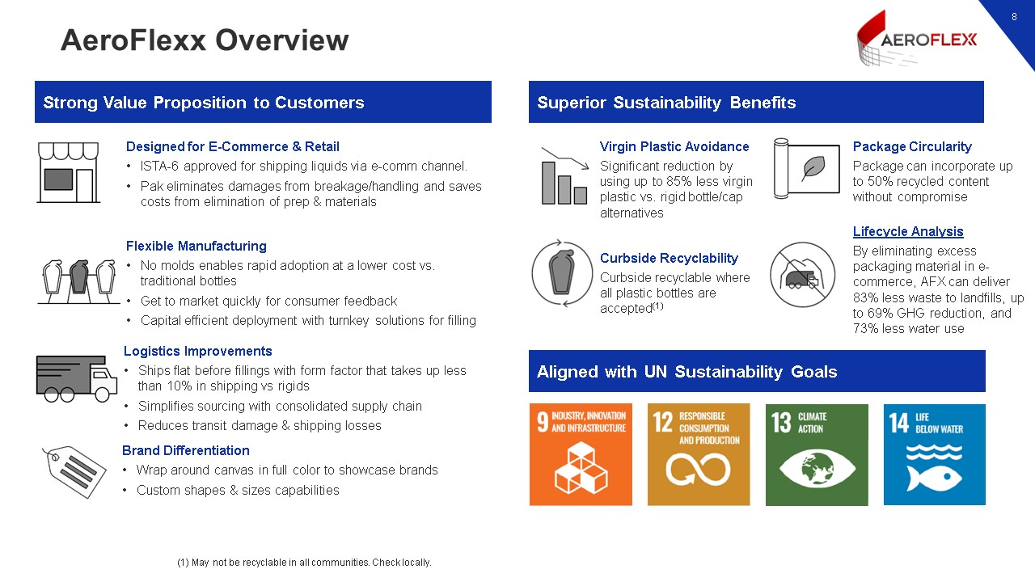
AeroFlexx Overview 8 Superior Sustainability Benefits Strong Value Proposition to Customers Aligned with UN Sustainability Goals Virgin Plastic Avoidance Significant reduction by using up to 85% less virgin plastic vs. rigid bottle/cap alternatives Package Circularity Package can incorporate up to 50% recycled content without compromise Curbside Recyclability Curbside recyclable where all plastic bottles are accepted(1) Lifecycle Analysis By eliminating excess packaging material in e-commerce, AFX can deliver 83% less waste to landfills, up to 69% GHG reduction, and 73% less water use Designed for E-Commerce & Retail ISTA-6 approved for shipping liquids via e-comm channel. Pak eliminates damages from breakage/handling and saves costs from elimination of prep & materials Flexible Manufacturing No molds enables rapid adoption at a lower cost vs. traditional bottles Get to market quickly for consumer feedback Capital efficient deployment with turnkey solutions for filling Logistics Improvements Ships flat before fillings with form factor that takes up less than 10% in shipping vs rigids Simplifies sourcing with consolidated supply chain Reduces transit damage & shipping losses Brand Differentiation Wrap around canvas in full color to showcase brands Custom shapes & sizes capabilities (1) May not be recyclable in all communities. Check locally.

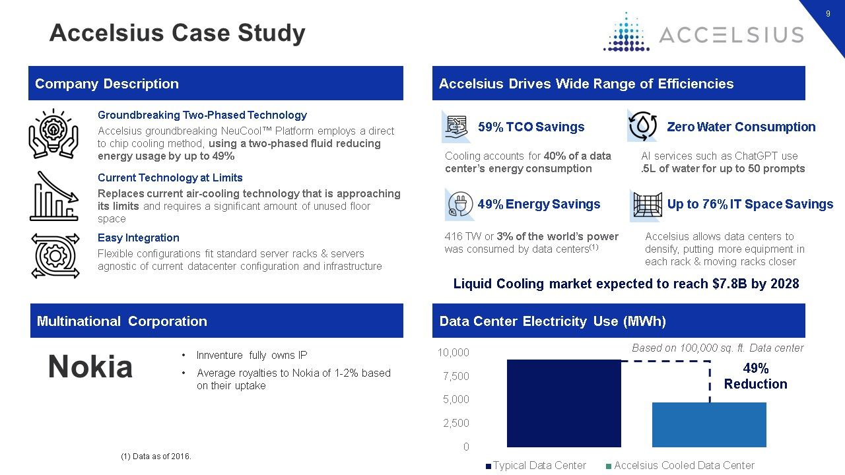
Accelsius Case Study 9 Company Description Groundbreaking Two-Phased Technology Accelsius groundbreaking NeuCool™ Platform employs a direct to chip cooling method, using a two-phased fluid reducing energy usage by up to 49% Current Technology at Limits Replaces current air-cooling technology that is approaching its limits and requires a significant amount of unused floor space Easy Integration Flexible configurations fit standard server racks & servers agnostic of current datacenter configuration and infrastructure Liquid Cooling market expected to reach $7.8B by 2028 Accelsius Drives Wide Range of Efficiencies Innventure fully owns IP Average royalties to Nokia of 1-2% based on their uptake Multinational Corporation Up to 76% IT Space Savings Cooling accounts for 40% of a data center’s energy consumption 59% TCO Savings AI services such as ChatGPT use .5L of water for up to 50 prompts Zero Water Consumption Accelsius allows data centers to densify, putting more equipment in each rack & moving racks closer 416 TW or 3% of the world’s power was consumed by data centers(1) 49% Energy Savings Data Center Electricity Use (MWh) Based on 100,000 sq. ft. Data center 49% Reduction (1) Data as of 2016. Nokia

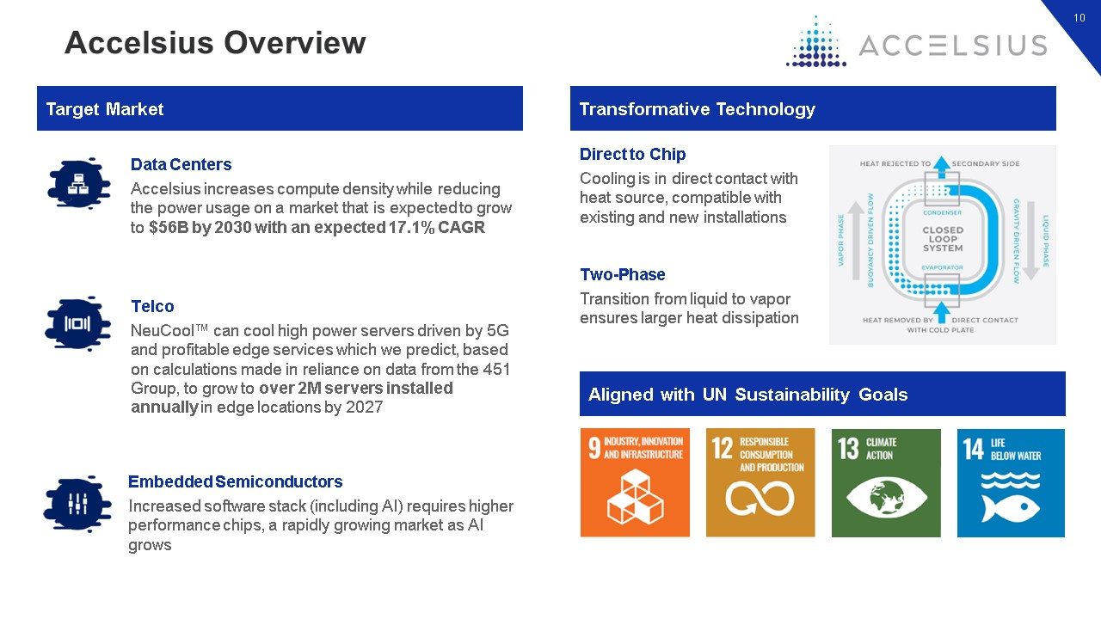
Accelsius Overview 10 Target Market Transformative Technology Telco NeuCool™ can cool high power servers driven by 5G and profitable edge services which we predict, based on calculations made in reliance on data from the 451 Group, to grow to over 2M servers installed annually in edge locations by 2027 Data Centers Accelsius increases compute density while reducing the power usage on a market that is expected to grow to $56B by 2030 with an expected 17.1% CAGR Embedded Semiconductors Increased software stack (including AI) requires higher performance chips, a rapidly growing market as AI grows Aligned with UN Sustainability Goals Direct to Chip Cooling is in direct contact with heat source, compatible with existing and new installations Two-Phase Transition from liquid to vapor ensures larger heat dissipation

